CONTENTS
Chapter 1 Preface 2
Chapter 2 Programming 3
2.1 Basic concepts 4
2.2 General description of program 5
2.3 Program instruction 5
2.4 Programme instruction and usage 13
2.5 Radius compensation of tool C 49
2.6 Comprehensive examples for programming 53
2.7 Usage for automatic tool setting gauge 56
2.8 Usage for automatical dividing center 57
Chapter 3 Operation explanation 59
3.1 Summary 59
3.2 Operation panel 59
3.3 Keyboard description 59
3.4 Manual operation 61
3.5 Auto operation 66
3.6 Operate safety, prompt alarm 69
3.7 Parameter operation 70
3.8 Set parameter of tool redeem 79
3.9 Screw compensation 81
3.10 Diagnosis 85
3.11 Operation of program 87
Chapter4 System installation and connection 93
4.1 System electrical specification 93
4.2 System technical index 93
4.3 Environment of operation 93
4.4 System installation and connection 94
4.6 System rear view 95
4.7 Interface connection graph 95
4.8 The machine installation of machine. 105
4.9 Electrical appliance plate of machine 111

Chapter 1 Preface
This system is a universal milling machine, drilling machine, boring machine CNC system which is developed by our company. The control circuit is using the latest industrial high-speed ARM processor, large-scale field and programmable FPGA technology, multilayer PCB, the machine adopts the high integrated chip and surface mount components, the structure is more compact and reasonable so that make sure the reliability and stability of the system.
Real-time control of high speed (the highest speed shift speeds of up to 30 m / min, the highest feed interpolation speed can reach to 15 m / min), high precision; the use of 800x600 dot matrix TFT LCD adaptive brightness LCD display, LED backlight brightness uniformity and long service life, and overcomes the display brightness by environmental temperature changes the shortcoming. Full screen English menu display, operation is simple and convenient.
This system is based on the milling machine as the representative of the two or three, four axis linkage, This system is based on the milling machine as the representative of the two or three, four axis linkage, closed-loop control universal fully digital control system, powerful function and many instructions, programming code accords with ISO international code standard. Direct control of AC servo, choosing the dual channel AC servo driver which is high price ratio.
This manual details the programming and using method of milling system.
Important Notice:
- All the functions of A axis are effective when configure fourth axis system.
- When use this system for the first time, please read carefully all the details of each chapter so as to make it work more efficiently.
- The “Run” button on the panel of system can be used when debugging (No.9 parameter in other parameter to set “Effective” “Invalid”), must plus an external “Run” button when fitting system, otherwise may cause accident because of the life of button!!!So the system prohibits using the button for many times, otherwise the consequences has nothing to do with the company

Chapter 2 Programming
CNC machine is highly effective automatical equipment according to programmed program to process workpiece. Programming is using the CNC system control language according to the requirement and drawing of the workpiece to describe the processing trajectory and the assistant action. Ideal system not only could promise process qualified workpiece, but also make the functions of cnc machine reasonable application and fully use, so it is very important to programming, this chapter will introduce many kinds of instructions and usage of CNC program, please read carefully.

2.1 Basic concepts
Program Segment：It is a complete command line consisted of instruction segment and data segment.
Program：is a congregation of program segment by machining logic structure in order to complete the machining of workpiece.
Machine Coordinate System：The establishment of coordinate is based on machine’s zero point。The milling machine coordinate axis and its direction should follow to "ISO841" standard。The method as follow: Through right hand rule we can make the program coordinate, The Z axis is parallel as spindle, The X axis is horizontal, The Y axis is determined by right hand rule. The A, B, C are rotated axis or assistant axis which parallel as X,Y,Z axis. Furthermore, The coordinate axis direction is the increasing workpiece dimension direction.
As no work coordinate, make machine coordinate as work coordinate.

+Z
＋X
＋Y
Vertical milling、drill machine
＋Z
＋X
＋Y
Horizontal milling machine
Machine Coordinate & direction sketch map

Working Coordinate System: Work piece processing uses the coordinate system is called as the work piece coordinate system, it is set by CNC. The work piece coordinate system could change to move its zero point.
Set the work piece coordinates:
1.Use G54 ~ G59: Use operating parameter set coordinate system may set 6 work piece coordinate system.
2.G52 instruction: Set a value in front of G52 instruction to set the workpiece coordinate system in program.
With absolute value instruction ,it must use the above method to establish the work piece coordinate system
Local coordinate system: Set local coordinate system of workpiece coordinate system in order to programme easily when programming in workpiece coordinate system.
Absolute Programming：It is confirmed coordinates data programming mode based on established absolute coordinate system.。It is settlements by “G90”。
Relative Programming(increment programming)：It is distance and direction of operation end point ,compared with starting point。It is settlements by “G90”。
Mode Instruction：The instruction which can remain the function in the program.It works both in this program and program in the future.
In the same operation, there may be several mode instruction, such as M03(spindle clockwise),M04(spindle counter clockwise),M05(spindle stop).They are all mode used to control spindle.The mode of same kind are categorized into one mode group.At any time it must be one of them,and there is only one of them.The original chosen mode is called mode origin.In the above mode group,M05 is such a mode origin 。
Suspending Mode（destroying mode)：It is instruction which can turn mode instruction into mode origin or destroy the mode.Such as M20(program ending instruction),meaning the end of operation and returning to original status.
None Mode instruction：It is the instruction which has no function to store,and only works in the segment of program.

2.2 General description of program
G02，T02，H02，D02，M02，S04，F04，X-043，Y-043，Z-043，A-043，I-043，J-043，K-043，L04，P4，R043。
Note 1:“-”means this data can be use.
Note 2:In front of the numeral is 0, indicated this data only write the effective data。
Note 3:The digital presentation is a figure, when is two, top digit expression integer figure biggest figure, after low position expresses decimal point most imperial throne.

2.3 Program instruction
Introduce all the functions and using method of instruction code in this system.
2.3.1 Functional meaning of address symbol,data list

Functions | Address symbol | meaning | Data range
Document No. |  | File name of machining workpiece | 0-9、A-Z
Program segment No. | N | No. of program segment | 0000-9999
Preparation function | G | Content and mode of designated instruction operation | 00-99
Auxiliary function | M | Auxiliary operation instruction | 00-99
Tool chosen | TDH | No.of Tool. | 01-99
Tool compensation | H D | The length compensates  No.of the radius compensates of the parameter | 1- 4
Spindle function | S SP | The spindle speed; spindle localization | 00-99999
Cutting speed | F | Speed per minute | 1-3000mm/min
Coordinates character | X Y Z A(B/C/U/V/W) | The coordinates value of X Z and 4th axes. | ⇦9999.999mm
Core coordinates | I J K | X Z axes and Z axes core coordinate increment value | ⇦9999.999mm
Step length | R | Circular arc radius | 0.001-999.999mm
Delay time | P.X | Delay time of designated delay | 0.001-99.999s
Program entrance | P | Entrance of calling program name | 0000-9999
Repeat times | L | Times of cycle or subprogram calling | 1-9999
Line skip | / | Not to carry out when “/” is in front of program line | No.12 parameter in other parameter can shield the function
2.3.2 Program instruction
Table 1 G Instruction-code and functions
G code | function
G00 | Fast positioning
G01 | The straight-line interpolation
G31 | No alarm when checking skip
G311 | Alarm when checking skip
G02 | Interpolation along the circle interpolation/the spiral line interpolation CW: The spiral motion spiral line interpolation makes up the 2 circular arcs insert makes up the axis synchronization migration other axes. The instruction method only is simply adds on is not the circular arc inserts makes up the axis the shifting shaft
G03 | The counter circle interpolation/ the spiral line interpolation CCW
G01(G00)X I | Beveling automatically
G01(G00)Y I | Beveling automatically
G01(G00)Z I | Beveling automatically
G01(G00)X R | Smoothing automatically
G01(G00)Y R | Smoothing automatically
G01(G00)Z R | Smoothing automatically
G04 | Delay
G15 | Polar coordinate instruction cancellation
G16 | Polar coordinate instruction: The polar coordinate (radius and angle), the angle to is anti-clockwise changes of the first axis positive direction on the plane, but the negative direction is clockwise changes .
G17 | Choose the Xp Yp plane |  | X：X axis or its parallel axis  Y：Y axis or its parallel axis  Z：Z axis or its parallel axis
G18 | Choose the Z X plane
G19 | Choose the Y Z plane
G20 | Inch input(British system)
G21 | Millimeter input(Metric system)
G28/G281/G282/G283/G284 | Go to machine zero point
M882, M883 | Drop set of Z axis automatic tool setting
M884-M887 | Aromatically finding edge of X, Y axis
M880 | Set tool automatically
G30/G301/G302/G303/G304 | Go to coordinate zero point
G26 | ZXY axis go to program original point
G25 | Memory current coordinate of X Y Z A
G261 | X axis go to program original point
G262 | Y axis go to program original point
G263 | Z axis go to program original point
G264 | A axis go to program original point
G61/G611/G612/G613/G614 | Back to the memory point by G25
G40 | Cancel tool radius compensation
G41 | tool radius compensate(left)
G42 | tool radius compensate(right)
G43 | Positive tool length compensation
G44 | Negative tool length compensation
G49 | Cancel tool length compensate
G45 | Tool offset adding
G46 | Tool offset subtract
G47 | Double tool offset adding
G48 | Double tool offset subtract
G37 | Cancel scale zoom
G36 | Enable scale zoom：format：G36 X_Y_Z_R_
G12 | Cancel programmable mirror
G11 | Enable programmable mirror
G50/G52 | Set coordinate system: the programmer in work coordinate system is easy program, subcoordinate system is permitted in workpiece coordinate system.
G53 | Choose machine coordinate system
G54.1/G54.48 | Choice work coordinate 1
G55 | Choice work coordinate 2
G56 | Choice work coordinate 3 | Note：These six work coordinates are saved in CNC，user may choose one of them
G57 | Choice work coordinate 4
G58 | Choice work coordinate 5
G59 | Choice work coordinate 6
G60 | exactitude stop positioning
G64 | Continue path work
G68 | rotate coordinate。format：  G17  G18 G68 a-b- R-; R:Angle  G19
G69 | Cancel rotate coordinate
G73 | Drill deep hole loop：intermittent feed, rapidly back.
G80 | Cancel cycle mode/cancel external operation
G81 | Drill cycle：cutting feed, boring cycle or external operation, rapidly back
G82 | Chip removal drill cycle or reverse boring cycle: cutting feed, stop tool at the bottom of hole, rapidly back.
G83 | Drill small deep hole cycle: intermittent feed, rapidly back.
G85 | Boring cycle:cutting feed, back cutting feed
G86 | Boring cycle:cutting feed, stop spindle at the bottom of hole, rapidly back.
G89 | Boring cycle: stop tool at the bottom of hole, back cutting feed
G74 | Left Tap cycle
G84 | Right Tap cycle
G90 | Absolute program
G91 | Incremental program
G98 | Go back to original point: used in final drill
G99 | Go back to R point : used in the first drill
G22 | Program cycle instruction
G800 | Cancel Program cycle instruction
Table 2 M code and function
Spindle | M03  M04  M05 | Spindle CW  Spindle CCW  Stop Spindle | M7053/M7054 P xxxx; It will stop after spindle CW or CCW for a time, the time is determined by “P”. Unit: Millisecond.  Example: M7053 P2000; Means it will delay 2 seconds to stop spindle.
Cooling | M08 | Turn on cool
Cooling | M09 | Turn off cool
Chuck | M10 | Tighten tool
Chuck | M11 | Loosen tool
Huff | M58 | Turn off huff | Controls M59 signal
Huff | M59 | Turn on huff | Controls M59 signal
Lubrication | M32 | Turn on lubricate | Controls M32 signal
Lubrication | M33 | Turn off lubricate | Controls M32 signal
User-defined | M79 | User self-defined 7 output turn on | Double signal output
User-defined | M78 | User self-defined 7 output turn off | Double signal output
User-defined output | M61 | User self-defined2 output turn on | Controls M61 signal
User-defined output | M60 | User self-defined2 output turn off | Controls M61 signal
User-defined output | M63 | User self-defined3 output turn on | Controls M63 signal
User-defined output | M62 | User self-defined3 output turn off | Controls M63 signal
User-defined output | M65 | User self-defined4 output turn on | Controls M65 signal
User-defined output | M64 | User self-defined4 output turn off | Controls M65 signal
User-defined output | M67 | User self-defined5 output turn on | Controls M67 signal
User-defined output | M66 | User self-defined5 output turn off | Controls M67 signal
User-defined output | M69 | User self-defined6 output turn on | Controls M69 signal
User-defined output | M68 | User self-defined6 output turn off | Controls M69 signal
User-defined output | M71 | User self-defined7 output turn on | Controls M71 signal
User-defined output | M70 | User self-defined7 output turn off | Controls M71 signal
User-defined output | M75 | User self-defined8 output turn on | Controls M75 signal
User-defined output | M74 | User self-defined8 output turn off | Controls M75 signal
Spindle shifting | M41 | SP Speed first gear | Output S01,S02,S03,S04, to adjust analog voltage of spindle
Spindle shifting | M42 | SP Speed second gear | Output S01,S02,S03,S04, to adjust analog voltage of spindle
Spindle shifting | M43 | SP Speed third gear | Output S01,S02,S03,S04, to adjust analog voltage of spindle
Spindle shifting | M44 | SP Speed fourth gear | Output S01,S02,S03,S04, to adjust analog voltage of spindle
User-defined input | M12  M13 | Check M12 input valid  Check M12 input invalidate | To skip when conditions are tenable  Example: M12 P120  Program skips to 120th line to execute.
User-defined input | M14  M15 | Check M14 input valid  Check M14 input invalidate
User-defined input | M16  M17 | Check M16 input valid  Check M16 input invalidate
User-defined input | M18  M19 | Check M18 input valid  Check M18 input invalidate
User-defined input | M28  M29 | Check M28 input valid  Check M28 input invalidate
User-defined input | M22  M23 | Check M22 input valid  Check M22 input invalidate
User-defined input | M24  M25 | Check M24 input valid  Check M24 input invalidate
Subprogram | M97  M98  M99 | Program skip | L=1-99  P is the line number of transferring program
Subprogram | M97  M98  M99 | Invoke subprogram | L=1-99  P is the line number of transferring program
Subprogram | M97  M98  M99 | Cancel invoke subprogram | L=1-99  P is the line number of transferring program
Program controlling | M87 | Number of workpiece plus 1 | other parameter P10=0 is set not to symptomatically plus 1, instruction M87 to make workpiece number plus 1
Program controlling | M00 | Suspend program
Program controlling | M01 | Suspend program,input M22 effective suspend  Program is over
Program controlling | M02 | Program end
Program controlling | M30 | M05,M09 program is over
Program controlling | M20 | Program is over, automatic repeat run the program according to the parameter which set the running times, be used for the debugging
Speed of spindle | S  SS | Set speed of the first spindle  Set speed of the second spindle | S=0-99999  SS=0-99999
Read the position of absolute motor | M500  M501  M502  M503  M504 | M500: read absolute motor position of all the feeding axis and reset the current machine coordinate.  M501: read absolute motor position of X axis and reset the current machine coordinate.  M502: read absolute motor position of Y axis and reset the current machine coordinate.  M503: read absolute motor position of Z axis and reset the current machine coordinate.  M504: read absolute motor position of the fourth axis and reset the current machine coordinate.

2.4 Programme instruction and usage
2.4.1 Programme convention
(1). Multiply instruction exist in a segment simultaneously: one program line allows multiply instructions in order to reduce the lines, but the same group of instruction can not share one segment.
(2). Within a program segment, instruction and parameters can be arranged optionally.
Such as: M03 G01 X20 Y-30 can be written: G01 Y-30 X20 M03
(3). No repeat of instruction within a program segment.
(4). It can’t be irrelative parameters and operation in a segment.
(5). “0” before a instruction is allowed to delete, such as: G01 G03 can be written as G1 G3.
(6). The command of optional point, line start or that after tool changing instruction must be programmed by absolute coordinates.
(7). Non mode command only in specified program line is effective,such as: G04.
(8). Mode instruction is always effective before appearing the same instruction.
For example: N0000 G01 X300 F100; G01 instruction
N0001 X260 ; G01 instruction
N0002 G00 Z200 ; G00 instruction, G01 is invalid

2.4.2 Instruction of G function
(1) Choose instruction of coordinate system.(G53/G54/G55/G56/G57/G58/G59)
Format: G53（G54/G55/G56/G57/G58/G59） Mode after setting
G53 machine coordinate
G54 work coordinate 1
G55 work coordinate 2
G56 work coordinate 3
G57 work coordinate 4
G58 work coordinate 5
G59 work coordinate 6
G53 machine coordinate is decided by machine reference point。The default coordinate is G53. Suggest not to adjust the value of G53, all the workpiece coordinate will have offset.
G54/G55/G56/G57/G58/G59 work coordinate have offset relative to machine coordinate which can be set in parameter.
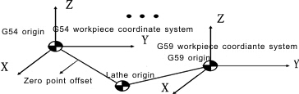
Example: G00 G54 X50 Y60 Z70
Move to X50 Y60 Z70 of G54 with speed of G00.
(2)Local coordinate system instruction
Set local coordinate system when programming in workpiece coordinate system is to programme easily. G50 is used to set workpiece coordinate system, and G52 is used local coordinate system setting.
Format:G52 X_ Y_ Z_ ; Set local coordinate system (Mode)
 G52 X0 Y0 Z0; Cancel local coordinate system
Use G52 to set local coordinate system in machine coordinate system(G53) or workpiece coordinate system(G54~G59). The origin of local coordinate system is set by X_ Y_ Z_.
Once local coordinate system is done, the instructions by G90 will move in the local coordinate system. G50/G52 are used to specify the new zero point, changing position of local coordinate system. Local coordinate system should share the same zero point with workpiece coordinate system in order to cancel local coordinate and specify coordinate in workpiece coordinate system.
Local coordinate system setting does not change the workpiece coordinate system and machine coordinate system. When using the G52 instruction to set workpiece coordinate system, if it is not the instruction of all the axis coordinate value, the local coordinate system of non-specified axis will remain unchanged .Use the absolute mode to specify motion instruction next theG50/G52 program segment .
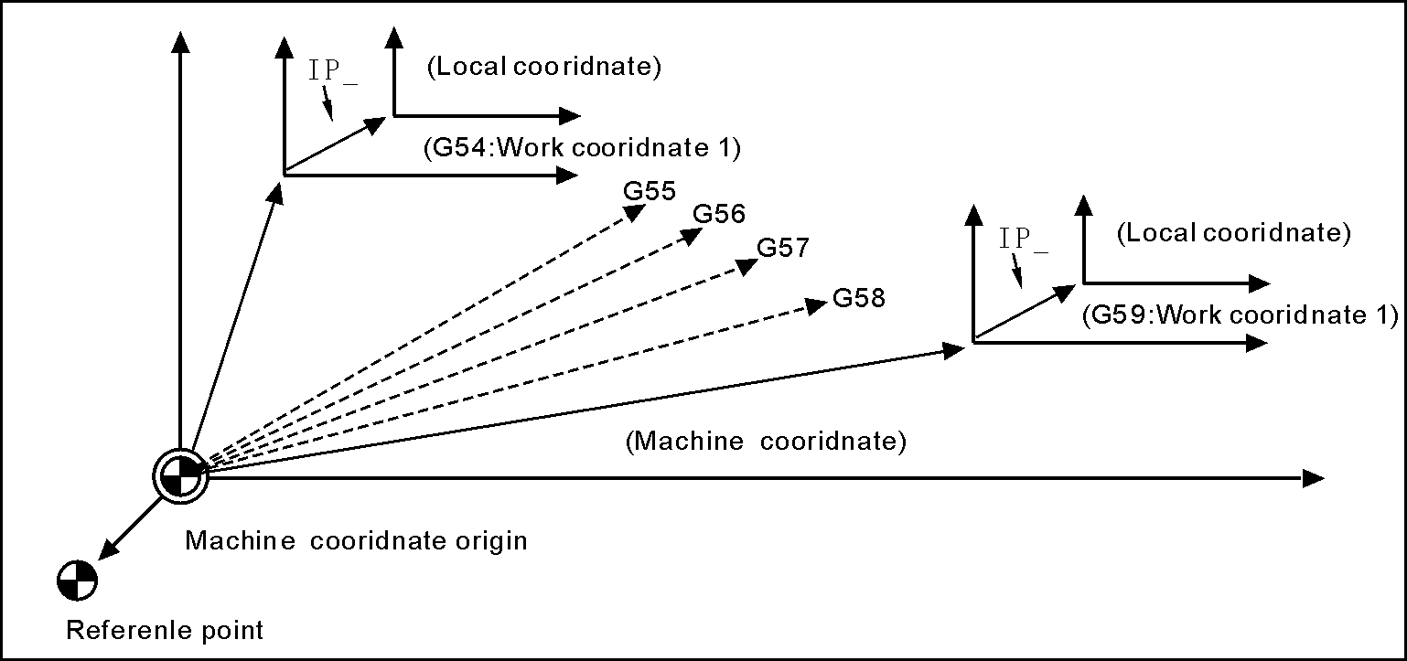
(3)Program method(G90/G91)
Two methods to move tools: Absolute value instruction and incremental value instruction. Programme coordinate value of end point with absolute value; while programme incremental value of moving distance with incremental value. G90 and G91 are respectively used to point out the coordinate with absolute value or incremental value.
Format: G90 （Mode,initial） ;Absolute
 G91 （Mode） ;Increment
Pay attention:The rotating axis use nearest calculation and move accordingly when using absolute coordinate to programme, using programming calculation to work when using relative coordinate to programme.
(4)Select Plane(G17/G18/G19)
Format：G17 (Mode，Original) ;Set XY Plane
G18 (Mode) ;Set ZX Plane
G19 (Mode) ;Set YZ Plane
Used to point out arc interpolation plane.
Note：this instruction does not produce motion.
(5)Rapid motion(G00)
Tool moves to workpiece coordinate system by instruction according to G00 speed in parameter.
In absolute method, use endpoint coordinate to program；
In incremental method, use moving distance of tool to program.

Format：G00 X- Y- Z- A- (Mode，original)
Note：X，Y，Z，A , means motion axis.The data point out motion distance and direction by absolute or incremental method.
In G00 instruction, each axis moves to endpoint separately with the specified speed. Each axis stops moving till the aim point, and next axis keep moving to instruction position. All of axis can move simultaneously by other parameter P9, D6=0 means linked moving.
Moving speed is determined by Speed parameter of G00.
(6) Line interpolation(G01)
Used for single axis motion or 2,3,4 axis interpolation processing..

Format：G01 X_ Y_ Z_ A_ F_ (Mode)

Note：X，Y，Z，A means motion axis.The data point out motion distance and direction by absolute or incremental method.Motion speed is determined by F word. The F instruction is mode.
The feeding speed of F in G01 can be adjusted by feeding override on the panel, the range is 0%~150%.
G01 instruction also can be written G1.
(7) Arc interpolation(G02/G03)
In the program plane, G02 clockwise and G03 counter-clockwise are used to execute arc interpolation processing
Format: .G17$\left\{\begin{matrix}\text{G02} \\ \text{G03}\end{matrix}\right\}\text{X_Y_}\left\{\begin{matrix}\text{I_J_} \\ \text{R_}\end{matrix}\right\}\text{F_}$ ;XY plane(Mode)
G18$\left\{\begin{matrix}\text{G02} \\ \text{G03}\end{matrix}\right\}\text{X_Z_}\left\{\begin{matrix}\text{I_K_} \\ \text{R_}\end{matrix}\right\}\text{F_}$ ;ZX plane(Mode)
G19$\left\{\begin{matrix}\text{G02} \\ \text{G03}\end{matrix}\right\}\text{Y_Z_}\left\{\begin{matrix}\text{J_K_} \\ \text{R_}\end{matrix}\right\}\text{F_}$ ;ZY plane(Mode)

Note：Arc interpolation must point out interpolation plane，the X、Y、Z word point out the arc end coordinate value，I、J、K is incremental value from original point(speed parameter P47 =+4 means endpoint) of X, Y, Z axis to center point. In another word, let the original point be zero point, and if the center is in the forward direction of original point, the value will be positive, if the center is in the backward direction of original point, the value will be negative.I J K are used to define center point coordinate. Besides, R program is also used to define center point coordinate，the R is negative when arc angle is over 180 degree, but it is not applicable for whole cycle.
The trend of arc goes from positive to negative direction that is perpendicular to arc interpolation plane in right-handed rectangular coordinates.
The arc track of different arc interpolation plane as follow:

G03
G02
0
X
Y
G17
G03
G02
0
Z
X
G18
G03
G02
0
Y
Z
G19

I J K are used to define the arc center position, the value behind I J K are vector component from original point to arc center. I J K must must be marked as positive or negative according to directions. I J K can be omitted, then endpoint and original point is the same one, and the arc will be whole cycle when center is specified by I J K, it will always be incremental as following no matter G90 or G91.
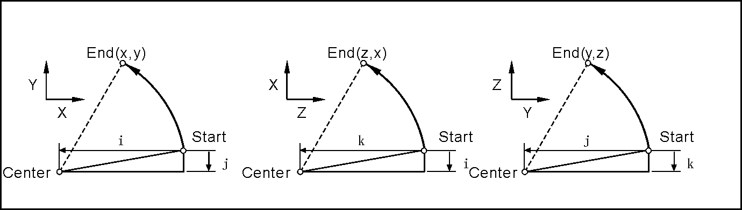
The arc interpolation speed is determined by F word.
Attention: I, J, K and R are the non-modality instruction.
Demonstration:
1) absolute programming
N0000 G92 X200 Y40 Z0; set start point absolute coordinate;
N0010 G90 G03 X160 Y40 I-20 J0; count-clockwise arc;
N0020 G02 X120 Y40 R20; clockwise arc;
N0030 G02 X120 Y40 R20; whole cycle;
N0040 G26 M02; end and back to start point.
2) Relative programming
N0000 G91 G17 G03 X-40 Y0 R20 F300; count-clockwise arc;
N0010 G02 X-40 Y0 R20; clockwise arc;
N0020 G02 X0 Y0 R20; whole cycle;
N0030 G26 M02; end and back to start point.
Two methods have the same result.
(8) Spiral interpolation (G02/G03)
Spiral interpolation means arc interpolation adding another linear-axis interpolation, F instruction defines arc interpolation speed.therefore, the feed speed of line interpolation axis is as follow:
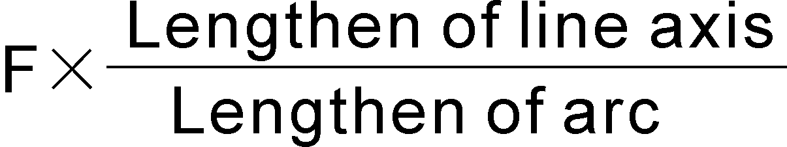

Format ：G17$\left\{\begin{matrix}\text{G02} \\ \text{G03}\end{matrix}\right\}\text{X_Y_}\left\{\begin{matrix}\text{I_J_} \\ \text{R_}\end{matrix}\right\}\text{Z_F_}$ ;XY plane(Mode)
G18$\left\{\begin{matrix}\text{G02} \\ \text{G03}\end{matrix}\right\}\text{X_Z_}\left\{\begin{matrix}\text{I_K_} \\ \text{R_}\end{matrix}\right\}\text{Y_F_}$ ;ZX plane(Mode)
G19$\left\{\begin{matrix}\text{G02} \\ \text{G03}\end{matrix}\right\}\text{Y_Z_}\left\{\begin{matrix}\text{J_K_} \\ \text{R_}\end{matrix}\right\}\text{X_F_}$ ;YZ plane(Mode)
Spiral line enhancement: screw pitch K(J or I) can be inserted into program to process multi-turn spiral line.
G02(G03) X__ Y__ I__ J__ F__ Z_ K__ (G17, K screw pitch, unit:mm)；
G02(G03) X__ Z__ I__ K__ F__ Y_ J__ (G18, J screw pitch,unit:mm)；
G02(G03) Y__ Z__ J__ K__ F__ X_ I__ (G19, I screw pitch，unit:mm)；
G02(G03) X__ A__ I__ J__ F__ Z_ K__ (G177/XA plane, K screw pitch，unit:mm)；
G02(G03) Z__ A__ K__ I__ F__ Y_ J__ (G188/ZA plane, J screw pitch，unit:mm)；
G02(G03) Y__ A__ J__ K__ F__ X_ I__ (G199/YA plane, I screw pitch，unit:mm)；
The cutting tool radius compensates only carries on to the circular arc, cutting tool bias and the cutting tool length compensate cannot be inserted in the segment of spiral line program.
In the spiral interpolation section, cannot use tool length and radius compensation.
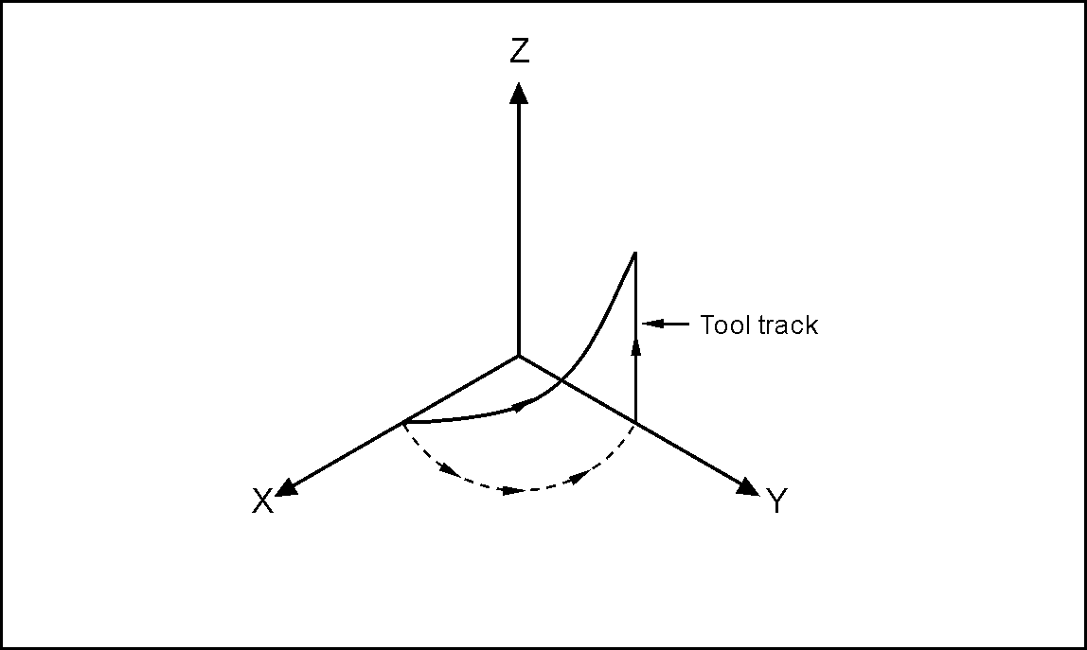

N0001 G90 G17 G54
N0002 G01 X20 Y0 Z0 F600
N0003 G03 X0 Y20 R20 Z15 F180
……

(9) Three dimension space arc instructionG06
Format: G06 X__ Y__ Z__ I__ J__ K__ F__
Function: if center point and radius of three-dimension space arc are unknown,but the coordinates of three points in arc are known, then G06 can be used to find direction of arc by the middle point between start point and endpoint.
Definition of instruction: G06 is mode G code;
I: relative coordinate value(X direction) of middle point relative to start point on arc(radius value and with direction);
J: relative coordinate value(Y direction) of middle point relative to start point on arc(with direction);
K: relative coordinate value(Z direction) of middle point relative to start point on arc(with direction).
Attention:
1) Middle point: refers to any point in the arc except for start point and endpoint;
2) if there are three col-linear points, it will alarm;
3) when I is omitted, it defaults to I=0; when K is omitted, it defaults to K=0;when J is omitted, it defaults to J=0. but if I,J, K are omitted at the same time, it will alarm.
4)IJK of G06 is just similar to the displacement value IJK of center point relative to start point coordinate in G02/G03.
5) G06 cannot be used to process whole cycle.
6) the instructions requires a lot of math operation, therefor it works perfect in bus type controller, while it may not work fluently as Bus type in other type controllers.
Example:
G0 X10 Y28 Z10
G06 X30 Y98 Z10 I5 J-6 K-5 F100
X130 Y198 Z120 I55 J-86 K-65
G0X0Z0
M02
(10) Delay instruction(G04)
Used to delay a certain time for the requirements of processing technique.
Format：G04 P_ ;or
G04 X_ ;or
G04 U_ ;
Function:Every axis is stop and mode instruction is still working when execute this instruction, after delaying the specified time to execute the next program segment.
Instruction introduction:
a.The unit of P delay time is ms(Millisecond).
b.The unit of X and U delay time are S（second）.
c.Example:
G04 X1； delay 1s.
G04 P1000； delay 1s.
G04 U1； delay 1s.
d.Special application:G04 can be accurate stop instruction, such as processing corner kinds of workpiece, it appears over cutting sometimes, if use G04 instruction around the corner, it will eliminate the over cutting.
Example as follows:
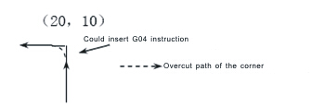

Program: … …
N150 G01 X20 Z10 F100；
N160 G04 P150；（Clear the over cutting）
N170 G01 W-10；
……
Pay attention: Set No.21 parameter in “N”(processing) parameter to clear the over cutting.

(11) Mirror instruction(G11/G12)
In order to decrease program codes, be used for machining symmetry workpiece.

Format：G11 X_ Y_ (Z_ X_ ) (Y_ Z_ )(mode)
according to XYZ symmetry axis
G12 (mode，original) ;Cancel Mirror。
Note: mirror processing perform symmetric machining of the axis by changing feeding direction of axis. The axis changing direction is determined by address character of current interpolation plane G17(X_ Y_ ); G18 (Z_ X_ ); G19（Y_ Z_). the value behind X_ Y_ Z_ is coordinate of current workpiece coordinate system.
In programmable mirror mode, such instruction about back reference point as G26,G61,G28,G30 and instruction about changing coordinate system like G52,G53/G59 cannot be employed. These G code cannot be specified until cancel the programmable mirror mode.
For example:

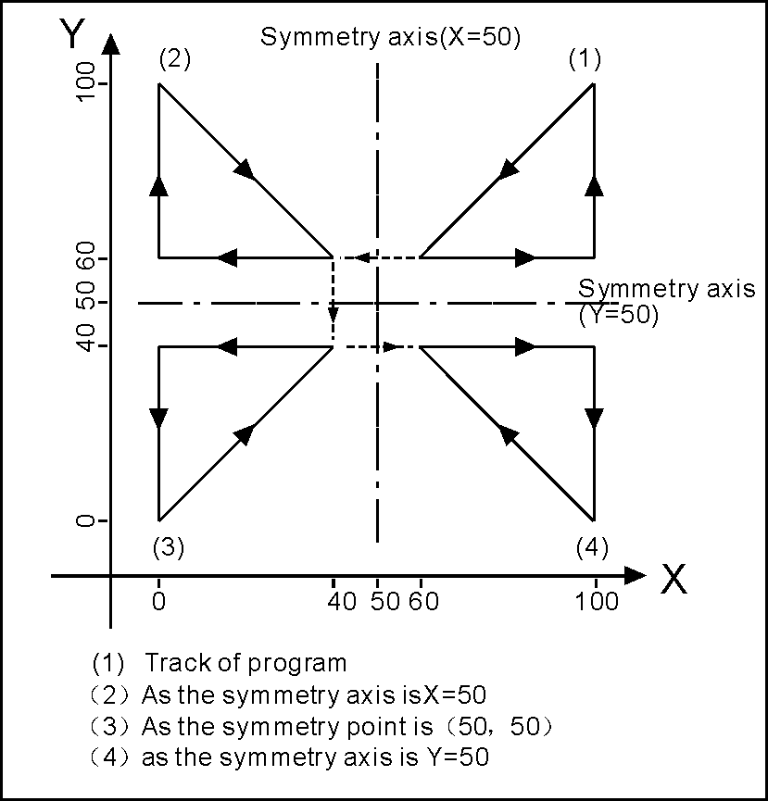
The mirror procedure gives an example:
Sub program
KG11
N10 G00 G90 X60.0 Y60.0；
N20 G01 X100.0 F100；
N30 G01 Y100.0；
N40 G01 X60.0 Y60.0；
N50 M99；
Main program
N10 G00 G90；
N20 M98 PKG11；
N30 G11 X50.0；
N40 M98 PKG11；
N50 G11 X50.0 Y50.0；
N60 M98 PKG11；
N70 G11 Y50.0；
N80 M98 PKG11；
N90 G12；
N100 M02
(12) Proportions scale instruction(G36/G37)
Used for unchanging the processing program, to process proportionally reduced or enlarged workpiece. Programming shape is magnified and reduced (scaling), use X_, Y_ and Z_ to specify scaling center. If an axis is not specified, the axis will not carry out scaling. The number behind the X_ Y_ Z_ is the coordinate of current workpiece coordinate system.
Format：G36 X_Y_Z_R_ (mode) ;Carry out
G37 (mode，original) ;Cancel
Note：behind R is the scale coefficient is
For example:
P1` P2` P3` P4` magnify to P1 P2 P3 P4,R=P0P4`/P0P4. When P1 P2 P3 P4 reduce to P1` P2` P3` P4`, R=P0P4/P0P4`. So: R<1 when magnifying, R>1 when reducing,R=1 can be default.

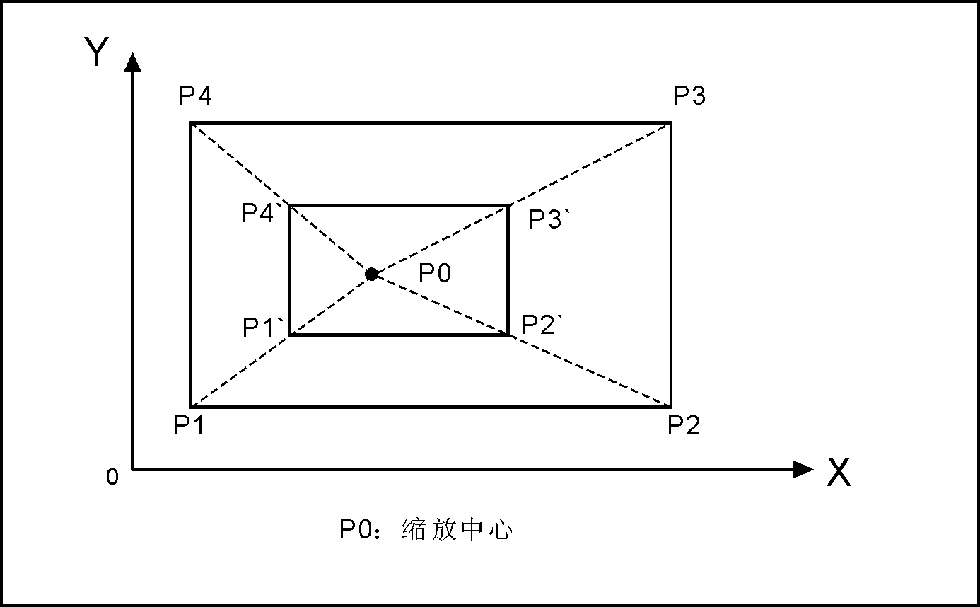
Scale center
In the proportions scale section, cannot use tool length and radius compensation:

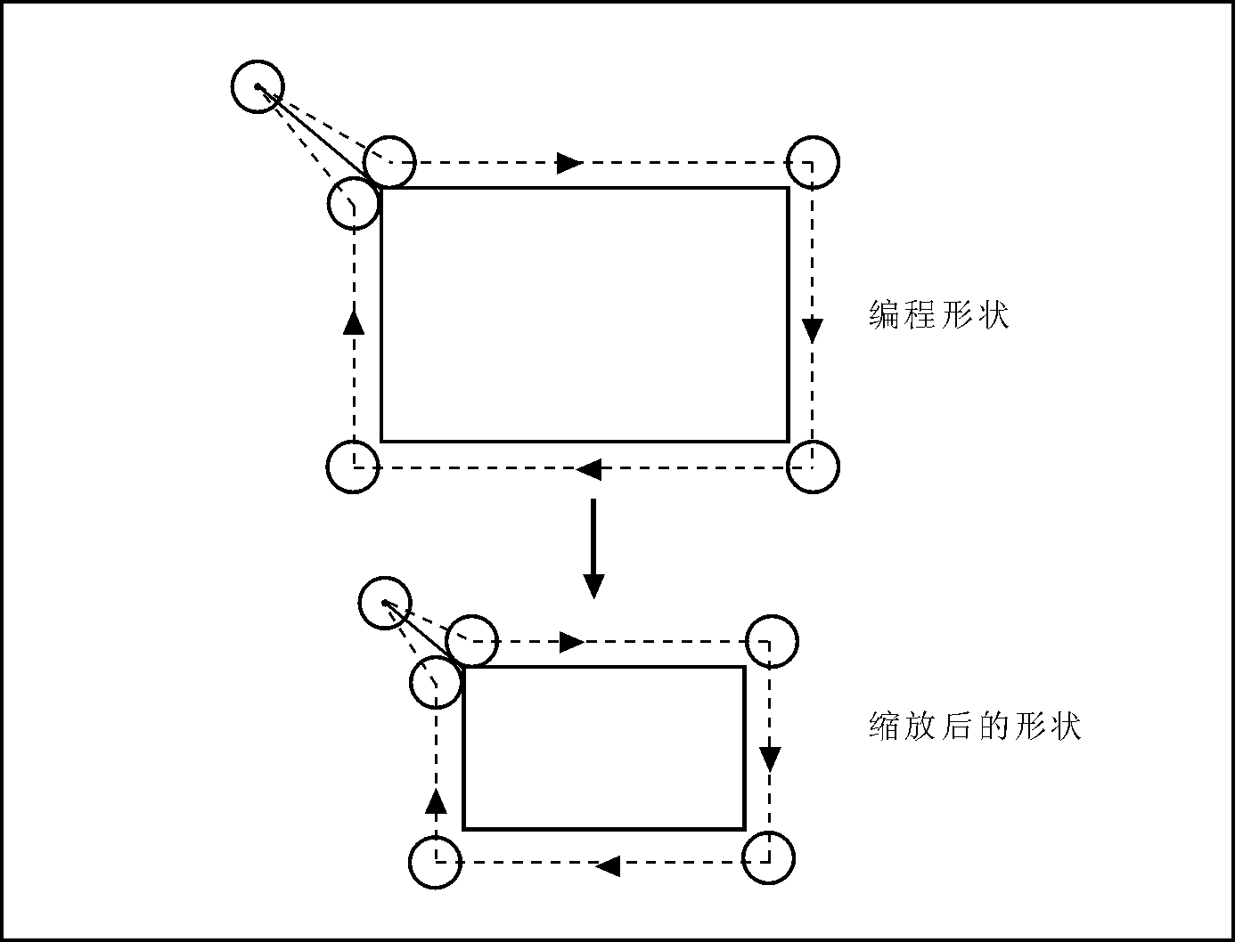
Original track
Track after scale
(13) Coordinate rotate(G68/G69)
Programming shape can rotate, the rotating instruction can make workpiece rotate for specified angle. Anyway, if the shape of workpiece is comprised of many same graphics, the graphics unit can be compiled to subprogram, then the subprogram is on tap for rotation instruction of main program. This can simplify the programming, saving storage space.

Format： G68 X- Y- R- (mode) ; enable
G68 Z- X- R- (mode) ; enable
G68 Y- Z- R- (mode) ; enable
G69 (mode，original) ; disable
Note： The (G17)X-Y- or (G18)Z-X- or (G19) Y-Z- behind G68 is used for pointing out rotate center.
R word is used for pointing out rotate angle, unit is °(degree), the value behind X_Y_Z_ is coordinates of current coordinate system;
positive R means rotate CCW;
Negative R means rotate CW.
Example:
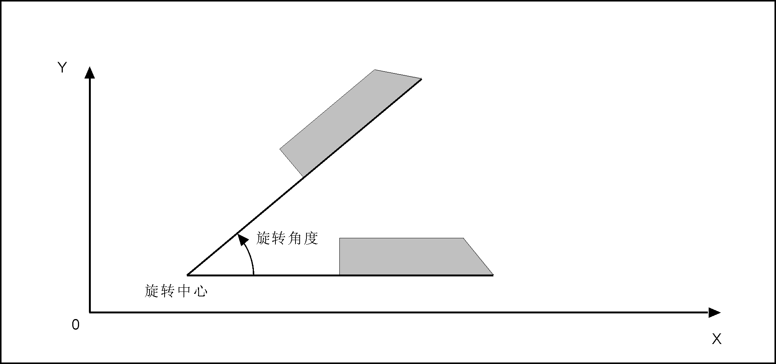
Rotate angle
Rotate center
To specify plane and select code(G17 G18 or G19) before the G68 code program segment, select the code cannot be specified in the mode of rotating coordinate system. Cancel the mode G69 code must occupy a program segment separately. After rotating the coordinate system to carry out tool radius compensation, tool length compensation, tool offset and other compensation.
In the mode of rotating coordinate system, the G code (G28 G26 G31 G30 etc) which is related with backing to the datum point and those related with the the G code (G52, G54/G59) of coordinate system cannot be specified, if need these G codes, must specify after canceling coordinate rotation mode. The first moving instruction must use absolute value instruction after the coordinate system rotation cancel G69, if use incremental instruction, it will not to carry out correct motion.
Example:
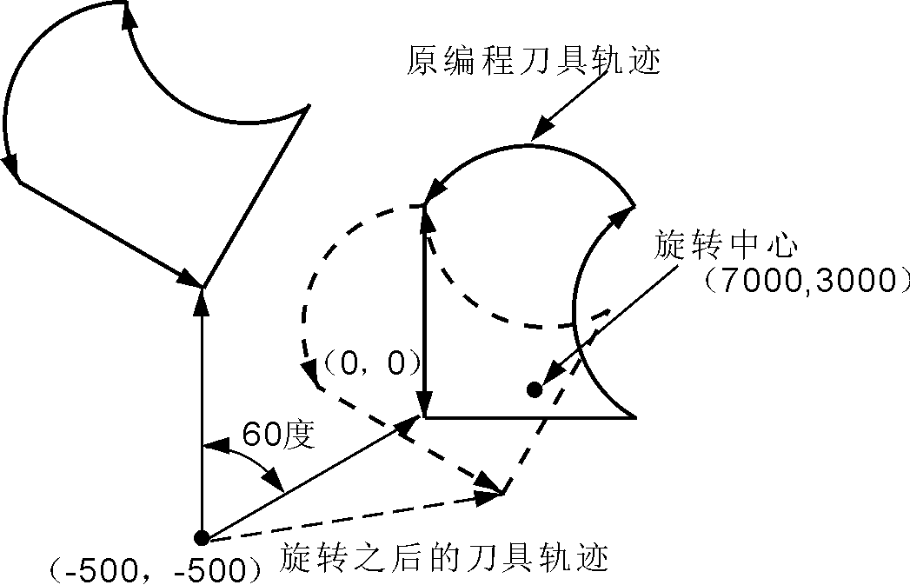
Rotate center
Original program tool track
。
Tool track after rotate
N1 G92 X-500Y-500F20000 G17;
N2 G68 X700Y300R60;
N3 G90 G01 X0 Y0 F20000;
N4 G91 X100
N5 G02 Y100 R100
N6 G03X-100I-50J-50;
N7 G01Y-100
N8 G69
N9 G90 X-500Y-500
N10 M02;
(14)Return reference point(Zero point) (G28/G281/G282/G283/G284/G301/G302/G303/G304)
Return Reference instruction means tool go to reference point according to appointed axis.
Format： G28 X(U)_ Y(V)_ Z(W)_ A_ B_ ;ZXYAB return to reference
G281 ;only X return to reference
G282 ;only Y return to reference
G283 ;only Z return to reference
G284 ;only A return to reference
G285 ;only B return to reference
G301 ;X axis return to zero
G302 ;Y axis return to zero
G303 ;Z axis return to zero
G304 ;A axis return to zero
Pay attention: Should clear tool radius compensation and tool length
(15)Tool length compensation instruction(G43/G44/G49)
The difference between programming tool length and actual using tool length can be compensated with this function so that not to adjust the program. Use G43 or G44 to specify the direction of offset, import the corresponding H code address to select tool length offset value from the offset table.
On the plane G17(XY), length compensation applies to Z axis, so tool should be installed in Z axis;
On the plane G18(ZX), length compensation applies to Y axis, so tool should be installed in Y axis;
On the plane G19(YZ), length compensation applies to X axis, so tool should be installed in X axis.
Format：
G43 H_ ;Add tool length compensate。
 G44 H_ ;subtract tool length compensate。
G49 or H0 ;cancel tool length compensate.
Note:tool length compensation refers to add or subtract the value of tool length compensation on Z axis or other axis. Invoking number is H1-H99. compensation value of parameter starts from the tool position before compensation.

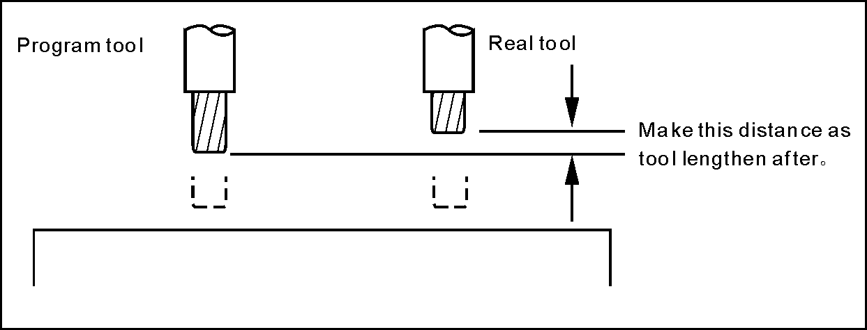
Example: N0000 G43 H2 X10 (H2 value is 5)
N0010 G44 H3 X20 (H3 value is 10)
Executing first section,tool length add 5. Executing second section,tool length subtract 10(real running is 10+5=15), backing to original position.
(16)Offset of tool radius instruction(G45/G46/G47/G48)
Used for processing groove of the workpiece, programming according to the size of workpiece drawing, the instruction line with the one of this set of instruction, then it can work out correct production in different tool radius.
Format： G45 T_ ;Add one radius。
G46 T_ ;subtract one radius。
G47 T_ ;Add two radius。
G48 T_ ;subtract two radius.
Note:The instruction of increasing or decreasing the tool radius is increasing or decreasing one or two tool radius parameter values with T number in the execution. And be used with XY (G17) plane of the G00, G01, G02, G03 instruction. Can not be used with tool radius compensation instruction (G41,G42)
Increase or decrease one or two tool radius in the direction of axis for G00 and G01.
For G02 and G03 is increasing or decreasing one or two tool radius in the direction of arc radius.

G45/G46/G47/G48 are non-modal instructions.
0
A
B
C D
E F F
H
G
L 150 K
I
J
Y
X
120
60
60
60
60
60
30
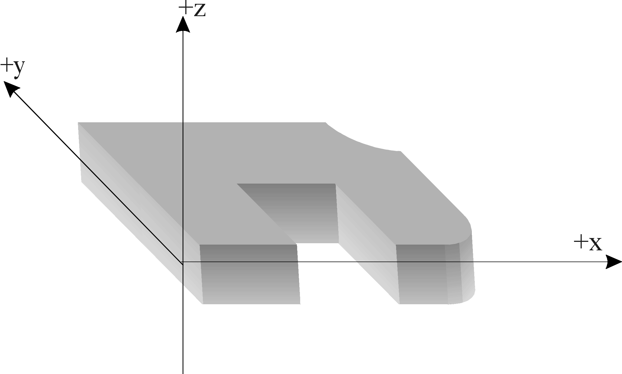

Program as follows:
N0000 G01 Z-20 F400 G91 ; Z point starts
N0010 G46 T01 X55 Y55 ; Point location to A point, X and Y axis both decrease one tool radius(T01)
N0020 G47 G01 X60 F200 ; A-B X axis increase two tools radius
N0030 Y60 ; B-C length not change
N0040 G48 X60 ; C-D X axis decrease two tools radius
N0050 Y-60 ; D-E length not change
N0060 G45 X30 ; E-F X axis increase one tools radius
N0070 G45 G03 X30 Y30 R30 ; F-G CCW radius increase one tool radius
N0080 G45 G01 Y60 ; G-H Y axis increase one tool radius
N0090 G46 X0 ; H-I Move for one tool radius along the negative direction of X axis
N0100 G46 G02 X-30 Y30 R30 ; I-J CW radius decrease one tool radius
N0110 G45 G01 Y0 ; J-K Move for one tool radius along the positive direction of Y axis

N0120 G47 X-150 ; K-L X axis increase two tools radius
N0130 G47 Y-120 ; L-M Y axis increase two tools radius
N0140 G46 X-55 Y-55 ; M-N X and Y axis both decrease one tool radius
N0150 G26 ; Program backs to the starting point to end
N0151 M02

The relationship between Plus(+), Minus(-) and tool radius in above example is addition of term of the same sign, subtraction of term of different sign. Coordinate can be zero, used to specify coordinate axis, run length is 1 or 2 radius. The direction is specified by signs of instruction and radius.
(17) Tool radius compensate instruction(G40/G41/G42)
When the tool is moving,tool track can offset a radius。In order to offset a radius，CNC establish offset vector whose length equal tool radius。Offset vector is vertical to tool track。Completed machining，it needs to cancel tool radius compensation。
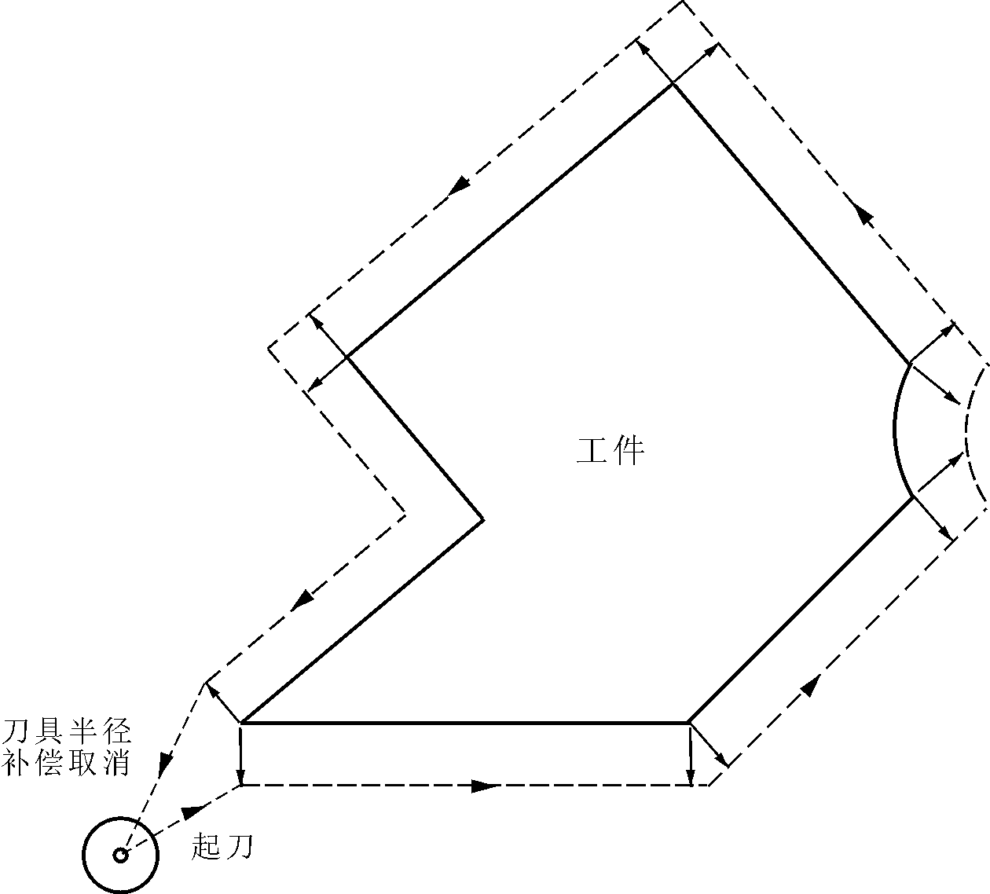
Cancel tool radius offset
Start
workpiece
Format：G40 (mode，original) ;Cancel compensation。
G41 T－ (mode) ;tool locate to Left offset of workpiece 。
G42 T－ (mode) ; tool locate to Right offset of workpiece。

Note：
Left or right side of G41/G42 is following in the direction of cutting, tool is in the left or right of workpiece. tool radius is invoked by T1-T99. execution of offset stars from the line of G41/G42. It will generate transition line at sharp corner, in order to transit from the tool radius offset vector in the end of last segment to the offset vector in the beginning of next segment. Tool offset vector refers to describing value and direction of tool offset.radius vector is radius of tool. For arc, its direction is the radius direction. And for line, it direction is vertical direction of line.
Tool radius compensation establish and cancel have two type: A type and B type，which can set in other parameter。Furthermore, Tool radius compensation establish and cancel must be executed in line section。
For example:
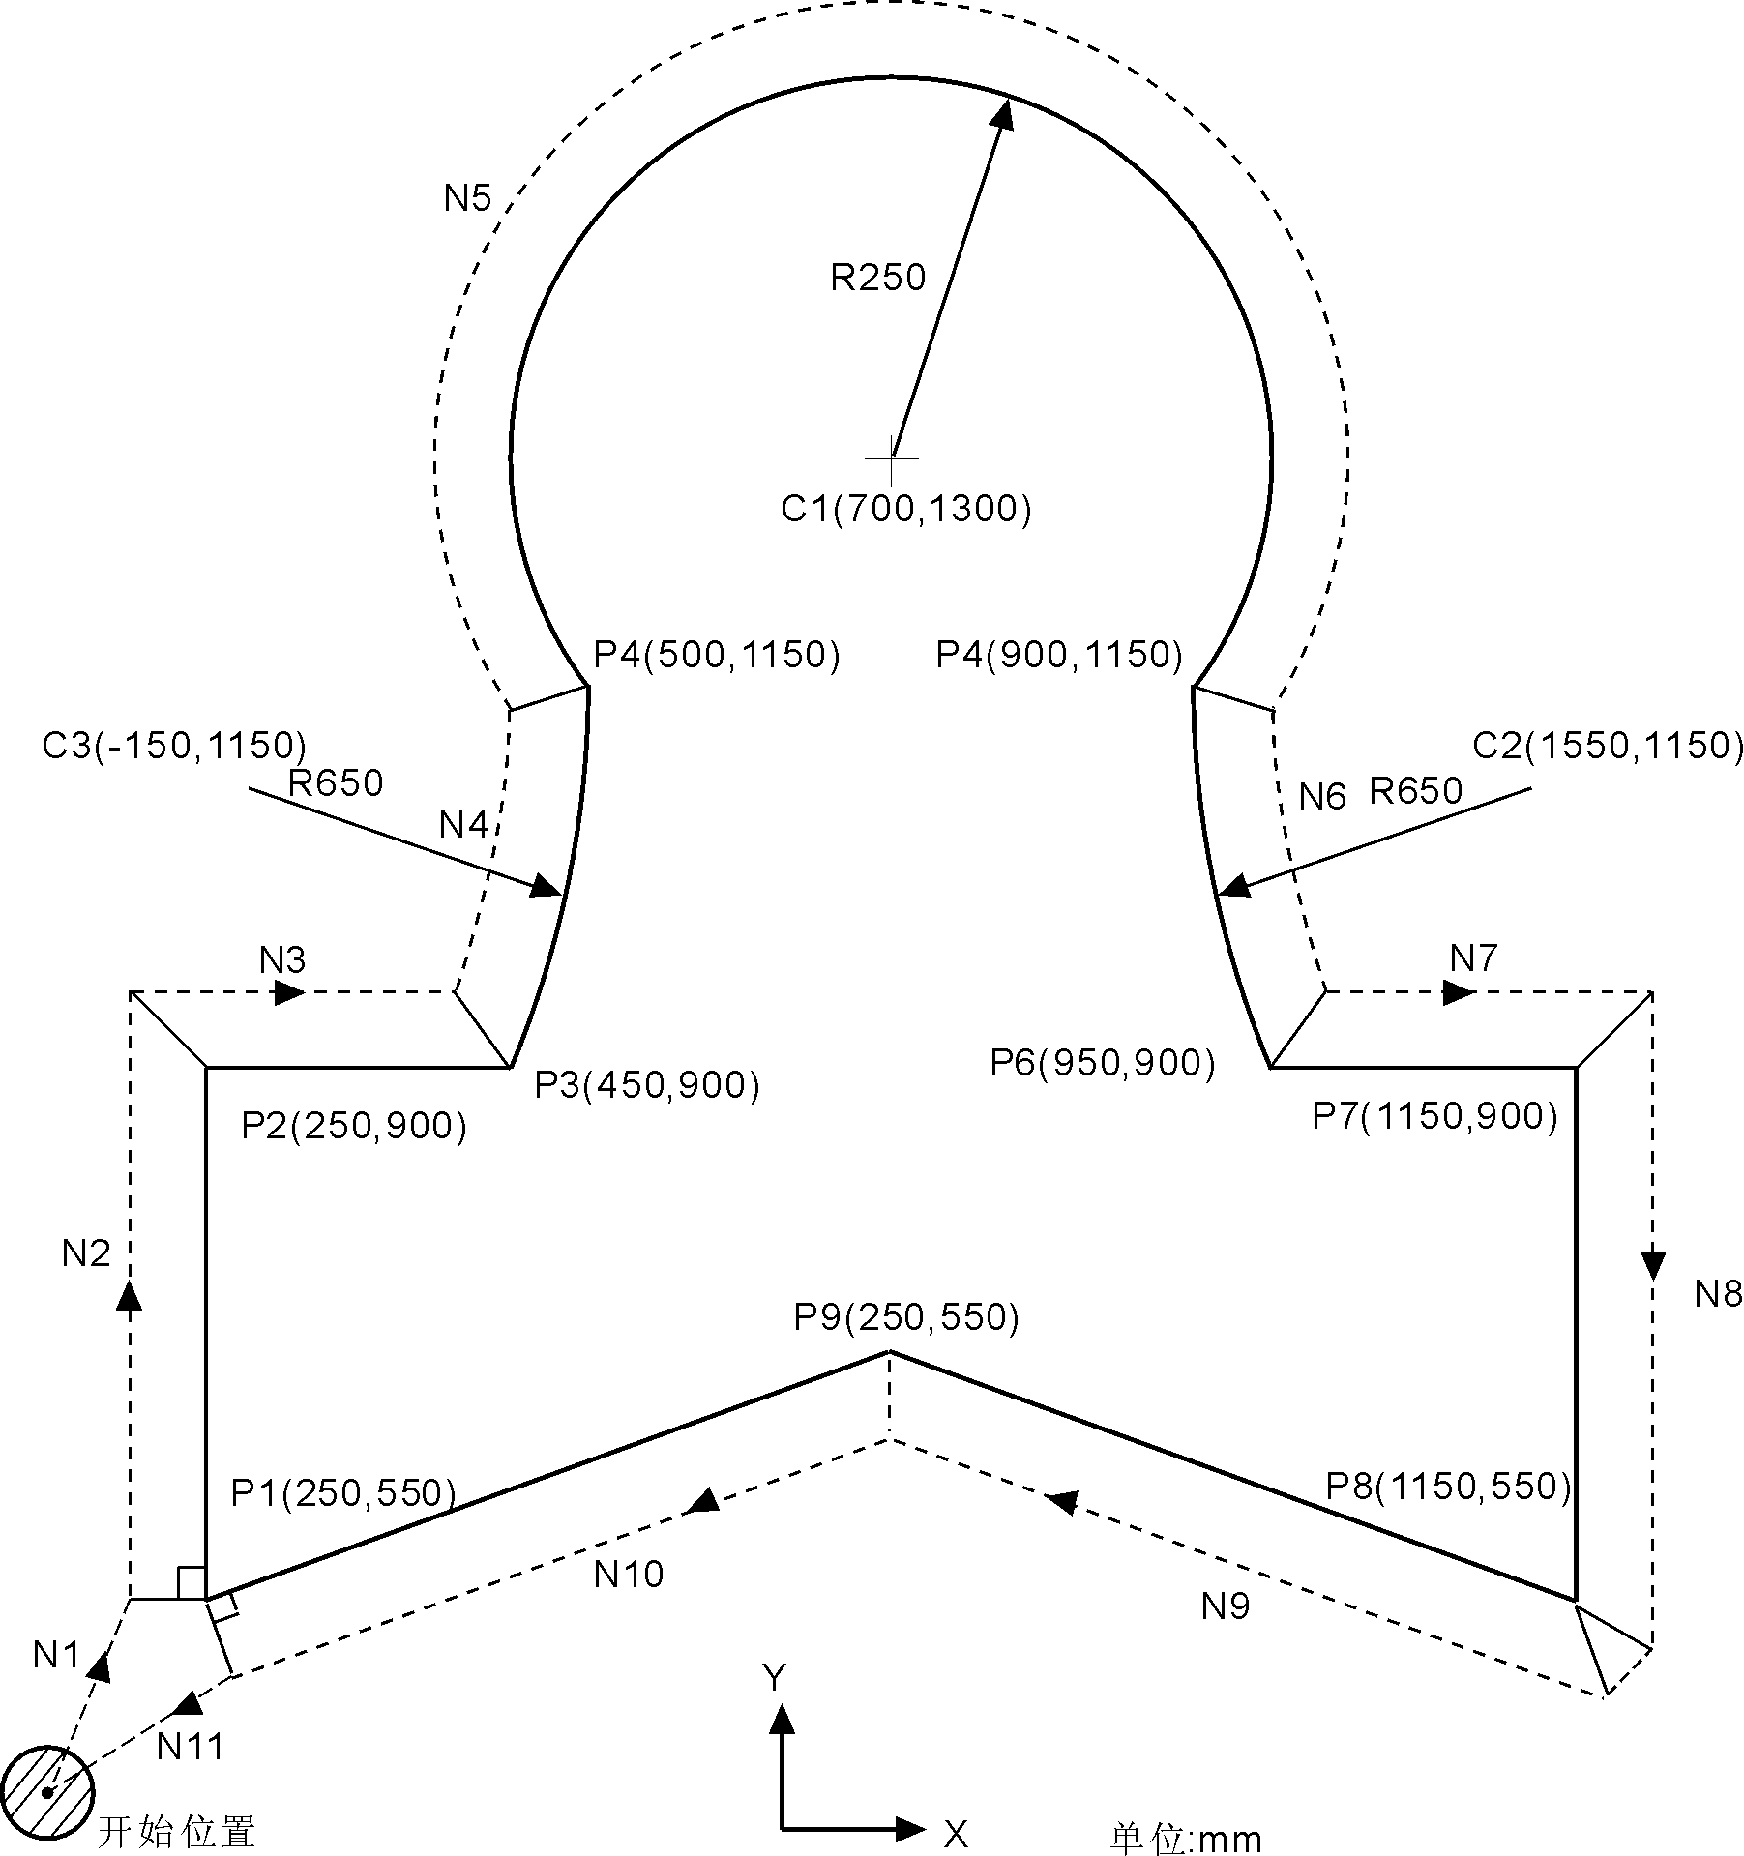
Start
Unit:mm

G54 X0 Y0 Z0;…………………………………
N1 G90 G17 G00 G41 T15 D2 X250.0 Y550.0; establish compensation
N2 G01 Y900.0 F150; ……………………… from P1 to P2
N3 X450.0; ……………………………………from P2 to P3
N4 G03 X500.0 Y1150.0 R650.0; ……………from P3 to P4
N5 G02 X900.0 R-250.0; ……………………from P4 to P5
N6 G03 X950.0 Y900.0 R650.0; ……………from P5 to P6
N7 G01 X1150.0; ……………………………from P6 to P7
N8 Y550.0; ……………………………………from P7 to P8
N9 X700.0 Y650.0; ……………………………from P8 to P9
N10 X250.0 Y550.0; …………………………from P9 to P1
N11 G00 G40 X0 Y0; ……………………… cancel compensation
(18) Program circulation instruction (G22--G800)
G22 is program circulation instruction, G800 is an instruction to end circulate. But G22 must be used with G800 for repeated processing. L means circulation times, the range is 1-99999.The circulation instruction can nest.

Format： G22 L2 ;begin
：
： ;circulating
：
G800 ;end

For example
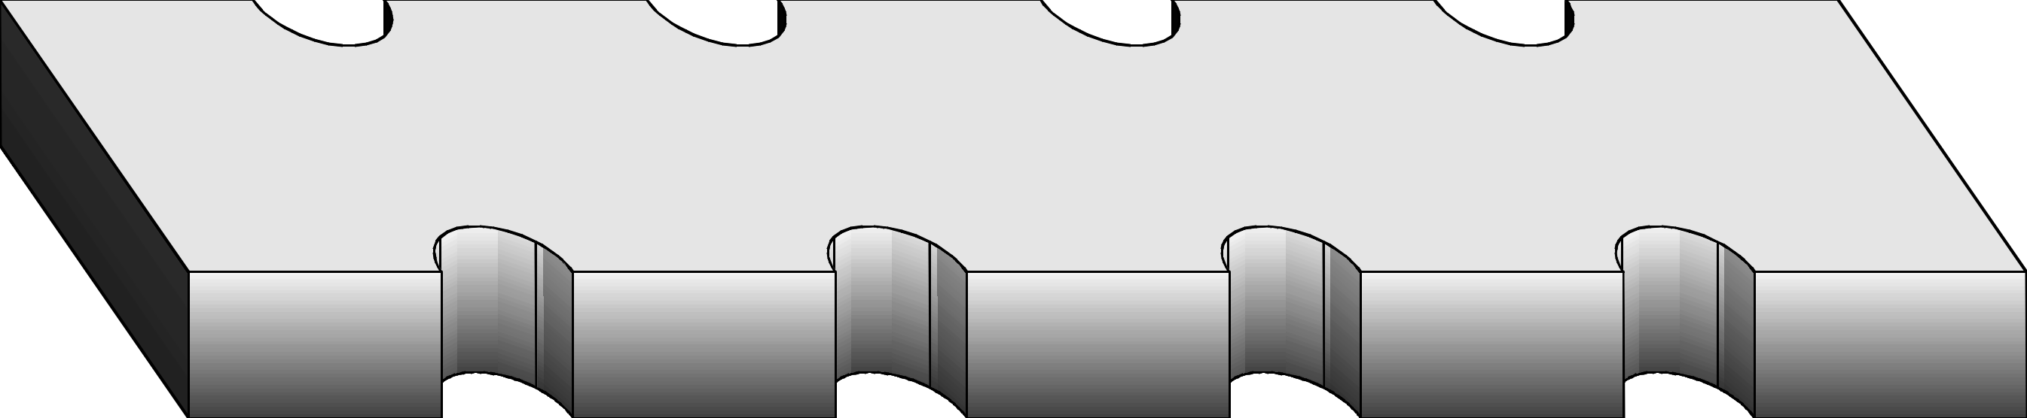

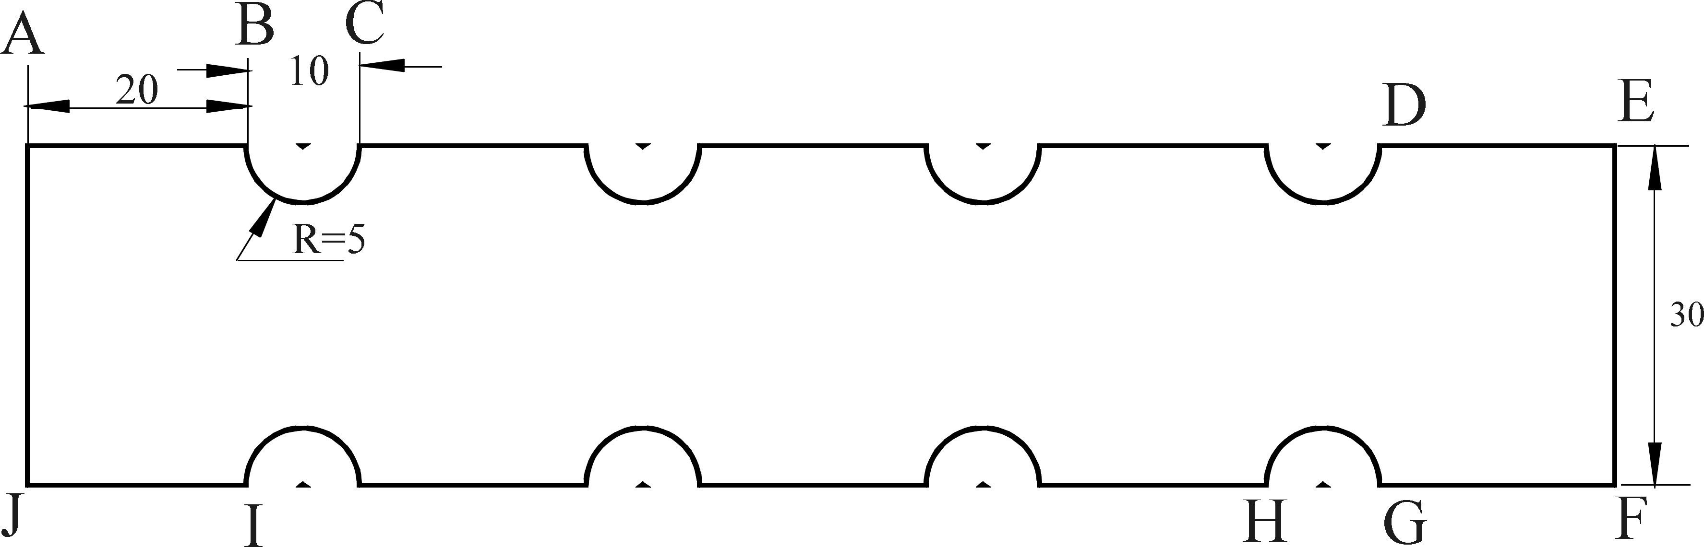
Program as follows:
N0000 G17 G90 X0 Y0 F250 M03 ;
N0001 G91 G01 Z-10
N0010 G22 L4 ;
N0020 G01 X20 ;
N0030 G03 X10 I5 J0 Y0 ;
N0040 G800 ;
N0050 G01 X20 ;D-E line
N0060 Y-30 ;E-F line
N0070 G11 X140 Y-30 ;set mirror
N0080 G22 L4 ;circulation begin
N0090 G01 X20 ;F-G line
N0100 G03 X10 I5 ;G-H arc
N0110 G800 ;circulation end
N0120 G01 X20 ;I-J line
N0130 G01 Y-30 ;cancel mirror
N0140 G12 ;J-A line
N0150 G26 ;go back to program begin point
N0160 M02 ;over
(19) Accurate localization/Continual way processing (G60/G64)
According to requirement of processing，we can set program section connection way by the G60/G64 instruction.
Format：G60 ; accurate stop (mode)
G64 ; continue section（mode，original）
(20) Circle instruction（G73、G74、G80～G89）
Using Circle instruction, we can shorten the program length,make the program more simple.
Circle instruction table
G code | Feed method | Motion in the bottom of hole | withdraw | application
G73 | Intermission feed | No | Rapid move | High speed drill deep hole
G80 | Continue feed | No | No | Cancel fixed cycle
G81 | Continue feed | No | Rapid move | Drill cycle
G82 | Continue feed | Stop | Rapid move | Drill cycle
G83 | Intermission feed | No | Rapid move | Drill deep hole cycle
G85 | Continue feed | No | Cutting feed | Bore hole cycle
G86 | Continue feed | Spindle stop | Rapid move | Bore hole cycle
G89 | Continue feed | Spindle stop | Cutting feed | Bore hole cycle
G74 | Continue feed | Stop-Spindle rotate CW | Cutting feed | Left tap cycle
G84 | Continue feed | Stop-Spindle rotate CCW | Cutting feed | Right tap cycle
Cycle instruction is consist of six motions
Motion 1 location of X and Y axis
Motion 2 rapid move to R point
Motion 3 machining hole
Motion 4 action in the bottom of hole
Motion 5 withdraw to R point
Motion 6 rapid move to original point

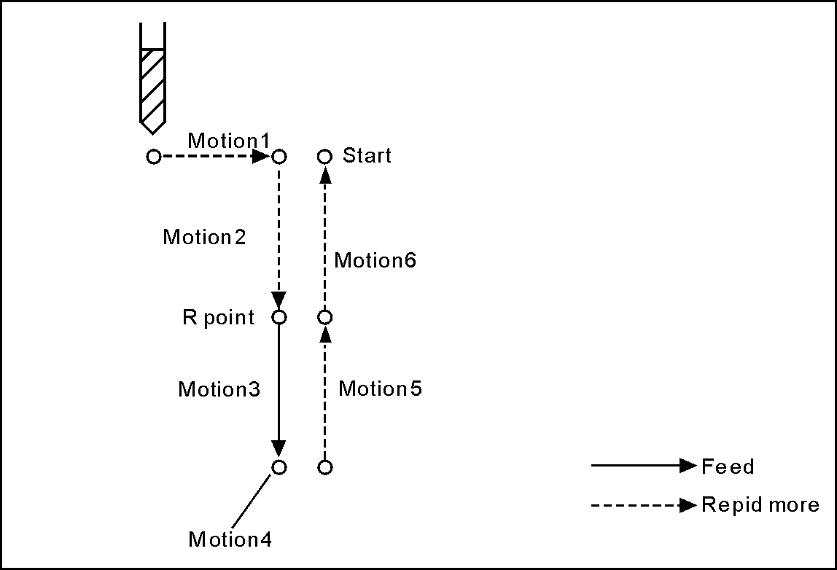
The difference of G90 and G91 as follow:
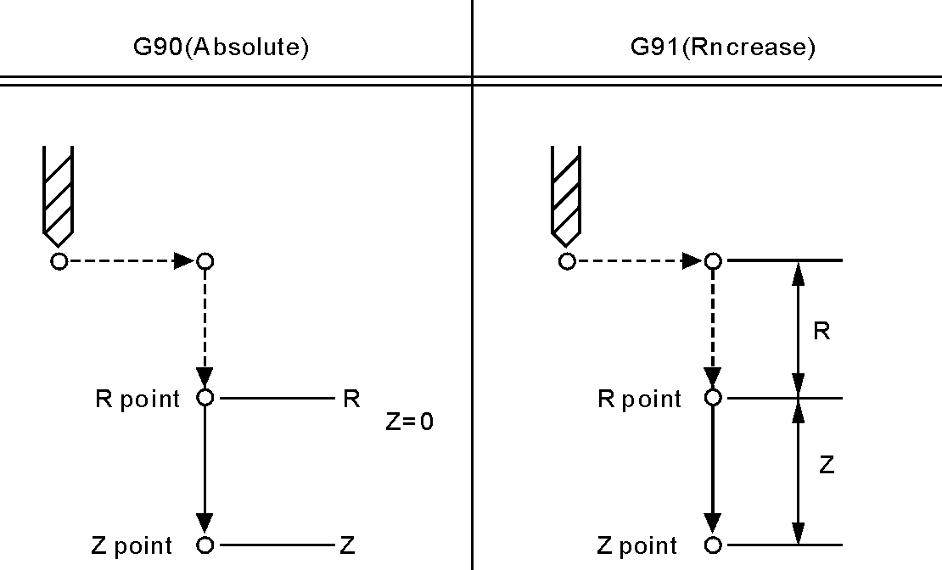

When tool touched the bottom of hole, tool will back to plane where R point stands, or original plane. Generally, G99 is used in first drilling, and G98 is used in final drilling.the original plane will not change even by G99, The difference of G98 and G99 as follow:
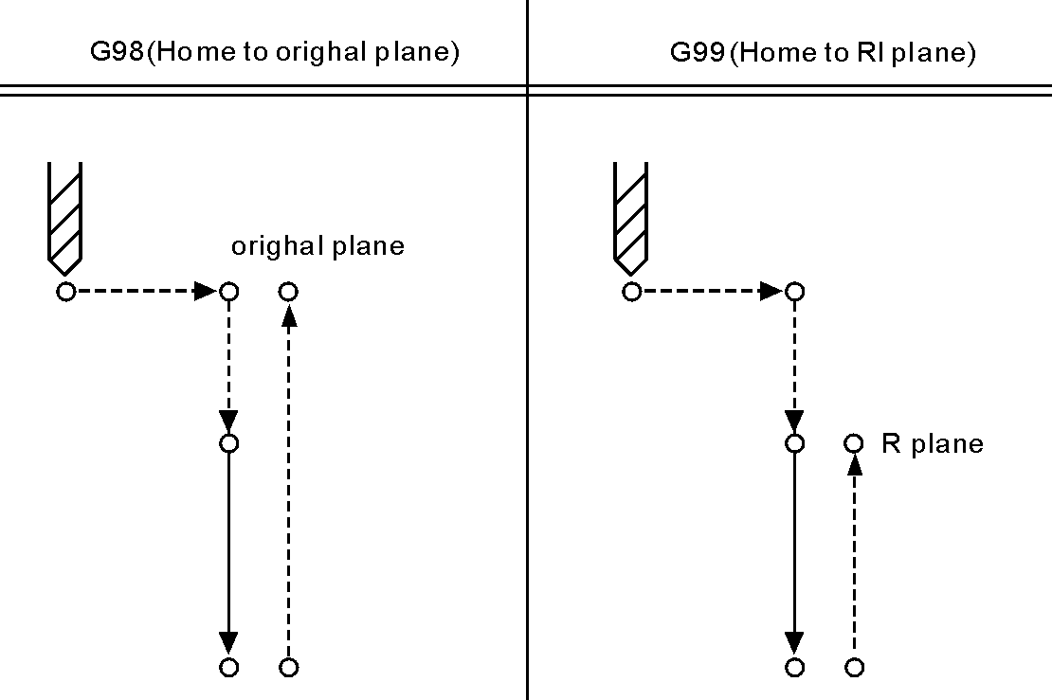
Use the L word to set cycle time, and L is just valid in specified segment. the maximum value is 9999, the default value is 1;
Orientation plane is determined by G17(XY)/G18(ZX)/G19(YZ). Besides, speed parameter P41 arc backlash compensation is set as 2 or 10.
(21) High speed drill deep hole(G73)
This cycle execute high speed drilling deep hole until reaching to bottom, at the same time, remove the cutting trifling from hole.

Format： G73 X_Y_Z_R_Q_F_L_ ;
X_Y_:hole position data
Z_:the distance(G91) or coordinate(G90) from R point to hole bottom
R_: the distance(G91) or coordinate(G90) from original point to R point
Q_:cutting depth every time
F_:cutting speed
L_:repeated times

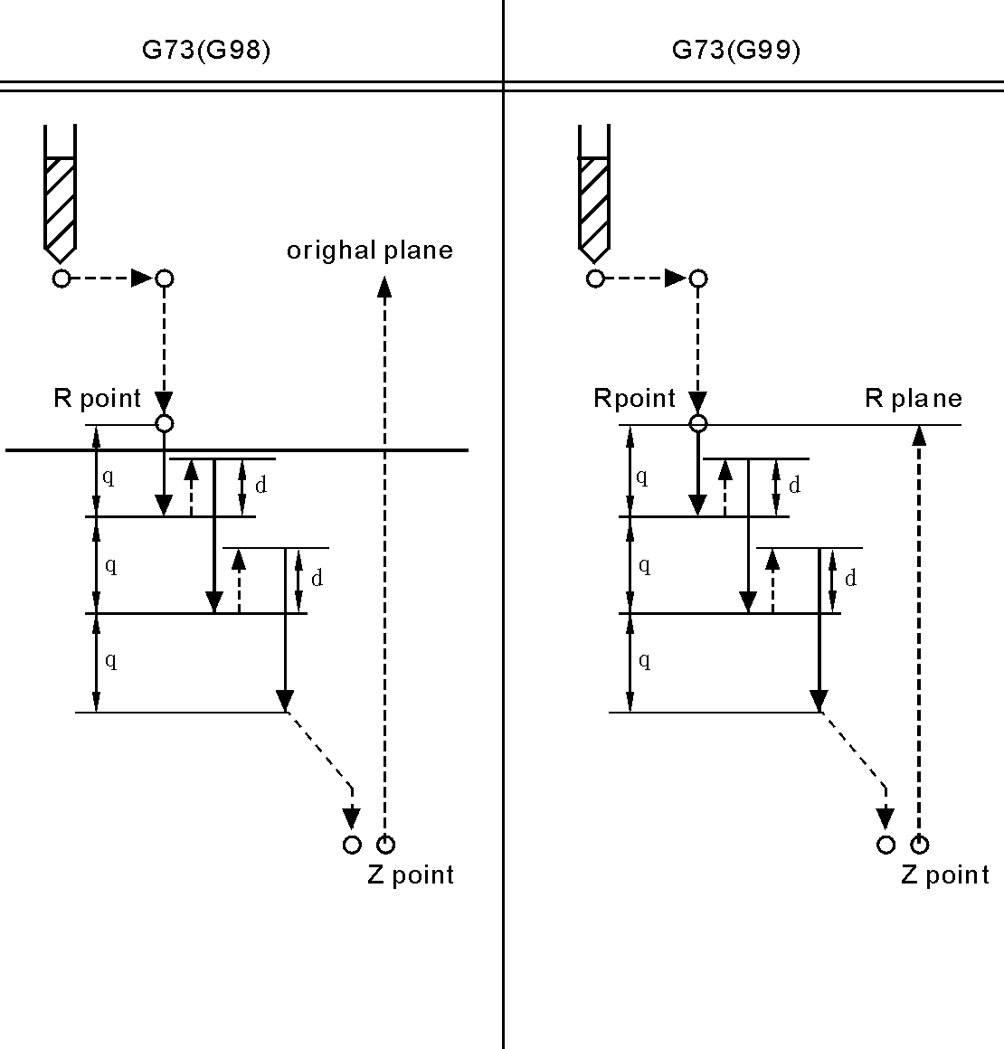

Note:High speed drilling cycle along the Z axis to carry out intermittent feeding, when using this cycle, the swarf can be easily discharged from the hole and can set the smaller value when backing. This allows to carry out drilling effectively. No.1 parameter in "N"(Processing) parameter is to set the value of the tool withdrawal(d).
Using auxiliary function to rotate spindle before specifying G73 (M code).
Set the offset of tool length(G43 G44 or G49) in changeless cycle which is located to R point to plus offset, the offset of tool radius is ignored.
For example:
M3 S2000 Spindle starts rotating
G90 G99 G73 X300. Y-250. Z-150. R-100. Q15. F120. Drill the fist hole and return to R point
Y-550.; Drill the second hole and return to R point
G98 Y-750.; Drill the third hole and return to R point
G80
M30; The end
(22) Drilling cycle, point drilling cycle(G81)
The cycle is used for normal drilling, execute the feeding cut to hole bottom. Then, the tool moves fast return form hole bottom.
Format：G81 X-Y-Z-R-F-L- ；
X-Y-：Data of hole position
Z-：Distance form R point to hole bottom（G91）or coordinate value（G90）
R-：Distance form initial point to R point（G91）or coordinate value（G90）
F-：Cutting speed
L-：Repeated times
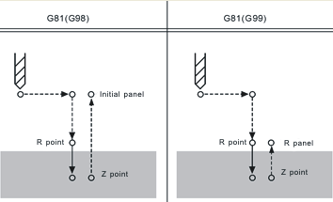
Note: Move fast to R point along the X and Y axis location, execute drilling process from R point to Z point, then tool returns with rapid move.
Use auxiliary function M code to rotate spindle before specifying G81
Locate to R point plus the offset when specifying the offset of tool length(G43 G44 or G49) in fixed cycle, the offset of tool radius is ignored.
Example:
M3 S2000; spindle begins to rotate
G90 G99 G81 X300 Y-250 Z-150 R-100 F120; drill the first hole, and then return to R point
Y-550; drill the second hole, and then return to R point
G98 Y-750; drill the third hole, and then return to panel of the initial position
G80
M30; end
(23) Drilling cycle,Reaming cycle(G82)
The cycle is used to drill hole,servo cut to the bottom and pause, then tool recede rapidly.
Format：G82 X-Y-Z-R-Ｐ-F-L- ;
X-Y-: hole position data
Z-: the distance(G91) or coordinate(G90) from R point to hole bottom
R-: the distance(G91) or coordinate(G90) from original point to R point
P-:pause time
F-:cutting speed
L-:repeat time

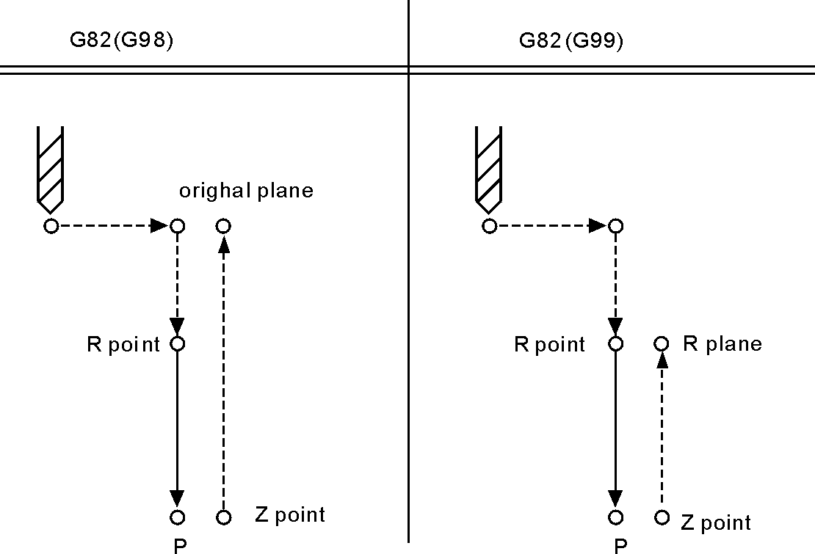
Note:orientating in the direction of X axis and Y axis, rapidly move to R, then drill from R to Z point, when tool arrive at the bottom, execute pause,then tool recede rapidly.
Rotate spindle with M code before G82 specified.
Set offset in the location of R point, while specify tool length offset(G43,G44,G49) in fixed cycle. Tool radius offset is ignored.
For example：
M3 S2000
G90 G99 G82 X300. Y-250. Z-150. R-100. P1000 F120.
Y-550.;
G98 Y-750.;
G80
M30;
(24) Intermission drill cycle (G83)
It applies to chip removal from hole during the execution of intermittent feeding cut to bottom of hole.
Format ：G83 X_ Y_ Z_ R_ Q_ F_ L_ ;
X_ Y_ : hole position data
Z_ : the distance(G91) or coordinate(G90) from R point to hole bottom
R_ : the distance(G91) or coordinate(G90) from original point to R point
Q_ :cutting depth every time
F_ :cutting speed
L_ :repeated times
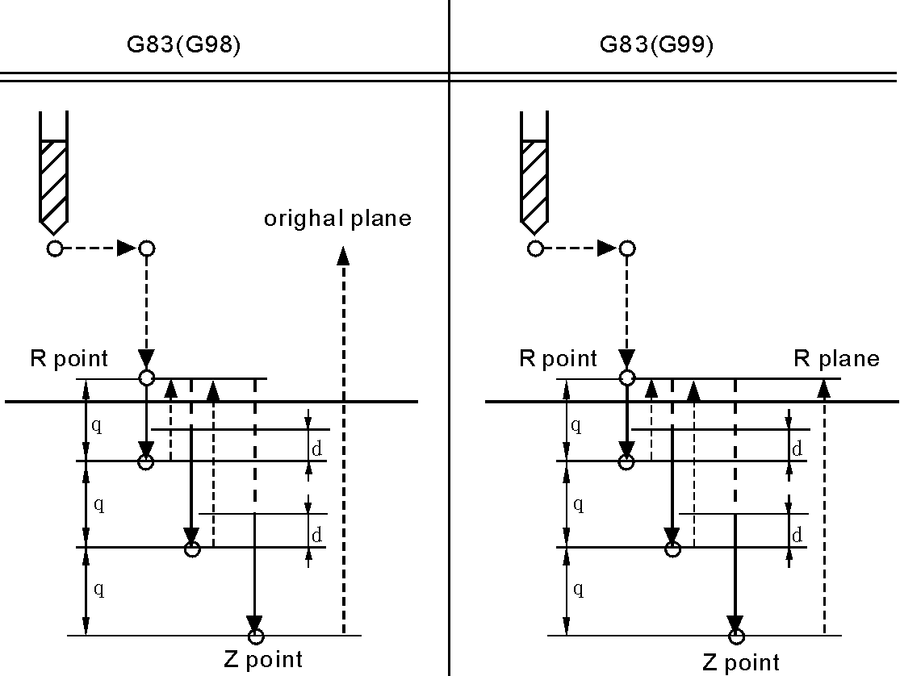
Note: Q means the cutting depth of each cutting feed, it must be specified in the incremental value. Cutting feed in the second and later must be executed quickly to move to d point to execute again before the end of last drilling, No.2 parameter in processing parameter set the cutting feed d, must specify the positive value in Q, negative is ignored.
Use the auxiliary functions M code to rotate spindle before specifying G83.
Set offset in the location of R point, while specify tool length offset(G43,G44,G49) in fixed cycle. Tool radius offset is ignored.
For example：
M3 S2000 spindle starts;
G90 G99 G83 X300. Y-250. Z-150. R-100. Q15. F120. drill the first hole, back to R;
Y-550.; drill the second hole, back to R;
Y-750.; drill the third hole, back to R;
G98 Y-600.; drill the fourth hole, back to original plane;
G80
M30; End.
(25) Boring cycle(G85)
Format：G85 X_ Y_ Z_ R_ F_ L_ ;
X_ Y_: Hole position data
Z_ : the distance(G91) or coordinate(G90) from R point to hole bottom
R_ : the distance(G91) or coordinate(G90) from original point to R point
F_ :cutting speed
L_ :repeated times
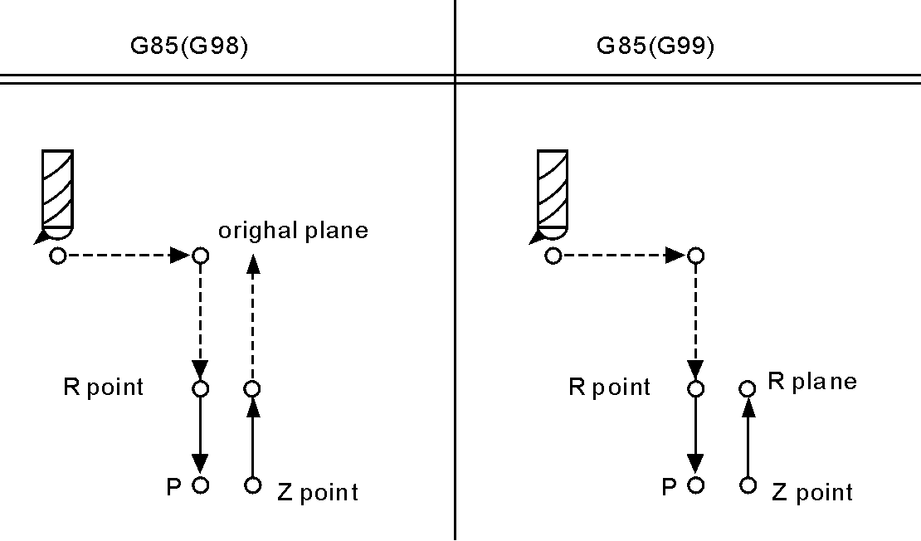
Note:Along the X and Y axis to locate, move fast to R point and carry out boring from R point to Z point, carry out cutting feed and return to R point when arriving the bottom of hole.
Set offset in the location of R point, while specify tool length offset(G43,G44,G49) in fixed cycle. Tool radius offset is ignored.
For example：
M3 S100 spindle starts
G90 G99 G85 X300. Y-250. Z-150. R-120. F120.bore the first hole, back to R;
Y-550; bore the second hole, back to R;
Y-750; bore the third hole, back to R;
G98 Y-600; bore the fourth hole, back to original plane
G80
M30; End
(26) Boring cycle(G86)
Format：G86 X_ Y_ Z_ R_ F_ L_ ;
X_ Y_ : hole position data
Z_ : the distance(G91) or coordinate(G90) from R point to hole bottom
R_ : the distance(G91) or coordinate(G90) from original point to R point
F_ :cutting speed
L_ :repeated times
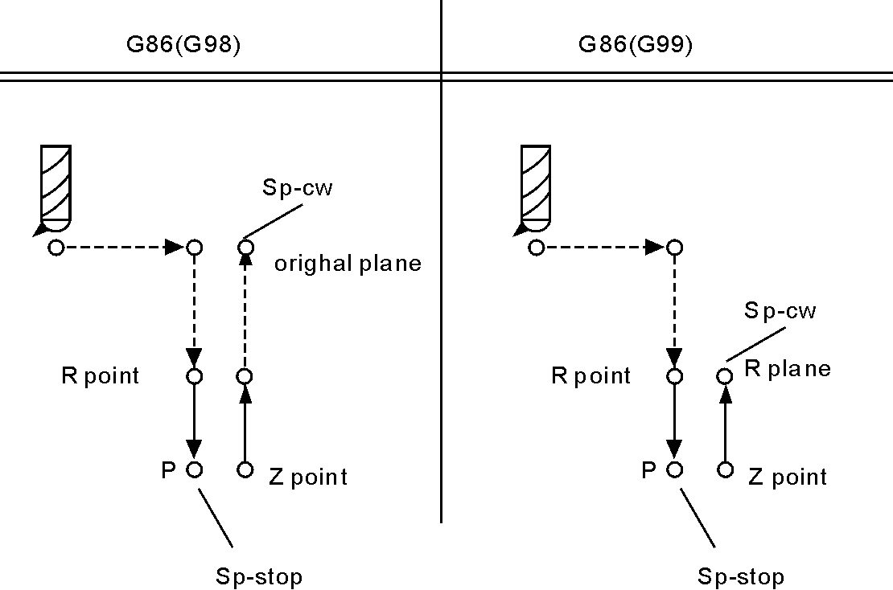
Note:Along the X and Y axis to locate, move fast to R point and carry out boring from R point to Z point. The tool will return quickly when spindle stopping at the bottom of hole.
Set offset in the location of R point, while specify tool length offset(G43,G44,G49) in fixed cycle. Tool radius offset is ignored.
For example：
M3 S2000 Spindle starts
G90 G99 G86 X300. Y-250. Z-150. R-100. F120. bore the first hole, back to R;
Y-550.; bore the second hole, back to R;
Y-750.; bore the third hole, back to R;
G98 Y-600.; bore the fourth hole, back to original plane
G80
M30; End.
(27) Boring cycle(G89)
Format：G89 X_ Y_ Z_ R_ P_ F_ L_ ;
X_ Y_ : hole position data
Z_ : the distance(G91) or coordinate(G90) from R point to hole bottom
R_ : the distance(G91) or coordinate(G90) from original point to R point
P_ :pause time
F_ :cutting speed
L_ :repeated times
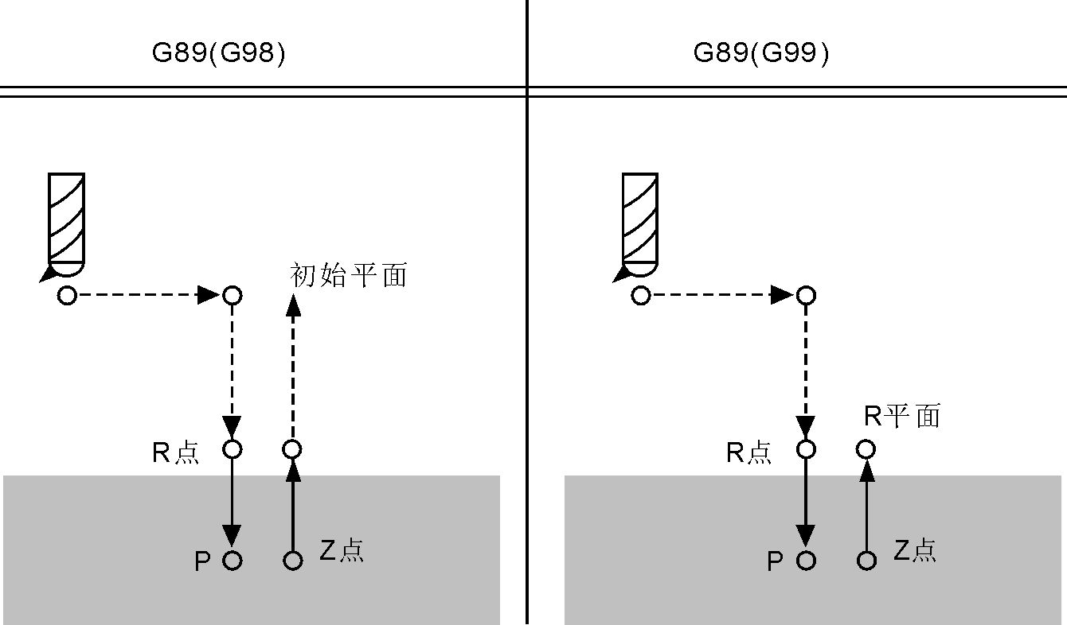
Note:It is the same as G85 unless suspending at the bottom of hole.
Rotate spindle with M code before G82 specified.
Set offset in the location of R point, while specify tool length offset(G43,G44,G49) in fixed cycle. Tool radius offset is ignored.
For example:
M3 S100 Spindle starts;
G90 G99 G89 X300. Y-250. Z-150. R-120. P1000 F120.bore the first hole, back and pause for 1 second at the bottom;
Y-550.; bore the second hole, back to R;
G98 Y-750.; bore the third hole, back to original plane
G80
M30; End
(28) Left tap cycle(G74)
Tapping has two kinds of methods: Tracking the spindle encoder (P411=2, spindle must assemble encoder) and interpolation of Z axis and spindle servo (P405=0, P410=95, P411=3). No.404~No.413 parameter in axis parameter to set.
Pay attention:
When the spindle and encoder drives not as 1:1, please modify the No.412 No.413 parameter in axis parameter;
412, the number of spindle teeth (requirement: less than or equal to the number of encoder teeth, must match our keysets when greater than the number of encoder teeth);
413, the number of encoder teeth
The loop is executed with tapping left, in the left tapping cycle, the depth Q of feeding, CCW spindle back distance d(by process parameter P7), type of chip removal set by process parameter P6(0 means high-speed removal and back by d, 8 means normal removal and back to R ). the spindle rotates CW when arriving at the bottom of hole.
Format：G74 X_ Y_ Z_ R_ P_ K_ S_ L_ ;
X_ Y_ : hole position data
Z_ : the distance(G91) or coordinate(G90) from R point to hole bottom
R_ : the distance(G91) or coordinate(G90) from original point to R point
P_ : pause time unit:s
K_ : screw pitch
S_ : spindle rotate speed
L_ : repeated times
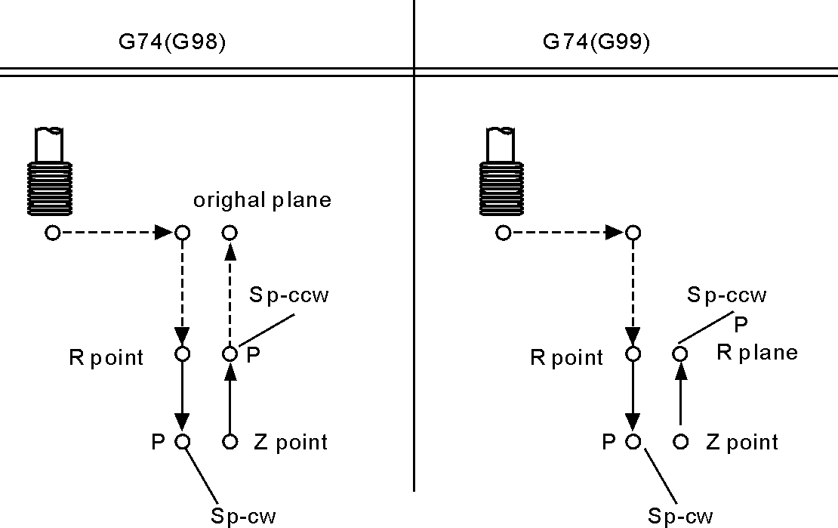
Note: The speed of coordinate axis is determined by speed of spindle and screw pitch when processing thread,it is not a matter with speed F. The system will limit the speed within maximum feeding speed.
Spindle override switch and feeding axis override switch are invalid when processing thread.
Should specify the screw pitch K value in every processing program segment of thread, otherwise not through compile.
Use spindle CCW rotation to carry out tapping. Should process a negative thread in order to return spindle CW rotation when arriving at the bottom of hole. In the left tapping period, feeding suspension does not stop machine until the return action completed.
Use auxiliary function to rotate spindle CCW before specifying G74. When the spindle is pulse controlling mode without using auxiliary functions M code.
Set offset in the location of R point, while specify tool length offset(G43,G44,G49) in fixed cycle. Tool radius offset is ignored.
For example：
N1 M4 S100 Spindle starts;
N2 G90 G99 G74 X300. Y-250. Z-150. R-100. K5 S100
tap the first hole, then back to R point;
N3 G98 Y-550. K5; tap the first hole, then back to R point;
N4 G80;
N5 M30; End;
(29) Right tap cycle(G84)
The same as G74 unless direction.
Format：G84 X_ Y_ Z_ R_ Ｐ_ K_ L_ ;
X_ Y_ : hole position data
Z_ : the distance(G91) or coordinate(G90) from R point to hole bottom
R_ : the distance(G91) or coordinate(G90) from original point to R point
P_ :pause time
K_ :screw parameter
S_ :spindle rotate speed
L_ :repeated times
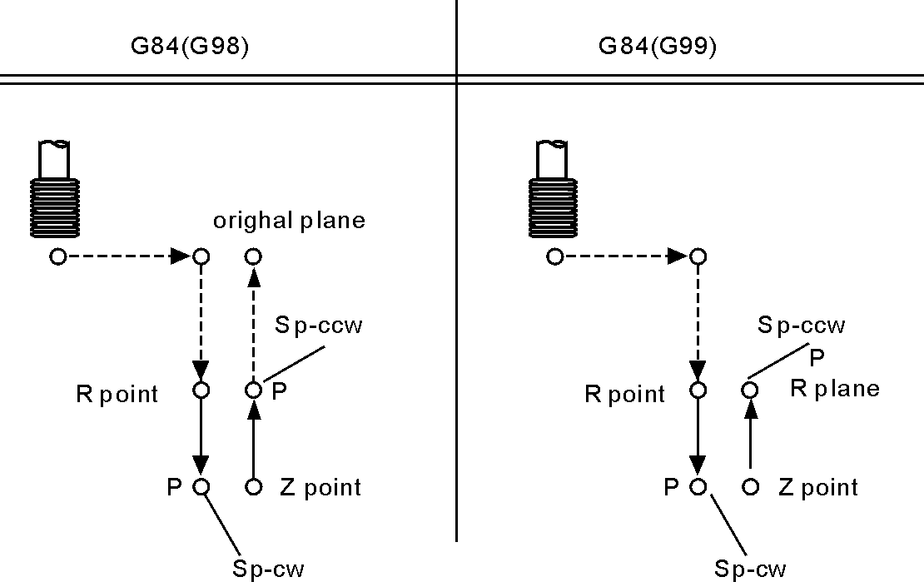
For example：
M3 S100 Spindle starts.
G90 G99 G84 X300 Y-250 Z-150 R-120 P300 K5 S100
Tap the first hole, then back to R;
Y-550. K5; Tap the second hole, then back to R;
G98 Y-750. K5; tap the third hole, then back to original plane;
G80
M30; End.
(30) Cancel cycle instruction (G80)
Cancel cycle instruction．
Format：G80 ;
Note: Cancel all cycle instruction and execute normal operation.
(31) Pole coordinate instruction(G15/G16)
Pole coordinate instruction inquire user provide radius and angle,the positive direction of angle is anticlockwise of positive direction of the first axis in plane, and negative direction is clockwise. Radius may use absolute and increase type(G90, G91),Angle only use absolute type(G91).

Format ：
G15 Cancel Pole coordinate;
(G17/G18/G19) (G90/G91) G16 IP_ ;establish
Note:
1.G17/G18/G19 specify the panel of pole coordinate instruction.
2.G90 specify the zero point of workpiece coordinate system as the origin of pole coordinate, measure radius from this point.
3.G91 specify current position as the origin of pole coordinate system, measure radius from this point.
4.IP_ specify the panel axis address and value of pole coordinate system panel selection.
First axis: Radius value of pole coordinate.
Second axis: Value of pole angle.
5.G90 set the zero point of workpiece coordinate system as origin of pole coordinate system:
Use programming instruction of absolute value to specify the radius(The distance between zero point and programming point).When using local coordinate system(G52), the origin of local coordinate system changes into the center of pole coordinate system, the angle uses absolute value. As the follow shown:

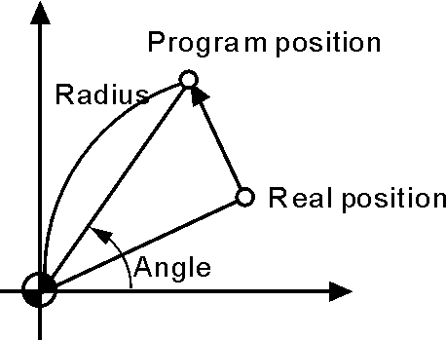
6.G91 set the current position as the origin of pole coordinate system:
Using programming instruction of incremental value to specify the radius(The distance between the current position and programming point).The angle use absolute value.As the follow shown:
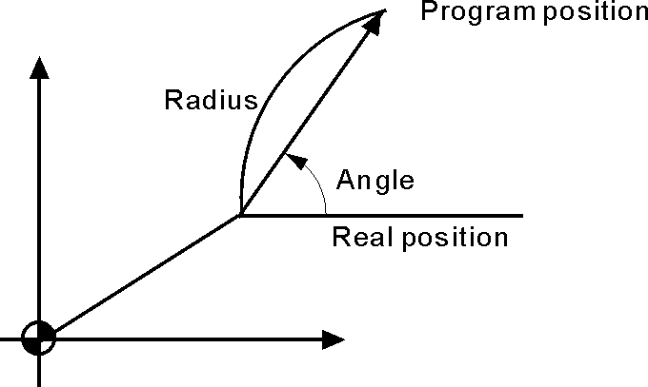
For example:
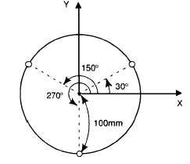
G17 G90 G16 X0 Y0; specify polar coordinate instruction, set the zero point of XY plane coordinate system as the original point of polar coordinate system;
G81 X100.0 Y30.0 Z-20.0 R-5.0 F200.0; specify distance of 100mm and angle of 30°;
Y150.0; specify distance of 100mm and angle of 150°
Y270.0; specify distance of 100mm and angle of 270°
G15 G80; cancel polar coordinate system.
(32) Switch Metric system and British system(G20/G21),
Feeding method(G94/G95)

Format：
G20 ; inch;
G21 ; millimeter;
G94: minute feeding;
G95: rotate feeding.
Note:The G code must be compiled in the beginning of the program, using separate program segment to specify before setting the coordinate system.Switch the unit of input data into minimal inch or millimeter after G code of switching inch or millimeter specifying,the angle of data input unit keeps unchanged, change the units of value as follows after switching the inch or millimeter:

· The feeding speed is specified by F code

· Position instruction

· Offset value of workpiece zero point

· Compensation value of tool

· The unit of manual pulse generator

· The distance in incremental feeding
Specification of unit under G20/G21(it is necessary to reset the unit in parameter):
- The minimum unit of British system G20 is 0.0001inch, the minimum unit of Metric system is 0.001mm.
- Under British system G20, unit of all instructions related to position is inch;
- Under British system G20, unit of feeding speed F instruction is inch/min;
- Under British system G20, unit of tool compensation and offset of worpiece coordinate system G54-G59 is inch;
- Under British system G20, unit of parameters related to distance(such as soft limit and compensation) change from mm of Metric system into 0.1 inch or from um into 0.001inch;
- Under British system G20, unit of parameters related to speed change from mm/min into 0.1inch/min ;
- Under British system G20, unit of parameters related to accelerated speed change from mm/min/s into 0.1inch/min/s;
- Under British system G20, handwheel incremental value are 0.0001inch, 0.001inch, 0.01 inch;
- Under British system G20,if pulse equivalent changes, system will adjust automatically, electronic gear will accords to metric system;
- Under British system G20, coordinate displays four numbers behind the decimal point;
- G20/G21 should be written in the beginning of program, instead of middle of program;
- Under British system G20, rotary axis rotating 1 degree accords to 0.1 inch;
- two systems can be converted by executing G20/G21 in MDI, and restating controller.
- It is necessary to set tool after conversion between G20 and G21;
- As to system prompt information, you just need to modify the parameter configuration file cncsystemen. For example, the parameter about speed: change mm/min into 0.1inch/min, parameter about position:change mm or degree into 0.1 inch, change um into 0.0001 inch.
(33) Go back the starting point of program(G26/G261/G262/G263/G264）

Format ： G26 ; ZXY all go back.
G261 ; X go back.
G262 ; Y go back.
G263 ; Z go back.
G264 ; A go back.
Note：G26 motion is according to linkage type.
(34) Memory the current point(G25)

Format：G25 ； To remember the coordinate of X Y Z A B

(35) Return to the memorial point(G61/G611/G612/G613/G614)

Format：G61 ；Return to X Y Z of memorial point
G611 ；Return to X of memorial point
G612 ；Return to Y of memorial point G613 ；Return to Z of memorial point
G614 ；Return to A of memorial point
Note:the way that G61 back to the point memorized by G25 is by G00.
(36) Check skip(G31、G311)
Format：G31 X_ Y_ Z_ A_ F_ P_ ;No alarm
G311 X_ Y_ Z_ A_ F_ P_ ;alarm
P: N line+(X00/X39+1000 or 2000)，1000 means skip when availability, 2000 means skip when invalidation.
For example：G31 X50 Z100 F100 P331022 ;if X22 availability then go to N33.
G311 X50 Z100 F100 P2021 ;if X21 invalidation then go to next line. And it will alarm till X21 is invalid.
- Automatic beveling (I) and smoothing(R)
The acquiescent panel of milling is G17

Format for G17：
G01(G00) X I automatical beveling, the coordinate in the next program segment must be G01(G00) Y.
G01(G00) Y I automatical beveling, the coordinate in the next program segment must be G01(G00) X。
G01(G00) X R automatical smoothing, the coordinate in the next program segment must be G01(G00) Y。
G01(G00) Y R automatical smoothing, the coordinate in the next program segment must be G01(G00) X。
Format for G18：
G01(G00) X I automatical beveling, the coordinate in the next program segment must be G01(G00) Z。
G01(G00) Z I automatical beveling, the coordinate in the next program segment must be G01(G00) X。
G01(G00) X R automatical smoothing, the coordinate in the next program segment must be G01(G00) Z。
G01(G00) Z R automatical smoothing, the coordinate in the next program segment must be G01(G00) X。
Format for G19：
G01(G00) Y I automatical beveling, the coordinate in the next program segment must be G01(G00) Z。
G01(G00) Z I automatical beveling, the coordinate in the next program segment must be G01(G00) Y。
G01(G00) Y R automatical smoothing, the coordinate in the next program segment must be G01(G00) Z。
G01(G00) Z R automatical smoothing, the coordinate in the next program segment must be G01(G00) Y。

Pay attention:
1.The address of I and R are specified with radius model. The running distance of this line and the next line must be greater than the length of beveling or radius of smoothing, otherwise the system will decrease the length of beveling or radius of smoothing to minimal running distance of this line and the next line automatically.
2. The two adjacent lines must be 90 degrees.
For example:
0 G54 G0 X-50 Y-50 Z20
N1 M03 S500
N2 G01 G42 D01 X0 Y0 F200
N3 G01 Z-5
N4 X100 I4 ；Beveling4x4
N5 Y40 R6 ；SmoothingR6
N6 X47 R5 ；SmoothingR5
N7 Y70 I3 ；Beveling3x3
N8 X15

N9 X0 Y40
N10 Y0
N11 G0 X-50 Y-50 G40
N12 Z50
N13 M30
(38) The calling program(M97 M98 M99)
Unconditional jump
The line running unconditional jump to the line which is specified by P; P4 stands for using four field of digital specify the program to the entrance line of the calling main program (mark line).
Subroutine call
In this system the subroutine should be an independent program.
M98 P L unconditional call subroutine instruction. P is to specify the name and path of subroutine call, L refers to the calling times address of subroutine.
The M98 instruction can be omitted without writing, format: PP file name, the file name can be hidden files, the first character of hidden files must be "HIDEFILE" at the beginning. Such as the file "HIDEFILE01", this program in the program area is not displayed, can use the instruction M98 PHIDEFILE01 or M98 P*01 or PP*01 or PPHIDEFILE01 when calling.
For example:
P sub/1390 means subroutine is tmp/NC/sub/1390
Note:
1.tmp/NC/ is the system's default path, sub is a folder for the following
2.The subroutine must be a independent program.
3.Method of the main program in USB calls the subroutine in USB: P[or P].
For example:
M98 P[A1234 means calling the subroutine A1234 in USB;
M98 P]SS12 means calling the subroutine SS12 in USB;
PP[FFDE means calling the subroutine FFDE in USB;
It needs to write the path of file if call the subroutine in folder of USB.
There must be space in front of L(Subroutine calling times). Return to the next program segment of main program when subroutine running to the end.If the program contains a fixed sequence or repeated pattern, then the sequence or pattern can be compiled to subroutine to save in memory storage in order to programme easily, the subroutine can be called by main program which is also can be called by another subroutine.
M99 is an instruction of ending subroutine return, must have this instruction to end the subroutine.
Pay attention:
1) M99 in the main program is the same as M02;
2) M99 with P in the main program is the same as M97;
3) M99 returns to main program call in subroutine is in the next line;
4) M99 with P in the subroutine returns to P program line in main program;
Subprogram can call another subprogram(embedded). no matter the program called is main program or subprogram, it will back to the program line next to main calling program. When the subprogram is called by the main program, it is consider as first-level subroutine.
The Sub-program can embedded call as follow :
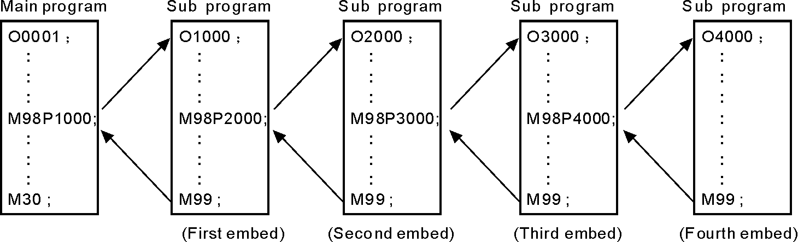
For example:
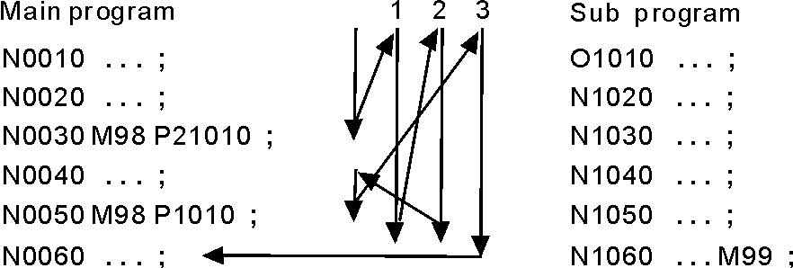
The calling instruction can be used for 9999 times in the most.
Conditional wait, jump instruction
The system of M code is used for detecting the external input signal as the condition, as follows:
Conditions wait
M12 M13 instruction are used to detect the input signal M12, M12 in program line is to detect M12 input signal is effective to execute the next program line , M13 means to detect M12 input signal is invalid to execute the next program line.The instruction is in an independent line.
M14 M15 instruction are used to detect the input signal M14, M14 in program line is to detect M14 input signal is effective to execute the next program line, M15 means to detect M14 input signal is invalid to execute the next program line.The instruction is in an independent line.
M16 M17 instruction are used to detect the input signal M16, M16 in program line is to detect M16 input signal is effective to execute the next program line, M17 means to detect M16 input signal is invalid to execute the next program line.The instruction is in an independent line.
M18 M19 instruction are used to detect the input signal M18, M18 in program line is to detect M18 input signal is effective to execute the next program line, M19 means to detect M18 input signal is invalid to execute the next program line.The instruction is in an independent line.
M22 M23 instruction are used to detect the input signal M22, M22 in program line is to detect M22 input signal is effective to execute the next line program, M23 means to detect M22 input signal is invalid to execute the next program line.The instruction is in an independent line.
M24 M25 instruction are used to detect the input signal M24, M24 in program line is to detect M24 input signal is effective to execute the next line program, M25 means to detect M24 input signal is invalid to execute the next program line.The instruction is in an independent line.

M28 M29 instruction are used to detect the input signal M28, M28 in program line is to detect M28 input signal is effective to execute the next line program, M29 means to detect M28 input signal is invalid to execute the next program line.The instruction is in an independent line.

Conditional jump
Plus Pxxxx (number of program line) in front of the M12 /M13 /M14 /M15 /M16 /M17 /M22 /M23 /M28 /M29 instruction. Shifting if the condition success, otherwise execute the next.
For example: M14 P0120
When the program running to this line and the system detecting the M14 input signal effectively, program will jump to the 120th line of program (the marking line),execute the next instruction if the M14 input signal is invalid.
(39) Feeding speed F function
It is the mode,actual running speed is the setting speed times the trimming rate of speed,
F is used for specify the processing speed of feeding instruction G01 G02 G03.
The range is 0.01-15000mm/min,feeding speed is Fx trimming speed, F has mode function.
Executing the F instruction at the first, and then execute the motion instruction when the F instruction and motion instruction are in the same line.
(40) T/H/D function
The T/H/D function is means that tool length and radius compensate,which is mode,used by code in program。
The tool code is from T01 to T99,every tool have four tool compensate value，which is length compensation from H1 to H99 and radius compensation from D1 to D99.
(41) Spindle speed S, SS function
The system offers two ways spindle controlling modes.
The first spindle speed is specified by S, the first spindle has two kinds of gear controlling mode:
(1) The first is four gear spindle speed electrical control, output four bits code of step speed change, M41-M44 instruction control corresponds to S01-S04 output code, step speed change. Use No.50 No.51 No.52 No.53 and No.54 parameter in axis parameter to set the mode of shifting.
(2) The second uses four gears + step-less speed, M41-M44 instruction control, correspond the output S01-S04 code. Use No.42 No.43 No.44 No.45 parameter in speed parameter to set the maximum speed of corresponding gear, use No.50 No.51 No.52 No.53 No.54 parameter in axis parameter to set the mode of shifting.
Stepless speed,the range is 0-99999, output 0-10V variable-frequency voltage. The output voltage trims x10V of maximum speed of specified spindle.
Second spindle speed is specified by SS, the highest speed is controlled by the No.46 parameter in speed parameter, output 0-10V variable-frequency voltage.
(42) Macroprogram instruction
1.Input instruction: WAT
Waiting for the input port X valid or invalid instruction
Format: WAT+ (-) X
Note: "+" to means the input is effective;
"-" means the input is invalid;
"X" means the input port X00-X55; see the I/O diagnosis;
2.The output instruction: OUT
Set the output port Y is valid or invalid instruction
Format: OUT +(-)Y
Note: "+" means the output is effective;
"-" means the output is invalid;
"Y" means the output port Y00-Y31; see the I/O diagnosis;
3. Variable and assignment: =
1) #0--#20 local variable: local variables only can be used to store data in macro program, such as a result of operation, when power is off, the local variables are initialized to the empty. The argument assignment to the local variable when calling the macro program.
2) #21--#600 global variables: The meanings are the same in different macro program.
When power is off, the variable #21--#100 is initialized to zero, the variable #101--#600 data is saved not to loss even if the power is off.
3) #1000-- system variable: the system variables are used to change various data when reading the running CNC. For example, the current position and the compensation of tool.
Special note: macro variables #100--#155 and #190--#202 have been used by the system, users can not use.
4) The macro variables #1001--#1099 corresponds the X axis offset value of machine T1--T99(Unit: micron)
The macro variables #1401--#1499 corresponds the Z axis offset value of machine T1--T99(Unit: micron)
Could read the value, for example: #200=#1003; To read the X axis offset value of the third tool into macro variables #200.
Could modify the value, for example: #1003=23000; To modify the X axis offset value of the third tool to 23000 micron.
#1003=#1003+50; To increase the X axis offset value of the third tool 50 micron.
5)The I/O variables:
#1800: X00-X07（D0-D7）
#1801: X08-X15（D0-D7）
#1802: X16-X23（D0-D7）
#1802: X16-X23（D0-D7）
#1803: X24-X31（D0-D7）
#1804: X32-X39（D0-D7）
#1805: X40-X47（D0-D7）
#1806: X60-X67（D0-D7）
#1808: Y00-Y15（D0-D15）
#1809: Y16-Y31（D0-D15）
Format:#i=Expression
6) Save all global macro variables with user program format.
FILEMS(AABBCC) or FILEMS[AABBCC]
To save #21-#999 into AABBCC files.
If you want to read these variables, just need to execute the file or call it as a subprogram.
- The arithmetic and logic operation
Table:
Function | Format | Note
Definition | #i = #j
Addition  Subtraction  Multiplication  Division | #i = #j + #k ;  #i = #j - #k ;  #i = #j * #k ;  #i = #j / #k ;
Sin  Asin  Cos  Acos  Tan  Atan | #i = SIN(#j) ;  #i = ASIN(#j);  #i = COS(#j) ;  #i = ACOS(#j);  #i = TAN(#j);  #i = ATAN(#j); | 90.5 degrees mean 90 degrees 30 minutes
Square root  Absolute value  Rounding off  Round down  Round up  Natural logarithm  Exponential function | #i = SQRT(#j);  #i = ABS(#j) ;  #i= ROUND(#j);  #i = FIX(#j);  #i = FUP(#j);  #i = LN(#j);  #i = EXP(#j);
Or  Exclusive or  And | #i = #j OR #k ;  #i = #j XOR #k ;  #i = #j AND #k ; | Executing with binary system
5. Unconditional transfer: GOTO N
Transfer to the program line with sequence number appears error when specifying beyond the 1-99999, could use expression to specify the sequence number.
For example: GOTO 5, GOTO#100
6.Conditional transfer: IF (Conditional expression) GOTO or THEN
1）IF （Condition）GOTO or THEN
2）IF （condition）
<operation>
ELSE
<operation>
ENDIF
3）IF （condition）
<operation>
ELIF
<operation>
ELIF
<operation>
ENDIF
If the conditional expression specified meet, execute this segment; if the conditional expression specified does not meet, execute the next segment.
For example:
IF (#100 EQ 2) THEN #100=5
IF (#101 GT 2) GOTO 6
Operation meaning:
EQ equal
NE not equal
GT greater than >
GE greater than or equal >=
LT less than <
LE less than or equal
7. Cycle: WHILE (conditional expression) DO 1, 2, 3
Specifies a conditional expression in front of WHILE. When the specified conditions are met, execute the program between DO and END. Otherwise, turn to the program line after END. Cycle of the embed is 3 at the most.
For example:
WHILE （#100 LT 3）DO 1
……
WHILE （#103 EQ 5）DO 2
……
WHILE （#200 GE 20）DO 3
……
END 3
……
END 2
……
END 1
- Non-mode to call macro program:G65
Format: G65 P- L- <A-B-C-...... Argument passing data >
P is the name of macro program, L is the calling times,A B C are argument, the name of argument as follows:
#0->A、#1->B、#2->C、#3->D、#4->E、#5->F、#6->H、#7->I、#8->J、#9->K、 #10->M、#11->Q、#12->R、#13->S、#14->T、#15->U、#16->V、#17->W、#18->X、 #19->Y、#20->Z.
Special attention: The address G、L、N、Q、P can’t be used in argument.
For example:
Main program:9000
G00 X0 Z0
G65 P8000 L1 A5 B6
G0 X0 Z0
M30
Macro program:8000
N1 #2=#0+#1
N2 IF （#2 EQ 10）GOTO 4
N3 GOO X#2
N4 G00 Z#1
N5 M99 ；Return
- Mode to call macro program:G66 G67
G67 instruction is to cancel G66 instruction.The format is the same as G65.
For example:
Main program:9000
G00 X0 Z0
G66 P8000 L2 A5 B6
A8 B1
A9 B10
G67
M30
Macro program:8000
N1 #2=#0+#1
N2 IF （#2 EQ 10）GOTO 4
N3 GOO X#2
N4 G00 Z#1
N5 M99 ；Return
10. information prompt dialog:
Format: MSG(parameter) or MSG[parameter]: parameter is information character string, pause;
Notice: the instruction also applies to NC program(non-macro program).
When prompting information dialog, system will convert into pause mode automatically.
Format: STAF(parameter) or STAF[parameter], parameter is information character string, not pause.
11. automatic generation of processing program
1> open the file:
FILEON(parameter) or FILEON[parameter]
Example: FILEON(AABBCC) or FILEON[AABBCC]
Means establish or open a file AABBCC.
- Close the file
FILECE means close the current file, if not edit the instruction, the system will close the file automatically when the program is finished.
- Write a string of character into opening file:
FILEWD (parameter) or FILEWD[parameter]
Example: FILEWD(G54G0X0Z0) or FILEWD[G54G0X0Z0]
Means write the string G54G0X0Z0 into the opening file.
- Write the absolute coordinates of current feeding axis into the opening file.
Format: FILEWC
Example:
G0X0Z0
FILEON[AABBCC]
FILEWD [G54G0X0Z0]
G1X45Z89
FILEWC
G1X99Z76
FILEWC
FILECE
After the program finished, system will generated a file AABBCC under program directory. The contents is as following:
G54G0X0Z0
X45Z89
X99Z76

(43)User-defined macro instruction(G120-G160,M880-M889)
Every user-defined G code is corresponding to a macro program ProgramGxxx, the M code is corresponding to a macro program of ProgramUser0 --ProgramUser9, the user cannot programme the macro program in NC system, must edit the macro code in the computer, and then copy into the system.
For example, defines the G152 function: the arc model porous drilling cycle. (must copy the macro program ProgramG152 into system).
Format:G152 Xx Yy Zz Rr Ii Aa Bb Hh Ff;
X: The X coordinate with absolute value or incremental value of center to specify.
Y: The Y coordinate with absolute value or incremental value of center to specify.
Z: Hole depth
R: Approaching fast to the point coordinate
F: Cutting feed speed
I: Radius
A: The angle of the first hole
B: Incremental angle specify(CW when negative)
Macro program ProgramG152 as follows:
#80=#0
#81=#1
#82=#2
#83=#3
#84=#4
#85=#5
#86=#6
#87=#7
#88=#8
#89=#9
#90=#10
#91=#11
#92=#12
#93=#13
#94=#14
#95=#15
#96=#16
#97=#17
#98=#18
#99=#19
#100=#20
#30=#4003
#31=#4014
G90
IF[#30 EQ 90] GOTO 1
G53
#98=#5001+#98
#99=#5002+#99
N1 WHILE[#86 GT 0] DO 1
#35=#98+#87*COS[#80]
#36=#99+#87*SIN[#80]
G81X#35Y#36Z#100R#92F#85
#80=#80+#81
#86=#86-1
END 1
G#30 G#31 G80
M99
(44) Rough milling of groove in circle G110/G111:
Format: G99 G110/G111 X_ Y_ R_ Z_ I_ W_ Q_ K_ V_ E_ D_ F_
Application: only the absolute type closed-loop controller support the function of G110-G142;
Function: starting from the center of circle, execute arc interpolation repeatedly in the way of spiral, till process the circle groove.
Definition of instruction: please refer to fixed cycle instruction in chart3-2.
G110: clockwise rough milling of circle groove;
G111: anticlockwise rough milling of circle groove.
1. I: radius of circle groove, I should be more radius of current tool;
2. W: the first cutting depth in the direction Z axis, the distance down from R reference plane, it should be more 0.(if the first cutting depth is more than groove bottom, processing can start from the bottom)
3. Q: increment of each cutting depth in the direction of Z axis.
4. K: increment of width cutting on the XY plane, it should be less than tool diameter, and more than 0;
5. V: the distance from the end processing plane when declining tool, it should be more than 0;
6. E: processing margin of rough milling of circle groove.( more than or equal to 0, negative value is absolute)
7.D: number of tool radius, range is 0-32, D0 default as 0, calling the current tool radius according to number.
Cycle process:
- Rapidly locating at the XY plane;
- Rapidly dropping to R point plane;
- Cutting by depth W by the cutting speed;
- Milling the disc of radius I and spread incrementally by K value from the center.
- Z axis returns to R reference plane rapidly;
- X and Y axis locate at the center;
- Z axis drops rapidly by the distance V to end processing plane;
- Z axis cuts by the depth Q+V;
- Loop step 4-step 8 till processing of disc is finished.
- Return to R point.
- Return to X Y hole orientation position. Instruction tracking as following.
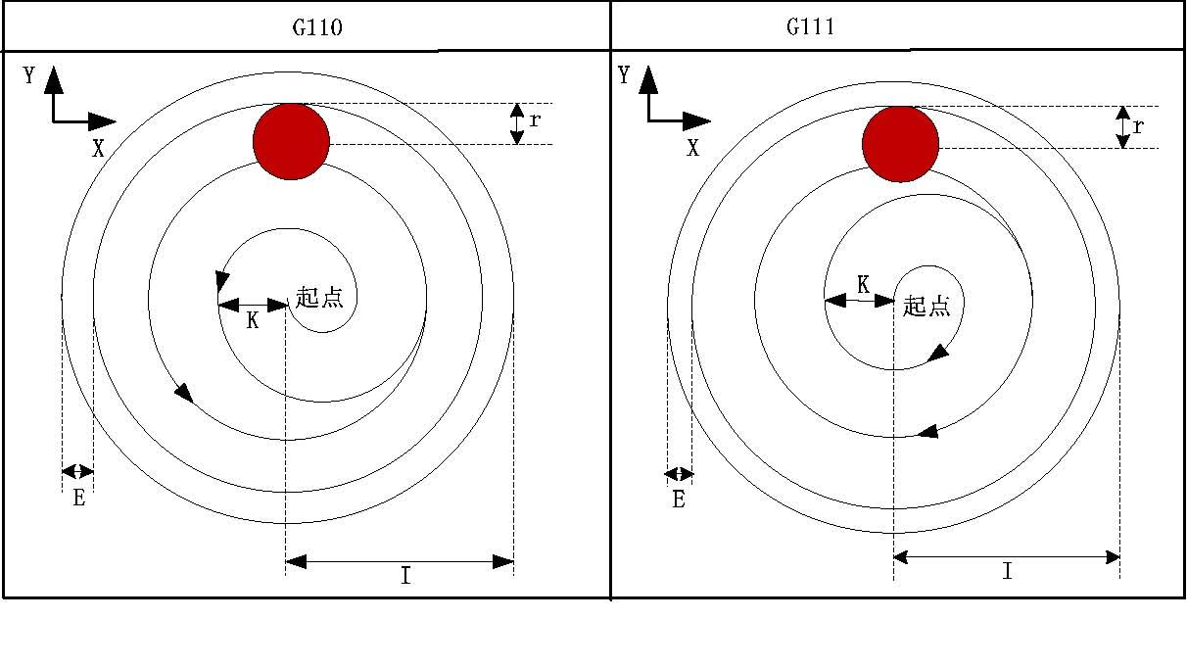
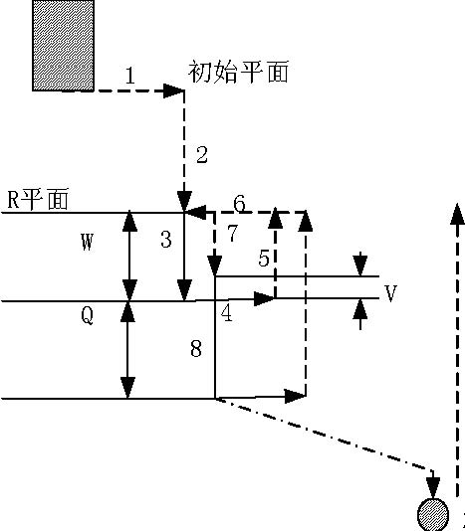

Example: rough milling of circle groove by fixed cycle G110, as following:
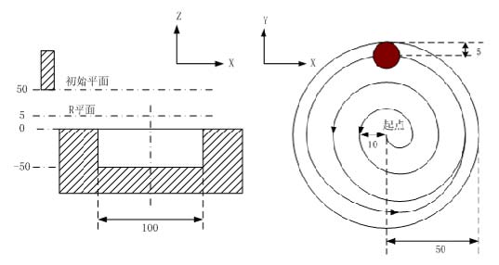
G90 G00 X50 Y50 Z50；（G00 rapid locating）
G99 G110 X25 Y25 R5 Z-50 I50 W20 Q10 K10 E0 V10 F800 D1 ； （rough milling of circle groove D1=5）
G80 X50 Y50 Z50； （cancel fixed cycle, return from R plane）
M30；
- Finishing milling cycle of inner circle G112/G113
Format: G99 G112/G113 X_ Y_ R_ Z_ I_ J_ D_ F_
Function:The tool mill inside a whole circle with the direction and radius I which is
specified, return after the accurate milling.
Note:The relative instruction according to the table 3-2.
G112: finishing milling cycle CCW.
G113: finishing milling CW.
I: Circle radius of accurate milling, the range -99999999~99999999 times the
minimum unit, take absolute value if negative.
J: The distance between the starting point of accurate milling and the center of
accurate milling circle, the range J≦I- the radius value of tool, take absolute value if
negative.
D: The number of tool, the range 1~32, D0 default is 0. Take out the radius of the
current tool according the number.
Cycle process:
(1) Orient to the position of XY plane
(2) Move down to the R point plane
(3) Cutting feed to the hole bottom
(4) Process the arc interpolation according to the track of transition arc 1
(5) Whole circle interpolation according to the arc 2, arc 3
(6)Arc interpolation to the starting point according to the track of transition arc 4
(7) Fixed to return R point
The track:
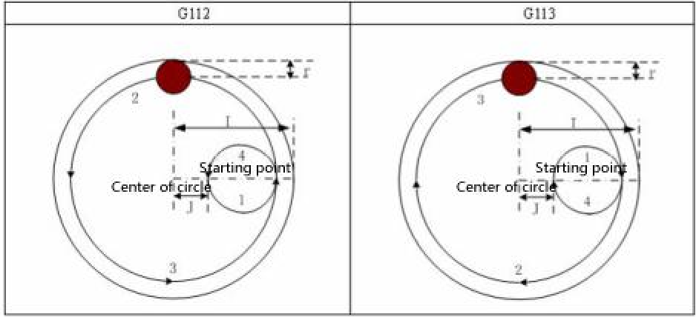
Note:
Q P L invalid under this cycle, but it will keep the value of Q P as the fixed mode cycle value to save.
Example: Use G112 to accurate milling the circle groove which has rough milled.
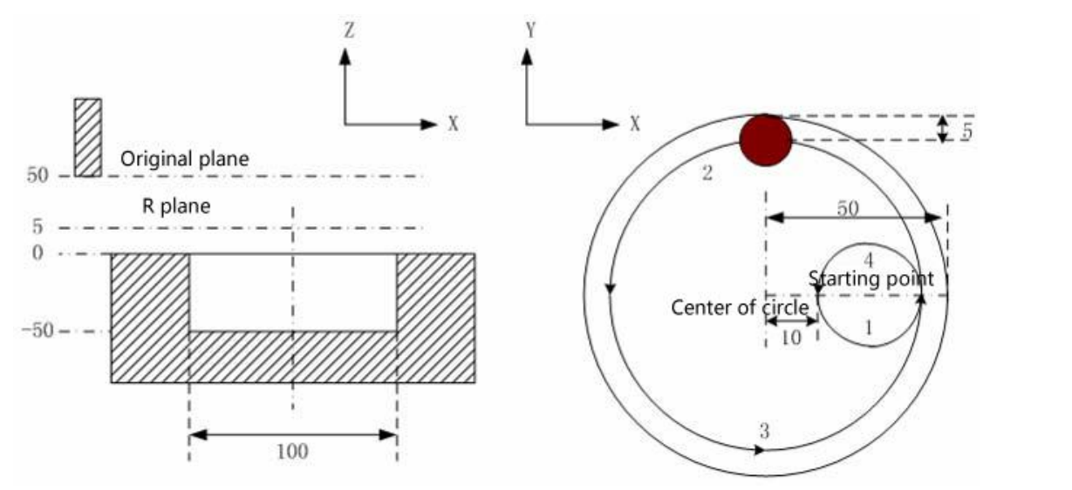
G90 G00 X50 Y50 Z50; (G00 orient with rapid move)
G99 G112 X25 Y25 R5 Z-50 I50 J10 F800 D1; (Start fixed cycle, move to the
hole bottom and process accurate milling cycle in circle D1=5)
G80 X50 Y50 Z50; (Cancel the fixed cycle, return from R point plane)
M30;

- Finishing milling cycle of outer circle G114/G115
Format: G99 G114/G115 X_ Y_ R_ Z_ I_ J_ D_ F_
Function: The tool accurate milling a whole circle at excircle with the specified
radius and direction, return after finishing.
Note: The relative instruction refers to the table 3-2.
G114: finishing milling cycle excircle CCW.
G115: finishing milling cycle excircle CW.
I: Circle radius of accurate milling, the range -99999999~99999999 times the
minimum unit, take absolute value if negative.
J: The distance between the starting point of accurate milling and the center of
accurate milling circle, the range J≥D(radius of tool), take absolute value if negative.
D: The number of tool, the range 1~32, D0 default is 0. Take out the radius of the
current tool according the number.
Cycle process:
(1) Orient to the position of XY plane
(2) Move down to the R point plane
(3) Cutting feed to the hole bottom
(4) Process the arc interpolation according to the track of transition arc 1
(5) Whole circle interpolation according to the arc 2, arc 3
(6)Arc interpolation to the starting point according to the track of transition arc 4
(7) Fixed to return R point
The track:
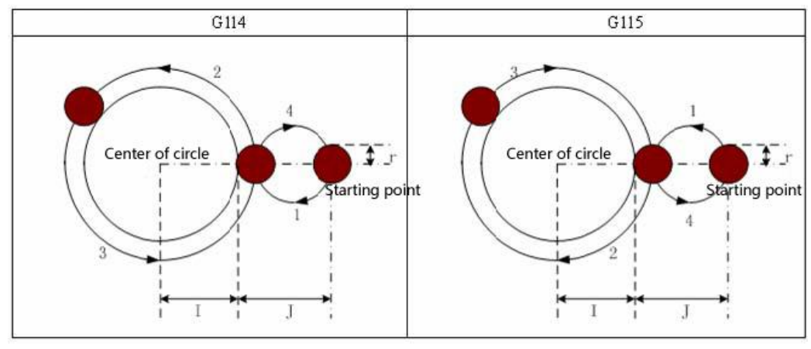
Note:
(1) The direction of transition arc and finishing milling arc is different when finishing milling excircle, the interpolation direction means the interpolation direction of accurate milling arc.
(2) Q P L invalid under this cycle, but it will keep the value of Q P as the fixed mode cycle value to save.
Example:
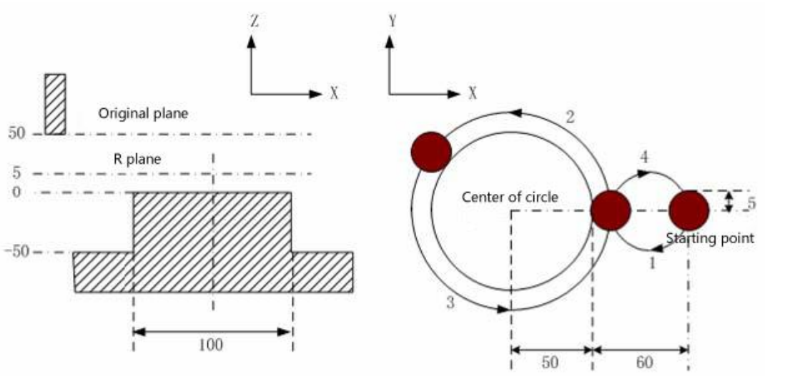

G90 G00 X50 Y50 Z50; (G00 orient)
G99 G114 X25 Y25 R5 Z-50 I50 J60 F800 D1; (Starts fixed cycle, move down to
the hole bottom and process accurate milling cycle of excircle D1=5)
G80 X50 Y50 Z50; (Cancel the fixed cycle and return from R point plane)
M30;
(47) Rough milling cycle of excircle G116/G117
Format: G99 G116/G117 X_ Y_ Z_ R_ I_ J_ W_ Q_ K_ C_ E_ D_ F_
Function: Start from starting point, the tool process whole circle interpolation until
process the size which is programmed.
Note: The relative instruction refers to the table 3-2.
G116: Rough milling cycle of excircle CCW
G117: Rough milling cycle of excircle CW
I: The radius of rough milling circle (should be greater than 0, take absolute value if
negative)
J: The radius of workpiece (should be greater than 0, take absolute value if
negative);
E: The allowance of rough milling excircle in XY plane (should be greater than 0 or
equal to 0, take absolute value if negative);
W: The first time cutting depth with the direction of Z axis, the distance from the R
plane move down, should be greater than0, take absolute value if negative( if the first
time cutting is deeper than the groove bottom, so process from the groove bottom)
Q: Every incremental depth with direction of Z axis, take absolute value if negative
K: The cutting incremental width in XY plane( should be smaller than the tool
radius, greater than 0, take absolute value, if not to specify K, the default is the tool
radius D)
C: The first time feed cutting ( C should be greater or equal to the tool radius +2.0,
X axis move positive direction when greater than 0, the workpiece is located at the
positive direction. When smaller than 0, X axis move negative direction, the
workpiece is located at the negative direction)
D: The number of tool, the range 0~32, D0 the default is 0. Take out the current
tool radius according to the number which is specified
Cycle process:
(1) Orient to the position of XY plane
(2) Move down to the R point plane
(3) Move down to W depth
(4) Process straight interpolation to feed tool with the first time feeding value C of
X axis and track of straight 1.
(5) Process whole circle interpolation with track of arc 2
(6) Every time according to the K value to increase to mill the (I+E) radius circle
from outside to the center
(7) Orient Z axis back to R plane
(8) Orient to starting position(XY plane)
(9) Z axis rapid move to the position (unmachined plane + Q)
(10) Cycle 5~9 motion until finish all the cutting depth Z
(11) Fixed return to R point
(12) Return to starting position of XY
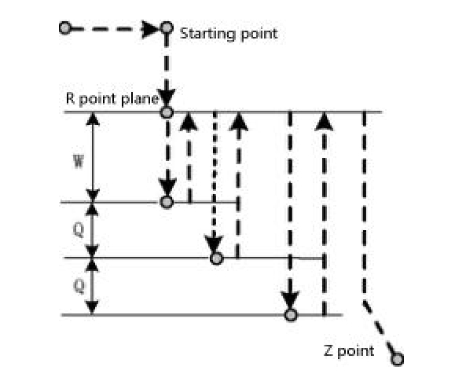
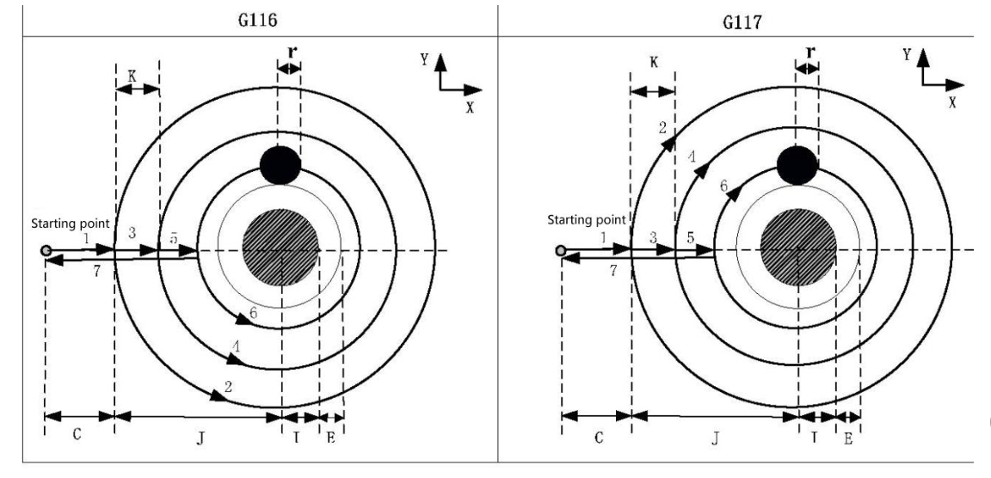
Note: P and L are invalid under the cycle, but it will keep the value of P as the fixed mode
cycle value to save.
Example: Use G117 to rough mill
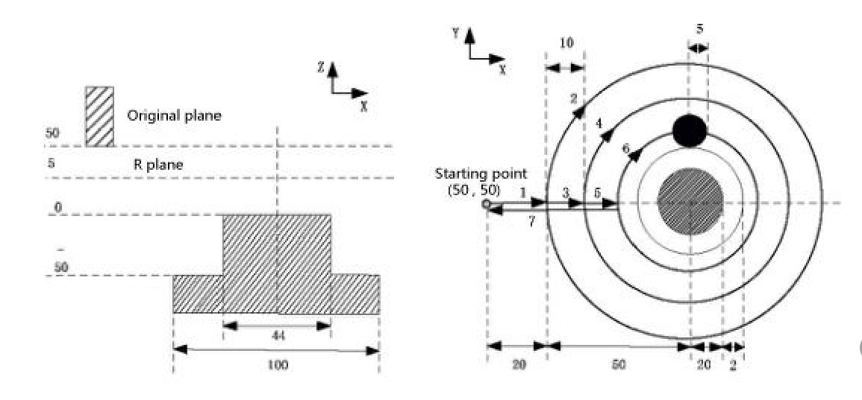
G90 G00 X0 Y0 Z50; (G00 orient)
G99 G117 X50 Y50 R5 Z-50 I20 J50 W20 Q10 K10 C20 E2 F800 D1; (process rough milling excircle cycle D1=5)
G80 X50 Y50 Z50; (cancel the fixed cycle, return from R point plane)
M30；
(48) Rough milling cycle of outer rectangle G132/G133
Format:G99 G132/G133 X_ Y_ Z_ R_ I_ J_ A_ B_ W_ Q_ K_ C_ E_ D_ F_
Function: Start from starting point to cycle the straight cutting according to the
parameter until process the size which is programmed.
Note: The relative instruction refers to the table 3-2.
G132: Rough milling outer rectangle CCW
G133: Rough milling outer rectangle CW
XY: The coordinate position of processing point
I: The width of rough milling outside rectangle in direction of X axis (should be
greater than 0. Take absolute value if negative)
J: The width of rough milling outside rectangle in direction of Y axis (should be
greater than 0. Take absolute value if negative)
A: The width of blank in direction of X axis (should be greater than 0. Take
absolute value if negative)
B: The width of blank in direction of Y axis (should be greater than 0. Take
absolute value if negative)
E: The allowance of rough milling outside rectangle in XY plane (should be greater
than or equal to 0. Take absolute value if negative)
W: The first time depth in direction of Z axis which is from R plane to downward
position, should be greater than 0, take absolute value if negative ( if the first time
cutting is deeper than the groove bottom, so process from the groove bottom)
Q: Every time the incremental cutting depth in direction of Z axis, take absolute
value if negative
K: The incremental cutting width in XY plane (should smaller than the tool radius,
greater than 0, take absolute value if negative, it not specify K, the default is K=D tool
radius)
C: The first time feed cutting in direction of X ( C should be greater or equal to the
tool radius +2.0, X axis move positive direction when greater than 0, the workpiece is
located at the positive direction. When smaller than 0, X axis move negative direction,
the workpiece is located at the negative direction)
D: The number of tool, the range 0~32, D0 the default is 0. Take out the current
tool radius according to the number which is specified
Cycle process:
(1) Orient to the position of XY plane
(2) Move down to the R point plane
(3) Move down to W depth
(4) Process straight interpolation to feed tool with the first time feeding value C of X axis and track of straight 1.
(5) Process straight interpolation with track 2.
(6) Every time according to the K value to increase to mill the rectangle with ( I+2E) long , ( J+2E) width.
(7)Arc angle of milling rectangle
(8) Z axis returns to R point plane
(9) X and Y axis orient to the starting point plane
(10) Z axis rapid move to the position (end processing plane + Q)
(11) Cycle 4~9 motion until finish all the cutting depth Z
(12) Fixed return to R point
(13) Return to starting position of XY
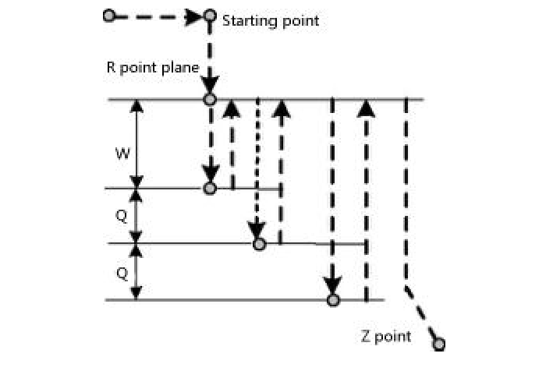

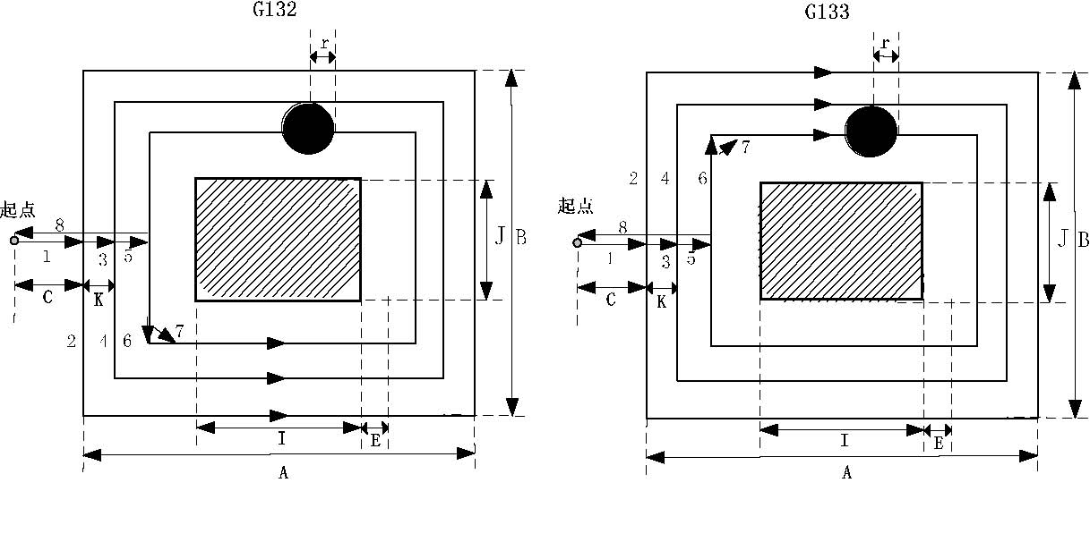
Note: P L invalid under the cycle, but it will keep the value of P as the fixed mode cycle value to save.
Example: Use G133 to rough mill
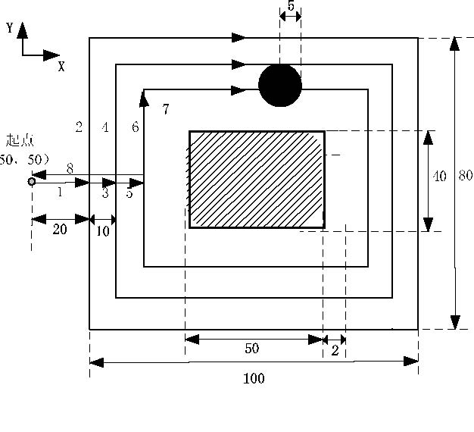
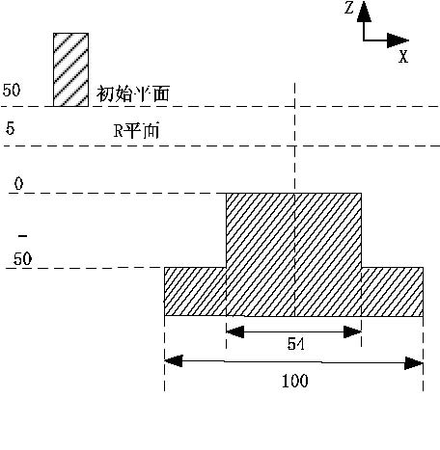
G90 G00 X0 Y0 Z50; (G00 to orient)
G99 G133 X50 Y50 R5 Z-50 I50 J40 A100 B80 W20 Q10 K10 C20 E2 U5 F800
D1; ( Process the rough milling groove cycle D1=5 in rectangle)
G80 X50 Y50 Z50;
M30;
(49) Rough milling cycle of rectangle groove G134/G135
Format: G99 G134/G135 X_ Y_ Z_ R_ I_ J_ K_ W_ Q_ E_ V_ D_ F_
Function: Start from the center of rectangle to straight cutting cycle with the
specified parameter data until process the rectangle groove which is programmed.
Note: The relative instruction refers to the table 3-2.
G134: Rough milling the rectangle groove CCW.
G135: rough milling the rectangle groove CW.
I: The width of rectangle groove in direction of X axis.
J: The width of rectangle groove in direction of Y axis.
K: The cutting incremental width in X Y plane, should be less than the diameter of
tool, greater than 0.
W: The first time depth in direction of Z axis which is from R plane to downward
position, should be greater than 0, take absolute value if negative ( if the first time
cutting is deeper than the groove bottom, so process from the groove bottom)
Q: Every time the incremental cutting depth in direction of Z axis, take absolute
value if negative
V: The distance from the tool to the processing plane when tool starts moving,
should be greater than 0
E:The allowance of rough milling rectangle groove in XY plane (should be greater
than or equal to 0. Take absolute value if negative, take the parameter data when not
to be specified)
D: The number of tool, the range 0~32, D0 the default is 0. Take out the current tool
radius according to the number which is specified
Cycle process:
(1) Orient to the position of XY plane
(2) Move down to the R point plane
(3) Move down to W depth
(4) milling rectangle plane incrementally by K value from the center.
(5) Z axis returns to R reference plane.
(6) X and Y axis orient to the center of rectangle;
(7) Z axis rapid move to the position (end processing plane + V)
(8) Z axis cuts down by the distance(Q+V)
( 9)Cycle 4~8 motion until finish all the cutting depth;
(10) Fixed return to R point
(11) Return to starting position of XY
(12) instruction tracking:
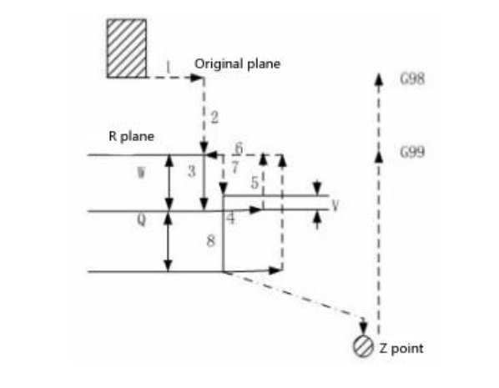

Note: P and L is invalid under the cycle, but it will keep the value of P as the fixed mode cycle value to save.
Example: Use the fixed cycle G134 to rough milling groove in rectangle
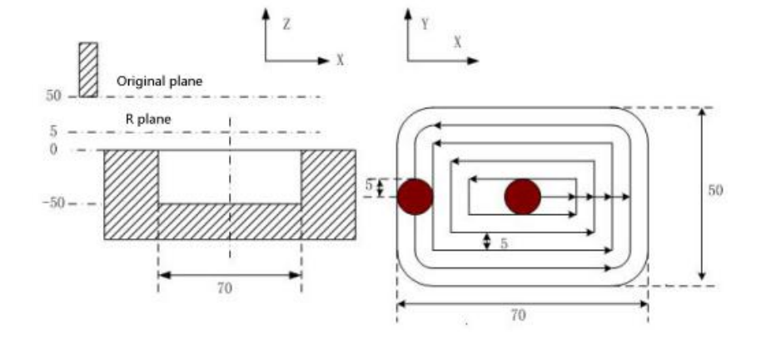
G90 G00 X50 Y50 Z50; (G00 to orient)
G99 G134 X25 Y25 R5 Z-50 I70 J50 W20 Q10 K5 E0 V10 U10 F800 D1;
( Process the rough milling groove rectangle cycle D1=5 );
G80 X50 Y50 Z5; (Cancel the fixed cycle, return from R point plane)
M30;
(50) Finishing milling cycle of inner rectangle groove G136/G137
Format:G99 G136/G137 X_ Y_ R_ Z_ I_ J_ D_ K_ U_ F_;
Function: The finishing milling in rectangle with specified width and direction,
return after finishing.
Note: The relative instruction refers to the table 3-2.
G136: Finishing milling cycle in rectangle groove CCW.
G137: Finishing milling cycle in rectangle groove CW.
I: The width of rectangle in direction of X axis, the range: -99999999~99999999
times the minimum unit. Take absolute value when negative.
J: The width of rectangle in direction of Y axis, the range: -99999999~99999999
times the minimum unit. Take absolute value when negative. The value must greater
than or equal to the tool radius D, otherwise it will alarm.
D: The number of tool, the range 0~32, D0 the default is 0. Take out the current
tool radius according to the number which is specified
K: The distance from the starting point to the rectangle in direction of X axis, the
range -99999999~99999999 times the minimum unit. Take absolute value when
negative.
U: Corner radius of arc, omit means no corner arc to transition. When omitting U or
U=0 and the tool radius greater than 0, it will alarm.
Cycle process:
(1) Orient to the position of X Y plane;
(2) Move to the R point plane;
(3) Cutting feed to the hole bottom;
(4) Start from starting point to arc interpolation with transition arc 1;
(5) Process straight line and arc interpolation with 2-3;
(6) Process arc interpolation to back to starting point with transition arc 4;
(7) Fixed back to R point
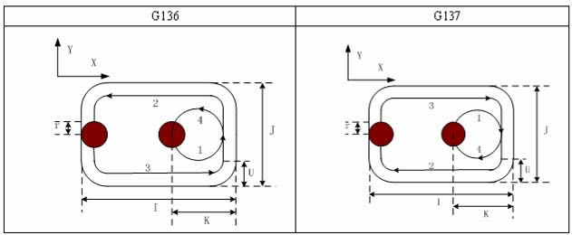
Note: P and L is invalid under the cycle, but it will keep the value of P as the fixed mode cycle value to save.
Example: Use the fixed cycle G136 to do finishing milling.
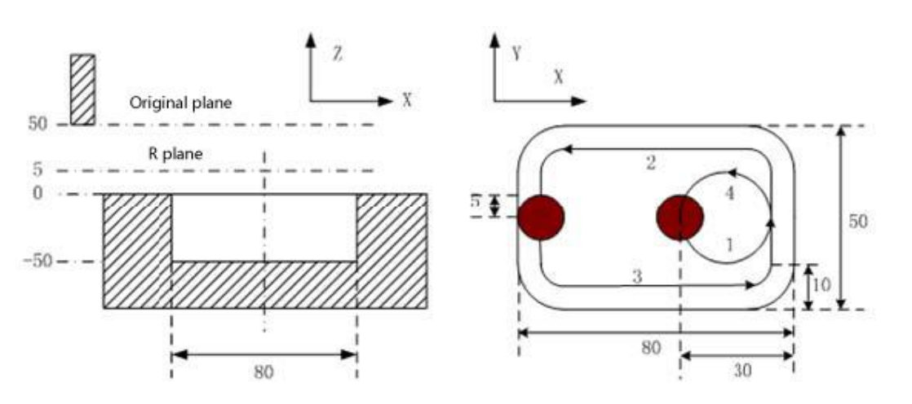
G90 G00 X50 Y50 Z50; (G00 rapid orientation)
G136 X25 Y25 R5 Z-50 I80 J50 K30 U10 F800 D1; ( Process accurate milling
D1=5 at the bottom of hole under the fixed cycle)
G80 X50 Y50 Z50； (Cancel the fixed cycle and return from R point plane)
M30；
(51) Finishing milling cycle of outer rectangle groove G138/G139/G141/G142
Format: G99 G138/G139/G141/G142 X_ Y_ R_ Z_ I_ J_ D_ K_ U_ F_
Function: The tool finishing milling on the outer the rectangle with specified width and direction, return after finishing.
Note: The relative instruction refers to the table 3-2.
G138: Finishing milling outside the rectangle CCW.
G139: Finishing milling outside the rectangle CW.
G141: Finishing milling of outer lateral rectangle or square (I>J).
G142: Finishing milling of outer vertical rectangle or square (I<J).
I: The rectangle width in direction of X axis, the range -99999999~99999999 times
the minimum unit. Take absolute value when negative.
J: The rectangle width in direction of Y axis, the range -99999999~99999999 times
the minimum unit. Take absolute value when negative.
D: The number of tool, the range 0~32, D0 the default is 0. Take out the current tool
radius according to the number which is specified
K: The distance from the starting point to the rectangle in direction of X axis, the
range -99999999~99999999 times the minimum unit. Take absolute value when
negative.
U: Corner radius of arc, omit means no corner arc to transition.
Cycle process:
(1) Orient to the position of X Y plane;
(2) Move to the R point plane;
(3) Cutting feed to the hole bottom;
(4) Start from starting point to arc interpolation with transition arc 1;
(5) Process straight line and arc interpolation with 2-3;
(6) Process arc interpolation to back to starting point with transition arc 4;
(7) Fixed back to R point.
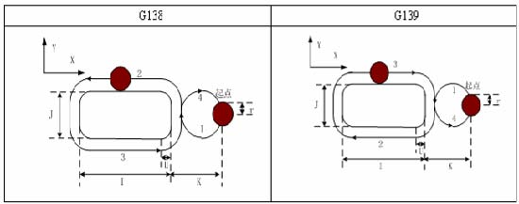
Note:
(1) The interpolation direction of transition arc and finishing milling arc is different, in finishing milling outside the rectangle, the interpolation direction means the direction of finishing milling arc.
(2) Q, P, L are invalid under the cycle, but it will keep the value of Q, P as the fixed mode cycle value.
Example: Use the fixed cycle G138 to do finishing milling.
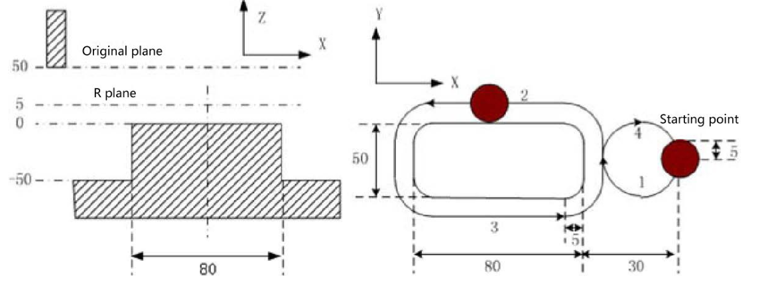

G90 G00 X50 Y50 Z50; (G00 to orient)
G99 G138 X25 Y25 R5 Z-50 I80 J50 K30 U5 F800 D1; (Process finishing milling
outside the rectangle at the bottom of hole under the fixed cycle)
G80 X50 Y50 Z50; (Cancel the fixed cycle and return from R point plane)
M30；

2.5 Radius compensation of tool C
C means the system calculates the tool trajectory of radius compensation according to the last program line and the next program line.
2.5.1 Inside and outside
It calls inside when the included angle of tool trajectory is over 180 degrees which is built by two program segments, it calls outside when the included angle is between 0 and 180 degrees. As the follows:
Inside： Outside：
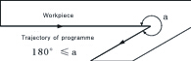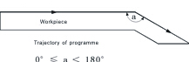
2.5.2 Tool motion when starting
The radius compensation without tool builds tool radius compensation
(1) Tool motion around the inside corner （α≥180）
The tool center will move to the tool vector radius vertex of the starting point in next program line.
Straight line->Straight line Straight line->Arc 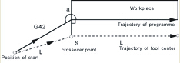 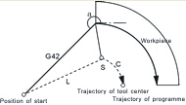

(2)The tool motion around the outside corner of obtuse angle（90≤α＜180）
The tool center will move to the tool vector radius vertex of the end point in this program line.
Straight line->Straight line
A type B type 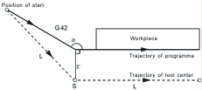 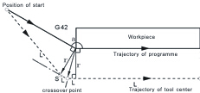

Straight line->Arc
A type B type
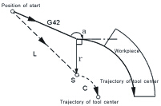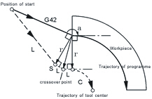

- The tool motion around the outside corner of acute angle（α＜90）
The tool center will move to the tool vector radius vertex of the end point in this program line.
Straight line->Straight line
A type B type
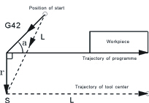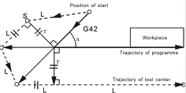
Straight line->Arc
A type B type
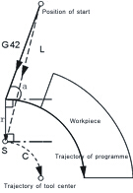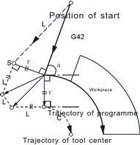

2.5.3 Tool motion in offset mode
(1)Tool motion around the inside corner（180≤α）
Straight line->Straight line Straight line->Arc
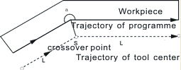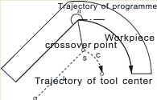
Arc-> Straight line Arc->Arc
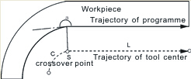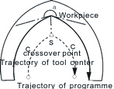
- The tool motion around the outside corner of obtuse angle（90≤α＜180）
Straight line ->Straight line Straight line ->Arc
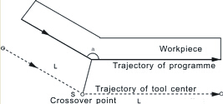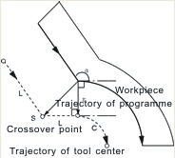

Arc-> Straight line Arc->Arc
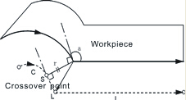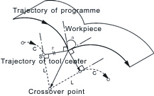

(3)The tool motion around the outside corner of acute angle（α＜90）
Straight line->Straight line Straight line->Arc
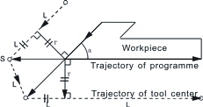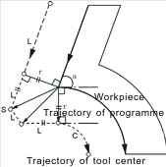
Arc-> Straight line Arc->Arc
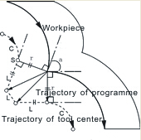
2.5.4 Tool motion in offset-cancel mode
(1) Tool motion around the inside corner（180≤α）
The tool center will move to the tool vector radius vertex of the end point in this program line.
Straight line－＞Straight line Arc－＞Straight line 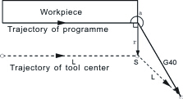 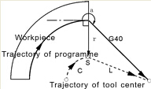
(2) The tool motion around the outside corner of obtuse angle（90≤α＜180）
The tool center will move to the tool vector radius vertex of the starting point in next program line.
Straight line－＞Straight line
A type B type
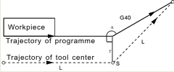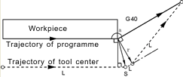
Arc－＞Straight line
A type B type
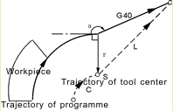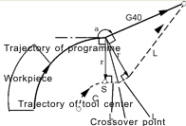
(3)The tool motion around the outside corner of acute angle（α＜90）
The tool center will move to the tool vector radius vertex of the starting point in next program line.
Straight line－＞Straight line
A type B type
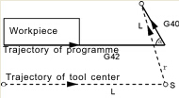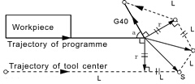
Arc－＞Straight line
A type B type
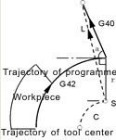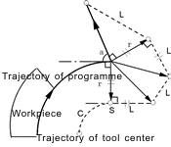

2.6 Comprehensive examples for programming
In the actual programming, must according to the drawings and processing requirements to select the install method and suitable tool correctly, combined with the actual working performance of machine to select the correct cutting allowance, for example:
Example 1: Cut square and cut circle

C
A
B
E
D
O
40

Beginning from the center, the center coordinate is G54 X0 Y0 Z50
The tool radius in the D01 of the T01 parameter
N0 G54 G00 X0 Y0 Z50 | Starting point of processing
N1 M03 S1000 | Turn on spindle
N2 G00 Y-40 X－40 G90 | Move outside of square
N3 Z10
N4 G01 Z－10 F200 | Start cutting from Z axis
N5 G01 G41 T01 D01 X-20 Y-20 F400 | Move to B point
N6 Y20 | Tool cuts BC line at the left of the workpiece
N7 X20 | Closed angle transition in C point, cut CD line
N8 Y－20 | Closed angle transition in D point, cut DE line
N9 X-25 | Closed angle transition in E point,cut CB line is for smooth，move 5mm more
N10 G00 X-40 Y-40 G40 | Move outside of circle
N11 G01 G41 X－20 Y－20 F500 | Lengthen T01 value along A-B
N12 Z－20 F100 | Start cutting from Z axis
N13 G91 G02 I20 J20 Y0 X0 | Circle of contact
N14 G00 Z50 | End cutting
N15 G40 G00 X0 Y0 | Cancel tool compensation
N16 M05 | Turn off spindle
N17 M02 | Program ends.
Example 2:
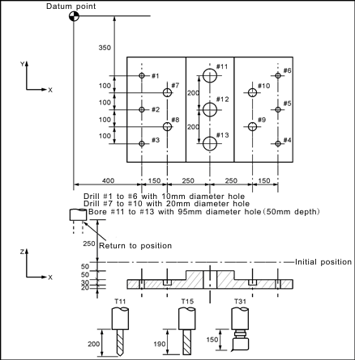
Assume to used 3 tools T11 T15 T31. The tool length compensation values were 200 (H1), 190 (H1), 150 (H1), entered into the tool parameter. According to the processing requirements of parts drawing, the program is as follows:
N1 G54 X0 Y0 Z0 | Set workpiece coordinate at the datum point
N2 G90 G00 Z250.0 T11 | Tool exchange
N3 G43 Z0 H1 | The offset length in initial position
N4 S30 M3 | Turn on spindle
N5 G99 G81 X400.0 Y-350.0 Z-153.0 R-97.0 F120 | To drill #1 hole
N6 Y-550.0 | To drill #2 hole and return to initial position
N7 G98 Y-750.0 | To drill #3 hole and return to initial position
N8 G99 X1200.0 | To drill #4 hole and return to initial position
N9 Y-550.0 | To drill #5 hole and return to initial position
N10 G98 Y-350.0 | To drill #6 hole and return to initial position
N11 G00 X0 Y0 M5 | Return to the datum point and stop spindle
N12 G49 Z250.0 T15 | Cancel the tool length offset to change tool
N13 G43 Z0 H1 | Tool length offset in initial position
N14 S20 M3 | Turn on spindle
N15 G99 G82 X550.0 Y-450.0 Z-130.0 R-97.0 F500 | To drill #7 hole and return to initial position
N16 G98 Y-650.0 | To drill #8 hole and return to initial position
N17 G99 X1050.0 | To drill #9 hole and return to initial position
N18 G98 Y-450.0 | To drill #10 hole and return to initial position
N19 G00 X0 Y0 M5 | Return to the datum point and stop spindle
N20 G49 Z250.0T31 | Cancel the tool length offset to change tool
N21 G43 Z0 H1 | Tool length offset in initial position
N22 S10 M3 | Turn on spindle
N23 G85 G99 X800.0 Y-350.0 Z-153.0 R47.0 F150 | To bore #11 hole and return to initial position
N24 G91 Y-200.0 | To bore #12 hole and return to initial position
N25 Y-200.0 | To bore #13 hole and return to initial position
N26 G90 G28 X0 Y0 M5 | Return to the datum point and stop spindle
N27 G49 Z0 G80 | Cancel the tool length offset
N28 M02 | Program ends.

2.7 Usage for automatic tool setting gauge
1. Note for parameter:
Define macro variables of the automatic tool setting gauge function are as follows (corresponding to the other parameters P380 - P389):
#380: The X axis machine coordinate of initial position when automatic tool setting;(Unit:mm)
#381: The Y axis machine coordinate of initial position when automatic tool setting;(unit:mm)
#382: The Z axis machine coordinate of initial position and returning point with automatic tool setting;(unit:mm)
#383: The negative speed of automatic tool setting;(mm/min)
#384: The positive speed of automatic tool setting;(mm/min)
#385: The Z axis coordinate of workpiece surface in current workpice coordinate system after automatic tool setting;(mm)
#386: The speed which is rapid move to locating position with automatic tool setting;(mm/min)
#387: Automatic tool setting mode (1 means fixed point, 0 means floating point).
#388: The minimal machine coordinate value of Z axis (mm);
#389: The gap value of Z axis [The height which is the gauge surface relative to the workpiece surface(mm)];
Fixed point gauge means putting the gauge in a fixed position, every time the X Y Z axis are automatic running to the fixed point first in tool setting; But the floating point gauge search the tool setting gauge signal along negative of the Z axis.
The input point X25 is default to be the checking point of automatic tool setting gauge to input.
2.The instruction:
M880 (corresponding to ProgramUser0) automatic tool setting instruction;
M882 (corresponding to ProgramUser2),
M883 (corresponding to ProgramUser3) set the gap of Z axis.
3. Automatic tool setting steps:
1)Set the No.380--No.388 parameter in other parameter;
2)Set the No.389 parameter in other parameter to set the drop value of Z axis: this operation needs to be set only once.
A.Run M882 instruction in MDI to set the gap of Z axis;
B.Manual run Z axis to move the tool nose to the workpiece surface;
C.Run M883 instruction in MDI to automatical set the gap of Z axis No.389 parameter in other parameter;
3) MDI choose the workpiece coordinate system G54/G59;
4) Automatic tool setting: MDI running the M880 instruction, automatical set the Z
axis offset of the current workpiece coordinate system.

2.8 Usage for automatic dividing center
1. The X axis is divided center: M884(Corresponding to ProgramUser4)
1) Choose the current coordinate system such as G54;
2) Manually moving the X to the negative terminal of workpiece; MDI running the M884 instruction;
3) Manually moving the Y to the positive terminal of workpiece; MDI running the M885 instruction, automatically divide the center of Y axis and set the middle point of workpiece as current coordinate system of Y axis origin, that's automatically setting the current coordinate system, such as the coordinate offset value of Y axis in G54.
2. The Y axis is divided center (Corresponding to ProgramUser5): M885
1) Choose the coordinate system such as G54;
2) Manually moving the Y to the negative terminal of workpiece; MDI running the M885 instruction;
3) Manually moving the Y to the positive terminal of workpiece; MDI running the M885 instruction, automatically divide the center of Y axis and set the center point of workpiece as the current coordinate system of Y axis origin,that's automatically setting the current coordinate system, such as the offset value of Y axis in G54.

2.9 Instruction of follow-up axis
1.Method A: the coordinate of follow-up axis will not follow, while the fourth axis can be hidden in screen. When axis parameter P414 is 7, the fourth axis is following X axis in both automatic and manual mode. When P414 is 8, the fourth axis is following Y axis in both automatic and manual mode. When P414 is 9, the fourth axis is following Z axis in both automatic and manual mode.
Besides, when P414 is 17/18/19, the C axis is following X/Y/Z axis in both automatic and manual mode. When P414 is 27/28/29, the B axis is following X/Y/Z axis in both automatic and manual mode.
2. Method B: it is applied to specify follow-up axis with instructions in automatic mode, but not follow in manual mode. In this way, is coordinate following when axis is following.
M123: turn on the follow-up Y axis following X axis;
M124: turn off the follow-up Y axis following X axis;
M125: turn on the follow-up A axis following X axis;
M126: turn off the follow-up A axis following X axis.

Chapter 3 Operation explanation

3.1 Summary
When using this CNC system, as long as the master of the system parameters, the program edit, manual operation, automatically running, it can be very convenient to operate.

3.2 Operation panel
This system panel is composed of the main panel and side sub-panel. The main panel is used for parameter setting and program editing and the sub-panel is for tool setting and processing operations.

3.3 Keyboard description
3.3.1 Rate increase or decrease
- Rapid override(G) 
There are six gears in rapid override form 5% to 100%, by adjusting the key of rapid override is for the following instruction: G00,G26,G28,G611,G613, rapid feed fixed cycle, rapid manual feed.
- Feed override(F) 
There are sixteen gears in feed override from 0% to 150%, by adjusting the key of feed override is for the following instruction:G01,G02,G03, the feed override of the fixed cycle and manual run effectively.
(3) Spindle override(S) 
There are sixteen gears in spindle override from 5% to 150%, by adjusting the key of spindle override is for the speed of the first spindle.
3.3.2 Usage for intervention switch
It is used to start the execution of processing program.
3.3.3 Others keys
Keyboards | Functions
Letter key  Number key | ABCSEFGHIJKLMNOPQRSTUVWXYZ123456789.-： for program instructions, parameters’ edition; number keys are used for inputting data and selecting sub-menu.
Edit key | “↑、↓、→、←、Del、PgUp、PgDn”for programming, direction keys can be used for selecting menu.
+X,-X  +Y,-Y  +Z,-Z  +A,-A | It is used to feed manually.
Function key | “Esc” returning to upper level or stop a operation  “Enter” selecting sub-menu and changing a newline  “Del” delete program  “program”entering program edition  “parameter” entering parameter setting  “diagnosis” entering diagnosis I/o function  “manual” entering manual status  “handwheel” for starting or stopping handwheel function  “Tool” for confirming current tool ‘s position in machine tool coordinates system.  “Redeem” for amending tool change errors  “Auto” entering automatic status  “MDI” entering MDI function  “”selecting auto-coordinates/diagram machining  “”for single segment or constant work  “” for coordinates mode or diagram mode speedy simulating  “”for manual increment or manual continuous
Control key | “”spindle cw, ccw rotation  “” coolant on/off  “”for the shift between electric tool carrier and gang tool carrier  “” for the shift between hand-driven continuous high speed and low speed.  “” all axes return to datum point  “” for spindle chuck on/off  “” for thumbstall on/off  “”handwheel gear selection  “” adjusting spindle speed  “”adjusting feed speed  “”adjusting G00 speed
Feed key | +Y +A–Y -A | For X、Y、Z 、A axes direction feed

3.4 Manual operation
The system adjusts one-level menu operation, intuitive, convenient, shortcut, prompt comprehensive information.
Powering the system is to enter the main interface
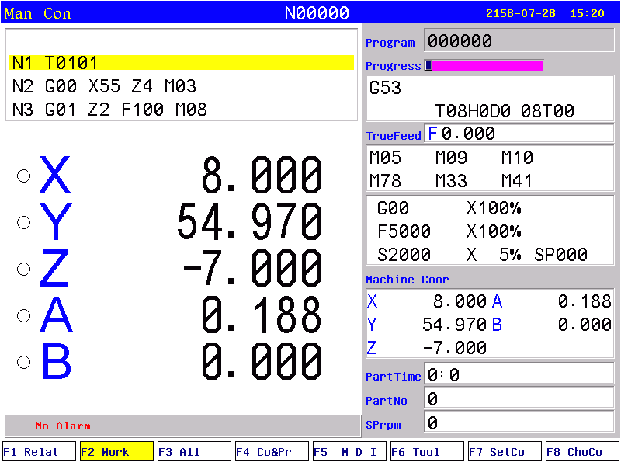
The left part of the first line on the screen is the running mode of system(manual continuous, manual incremental, auto continuous, auto single block, auto idle running, handwheel), middle part is the current line of processing program, right part is date and time.
The left top area is program part, the second line is current program line;
The left button area is workpiecec coordinate display;
The second area from bottom is the information display, like alarm;
The bottom area is the F1-F8 function keys.
The right area the display of program name, instructions, machine status and machine coordinate etc;
Menu operation
Press “program” to enter into program management, then edit, modify, check, delete, copy program;
Press “parameter” to enter into parameter management, then check and modify parameter of controller;
Manual mode is used to modify machine coordinate and management of machine auxiliary performance, tool setting, specify start point of work piece and manual process. Manual mode cannot used to run program.
3.4.1 The key of manual operation
(1) “F”: Taking mm/min as the unit to set the manual feed speed, the input range is from 1 to 30000mm/min. And the input method according to data input method in parameter.
(2) “”: Switching cycle from “manual continuous” to “manual increment”
(3)“S”: Set the speed of the first spindle. The range is from 0 to 99999, the max depends on the No.36 parameter in speed parameter.
(4)“I”： Modify the increment in manual increment
(5)“”：Press once to increase or decrease 10% feed speed when the No.1 axis parameter is 0, the range is from 0% to 150%,16 gears totally.
(6) “”: Press once to increase or decrease G00 or manual rapid override 20%.The range is from 5% to 100%,16 gears totally.
(7)“”: Press once to increase or decrease the spindle override 10% when the No.2 parameter in axis parameter is 0. The range is form 5% to 150%,16 gears totally.
(8)“”: To switch cycle “0.001” “0.01” “0.1”or “0.1” “0.01” “0.001” in the handwheel function.
(9)“Diagnosis”: Enter the diagnosis of input or output.
(10)“F7 Setup”：To set a value(G54-G59) in workpiece coordinate(G54-G59);Use “MDI” to set G54-G59 in machine coordinate(G53).
(11)“Auto”: Select automatic mode.
(12)“Manual”: Select manual mode.
(13)Spindle controlled: “”Controlling spindle on clockwise, counterclockwise, stop, correspond to instructions M03,M04,M05. When No.56 parameter in the axis parameter is “8”then press “spindle on counterclockwise” means counterclockwise inching turning.
(14)“Cooling”: Coolant on or off correspond to instructions M08,M09.
(15)“Chuck”: Chuck tightens or loose correspond to instructions M10,M11.
(16)“Manual speed controlled”: Press “1” “2” “3” “4” “5” “6” “7” “8” “9” to set feed override “F30” “F60” “F120” “F250” “F500” “F1000” “F1500” “F2000” “F2500” “F3000”.
(17) “Huff”: control huff on or off, correspond to instructions M59, M58.
(18) “Switch manual continuous or increment”: Press to manual continuous or increment, it displays I=XXXX.XXX when it is manual increment.
(19) “Back to datum point”: Press and X or Z, the X or Z axis goes back to the datum point automatically; Press “0”X axis firstly and then Z axis; Press “Esc” to cancel the construction. The speed controlled by No.31 No.33 parameter in speed parameter, the direction is determined by No.28 parameter in axis parameter.
(20) “Tool carrier controlled”: Press to change next tool automatically if it is gang tool carrier; After changing next tool it will be stop if it is electric tool carrier; Which tool has changed is going to be redeem. Press “T” and number to change tool directly
(21) “Coordinates feed”: Press “↑ ↓ ← →”correspond to feed A axis and Z axis’s positive or negative direction.
(22) “Switch speed”: Press to switch the speed to system speed which is changed by No.1 No.2 parameter in speed parameter when it is in coordinate feed, loosen it that will be the previous speed. If set the speed higher than the speed in parameter, it will be the set speed to feed.
(23) “Switch coordinates’ display”: Press “PgUp” or “PgDn” to switch the display which correspond to “relative” “absolute” “machine”.
(25) “Partno clear”: Press Del and Enter to clear quantity of processed work piece.
(26) User-defined “K1”: Turn on/off Y24
(27) User-defined “K2”: Turn on/off Y25
(28) User-defined “K3”: Turn on/off Y26
(29) “Incremental coordinate”: Press “Setup” to fix or set 0 after select “relative” coordinate.
(30) search center point: convert into G54-G59, press”K”. according to prompt information, controller will calculate value and save the offset of G43-G59.
PS: Machine coordinate clear: Press “E” in parameter and then press “Enter”.
3.4.2 Manual continuous
Continuous operation is to press the time as the basis, Press to feed, up to stop feeding. Making sure the axis and using “+X、-X、+Y、-Y、+Z、-Z、+A、-A” to feed, the speed of feed is determined by display on the interface(F) times the rate.
When continuous starting, press “” to switch the speed to No.1 No.2 No.3 parameter value in speed parameter. If set the speed higher than the speed in parameter, the feed speed will be No.1 No.2 No.3 parameter in speed parameter times rapid override.
In order to facilitate the user single axis cutting in the manual function, setting the manual speed in manual status. Press “F” and input the speed.
When the hard limit point beyond positive and negative feed running axis two direction at, stop the feed and prompt to feed reverse direction.(the same as hereinafter)
The manual maximum speed is limited by No.4 parameter in speed parameter, when setting the speed is higher than the value of parameter, then will be the No.4 parameter.
When No.38 other parameter is 8, “” is change into a switch, press once to turn on (no more to always press), press again to turn off.
3.4.3 Manual increment
This operation is to set the value of increment as the basis, press “↑ ↓ ← →” once to run a value of increment. It will prompts “I=0010.000” in manual increment represent for the value of increment is 10mm, press “I” to revise and Enter. But also press “handwheel” and “”to switch the value into 0.001mm 0.01mm 0.1mm.
The speed is the speed on display(F) times the rate.
3.4.4 Back to machine’s datum point (reference point)
There are two ways to back to datum point in this system, not only the switch for datum point, but also can set floating point, the methods as follows:
Switch for datum point:
Back to datum point operation is to feed every axis to machine’s datum point position in turn. When the parameter of feeding axis which back to datum point is 0, the axis of coordinate detects the datum point and return to the pulsing signal of “Zero”, the data of machine’s coordinate will be 0 automatically.
Switch on the power supply of the system, release alarm and the button of emergency after the CNC is power off, the need to back to datum point to set machine’s coordinate correctly.
Instruction:
1. The system requires for backing to the datum point every time when it is power on, the requirement can be set by No.38 parameter in axis parameter, it can be prompt or force;
2. The way and type of detecting signal can be set by No.39 parameter in axis parameter, so detect the switch of datum point is effective, also detect the Z pulsing signal of electrical motor after detecting the switch of datum point (precision higher), detect forward or reverse for Z pulsing signal of electrical motor.
3. The direction for backing to datum point can be set by No.40 parameter in axis parameter, D2 D3 D4 correspond to X Y Z axis, 0 is forward, 1 is reverse.
4. The type of the switch for datum point can be set by No.41 parameter in axis parameter, D0 D1 D2 correspond to X Y Z axis,0 is always on, 1 is always off.
5. The maximum length of detecting Z pulse of electrical motor can be set by No.37 No.38 No.39 parameter in axis parameter, the value must less than the pulse of electrical motor run a cycle.
6. The shifting distance after backing to datum point can be set by No.46 No.47 No.48 parameter in axis parameter, rapid move coordinate to the value of parameter after backing to datum point.
No switch for datum point:
To set floating point to make sure, turn on corresponding function of floating point by No.33 parameter in axis parameter, setting No.34 No.35 No.36 parameter to make sure the floating point of X Y Z axis, the datum point of machine
The steps to set floating point as follows:
1. Setting the No.33 parameter in axis parameter to enable corresponding floating point. For example: Turn X axis on is “00001000”. (turn all of them on is 00111000.)
2. Moving X axis to designate position so that set floating point.
3. Press “Parameter”, “Axis parameter” and select No.34 parameter, “Enter”, popup a dialog box of X axis’ floating point coordinate. Import the value of setting machine coordinate.
If it is 0, the machine coordinate of X axis now is the datum point of X axis. The machine backs to this position every time when backing to the datum point.
If it is 15, the current machine coordinate of X axis is 15.000, the distance to machine’s datum point is 15mm.
The method to set floating point of Y Z axis is the same as the above to set X axis.
Operation for backing to the datum point:
At the manual condition, press “”and select X Y Z A axis to back to the datum point in dialog box.Or import 0 to make the axis back in order, the cycle will turn to green in front when backing to the datum point successfully, defeat otherwise.
If stop in the process, press “Stop” or “Reset” to stop backing to the datum point.
Pay attention:
Every time when power on the system, it must back to the datum point to make sure the accuracy of machine process. The system power off unusually or in an accident, it must back to the datum point, otherwise could cause error.
3.4.5 Handwheel(MPG)
Two types: hand held and panel, No.1 parameter in other parameter to set.
1.Panel:
Press “handwheel” and “X” “Y” “Z” “A”to select an axis, “” to adjust the gear.
2.Hand held:
Press “handwheel” and operate the switch of axis selection to select an axis, operate the axis and switch of handwheel override to adjust the gear.
Instruction
The handwheel is mainly used for “Tool”, the speed and the handwheel feed of one measure is related to rotate the handwheel fast or low. The speed is not too fast best when the system cooperate with stepping motor.
Handwheel’s pulse generator speed to be lower than 200r/min(The handwheel to 100 pulse a cycle), the handwheel’s acceleration is controlled by No.24 parameter in speed parameter(the bigger the faster). The maximum speed is controlled by No.26(X axis) No.27(Y axis) No.28(Z axis) in speed parameter.
Handwheel is invalid in auto-coordinates diagram machining, it only works in working coordinates.
3.4.6 Workpiece coordinate system
1. Press "MDI" button to select the corresponding workpiece coordinate system (G54-G59);
2. Moving the axis which is going to set tool to the specified location;
3. Press "Setup" to import the corresponding coordinate of workpiece coordinate system..

3.5 Auto operation
Auto refers to processing the editing program of workpiece. This system can start at arbitrary point, and also can start at arbitrary line or with arbitrary tool. Starting arbitrary line or with arbitrary tool must use absolute coordinate to edit the program. Auto operation can’t move the manual coordinate.
Running program selection: In the program interface, press “↑ ↓” to move the cursor to a program which is going to be carry out, press “C” to select the program to run automatically.
Press “Auto” to enter automatic mode from manual mode.
Switch display of coordinates: Press “Pgup” “Pgdn” to switch the interface into “absolute coordinate” “relative coordinate” All coordinate”.
3.5.1 Automatical process
“Single or Continuous”: Press “” to switch cycle.
“Continuous”: The program continue to execute every program segment(program line) to end or the instruction of stop to stop.
“Single ”: The program just execute one program line and end, wait another operation or press “Run” again to execute one next program line.
“Coordinate or Figure”: Press “” to switch cycle.
“Automatic coordinate”: The axis of coordinate will display with value.
“Automatically figure”: The axis of coordinate will display with a figure. There are two kinds of figure, horizontal milling machine and slant-bed machine, No.3 parameter in tool parameter to control.
“Automatic idle run”: The program is speedy simulate, the axis of coordinate can’t move.
3.5.2 Processing at arbitrary program line or with arbitrary tool
A. Run at actual line
At the automatical process condition, press “—” to popup a dialog box, import a number of line, press “Enter” to confirm, the line will start from the defined actual line.
Pay attention:
1. The line is the actual line in the program, not the “N” stand for the line. The system process to the line you import with a speed which is set by No.6 parameter in speed parameter(G01/G02/G03), then process the program normally.
2. The line of default is the line of suspend the program last time, to facilitate user’s operations.
3. At the interface of coordinate to use “N” to search line and press “Reset” to back to the beginning of program.
B. Run at the marked line
The system has a function to run at the marking line. At automatical process condition, press “N” to prompt a dialog box to import the marking line, press “Enter” to confirm. Press “Run” to process program at the line you import(mark).
Pay attention:
The line is not the actual line, is the “N” stand for the line. The system process to the line you import with a speed which is set by No.6 parameter in speed parameter(G01/G02/G03), then process the program normally.
3.5.3 Start program
Press “Auto” to switch to automatical mode to process program, two methods as follows.
(1) Press “Run”
(2) Switch on the Run of external signal.
3.5.4 Stop processing program
Five methods as follows to stop:
- The instruction of program M00 M01 M02 M30 M20.
- Press “” to run a current line and stop.
- Pause switch on the panel.
- Switch on the Halt of external signal.
- Press “Reset” to stop all the actions of program.(Like spindle, tools and others)
3.5.5 Real-time control in automatic process
(1)“”：Press once to increase or decrease 10% feed speed when the No.1 axis parameter is 0, the range is from 0% to 150%,16 gears totally; When the No.1 axis parameter is 1, external band switch takes in control, Adjust the speed of process arbitrarily in the process according to the different situation.

(2) “”: Press once to increase or decrease G00 or manual rapid override 20%.The range is from 5% to 100%,16 gears totally. Adjust the rapid override arbitrarily according to the different situation.
(3) “”: Press once to increase or decrease the spindle override 10% when the No.2 parameter in axis parameter is 0. The range is form 5% to 150%,16 gears totally. When the No.2 axis parameter is 1, external band switch takes in control, Adjust the speed of spindle arbitrarily in the process according to the different situation.
(4) Stop in the process: At the continuous mode in process condition, press “” to stop running after executing a current program line, wait for operating.
(5) Suspend in the process: Turn the intervention switch right or middle and switch on external stop signal of Halt, the processing program will stop; Press “Reset” to exit automatical process mode and the program line is going to back to the first of the processing program.
(6) Keep feeding: When the process is suspending, press “Manual” to keep feeding automatically, also can adjust the coordinate, press “Auto” and “Run” to run to the point of suspend automatically to end.
(7) Exit process: Press “Reset” when processing, suspending or keep feeding.
(8) Enable macro program by input point during processing. For example: if X7 is valid, then run PrgramUser9, and add following PLC:
X07 M122
-----| |-------| |----------------(S)M300 ;if X7 is valid, run M300;
X07 M300 M122
----| |-------| |-------| |-----------(S)M1014 ;if X7 is valid, reset current program
M300 M122 X07
----| |-------|/|-------|/|---------(S)M1069 ;Enter in manual mode;
M300 M122 M01 X07
--| |---------|/|--------| |------|/|-----(S)M1079 ;Execute ProgramUser9;
|--(R)M300 ;reset M300
M300: intermediate register, the same M300 is prohibit in PLC;
M1014: reset current program;
M1069: manual mode
M1070-M1079: corresponds to ProgramUser0-9.
3.5.6 The operation mode of MDI
At the manual or automatical coordinate conditions, press “M” to get into the processing mode of MDI. Processing a program line that you import in “MDI”, press “Esc” to give up and exit when importing, press “Run” to carry out the program line that you import.
3.5.7 The operation mode of Handwheel
Press “Handwheel” at automatical mode, the program of turn handwheel is processing automatically, the speed is related to the speed of “F”, feed override and turn handwheel fast or slow. This mode is for trying to process in running program usually.
Pay attention: The acceleration, deceleration and maximum speed of running handwheel are controlled by No.23-No.29 parameter, use the acquiescent acceleration, deceleration and the speed of G00 when the parameter is set to be invalid.
3.5.8 The function of DNC
The storage space of user is 32Mbit in this system, use DNC to process when the processing program is greater than 32M or the remainder storage space. Switch on RS232 or USB to realize the function of DNC in this system.
- Instruction for RS232-DNC
- Use the dedicated communication wire to connect the computer and the system to set the corresponding communication interface and speed by the system.
- Use the dedicated communication software of this system by computer to set the corresponding communication interface and speed. Press “Send CNC program file”, select the program file to process linked, enter the status of sending program file.
- To enter the interface of program file in NC system, press "L" to enter the status of linked process, now the upper right corner of the display interface is "RS232--DNC", press “Run” to running carry out linked process in the automatic status.
- Turn “Intervention switch” to middle or right to stop the running system in the process of linked process, press “Stop” or “Reset” to exit the status of linked process.
Pay attention: 1. The baud rate is related to operational environment when using serial port to send files.
2. The communication cable can’t more than 10 meters length.
3. Only the dedicated communication software of this system can send program in user’s computer. To set the sending speed of PC as the NC, defeat otherwise.
B. Instruction of USB-DNC
USB-DNC is realized by U-disk, switch on U-disk and system, select program to execute in U-disk.
Press “B” to open U-disk in program interface, select corresponding program to press “C” to execute program, press “Auto” to get into automatical mode and press “Run” to process the program.
Pay attention: 1. Don’t unplug U-disk in the process of USB-DNC, defeat processing otherwise.
2. Back to the system program interface from U-disk interface after finish USB-DNC.
3. After selecting the program, it is best to press “P” to compile once to make sure the program is right before executing program of USB-DNC.

3.6 Operate safety, prompt alarm
3.6.1 Emergency stop
Press “” when emergency accidents happening, the system will stop all the actions of machine and shows “Emergency stop” on the interface. Wait for the button up. M67 imports effective signal when No.29 parameter in other parameter to be set effectively.
Press “” in the process or running machine, system coordinate and machine’s position may change, make sure the system coordinate again before processing, it is best to carry out operation of backing to the datum point to make coordinate same as the machine’s position.
The button can be external which is controlled by No.27 parameter in other parameter to set it normal open or close.
3.6.2 Reset system
Press “Reset” to stop current operation in anytime when the system is running, especially stop all the actions of machine(spindle, tools and so on) in automatical or manual mode, but the coordinate won’t lose, so needn’t to back to the datum point.
3.6.3 Alarm
The screen shows error information and twinkles when the machine has alarm, the program is stop running, the coordinate stop moving, check the reason for alarm and clear troubles to run again. The signal M67 is effective when No.29 parameter in other parameter is “1”.
(1) X、Y、Z、A axis are positive hard limited: X、Y、Z、A axis are in the positive position which is limited .
(2) X、Y、Z、A axis are negative hard limited: X、Y、Z、A axis is in the negative position which is limited .
(3) Spindle and inverter (frequency changer) alarm: The alarm signal of machine’s spindle is effective.(ALM1)
(4) No.0 alarm: The alarm signal of machine’s spindle is effective.(ALM2)
(5) X, Y, Z, A axis driver alarm: The alarm signal of servo drivers is effective. (ALM). Press “B” to import INTH signal to reset the servo drivers in diagnosis mode.
(6) No.5 alarm for door switch: The alarm signal of M12(door switch) is effective.
(7) +5V is under voltage: Supply voltage is low, +5V of the system is low.
(8) Emergency stop: Press the button of emergency stop.

3.7 Parameter operation
At any status conditions, press “parameter” to enter the status to set the parameter. Parameter in this system includes “processing parameter” “speed parameter” “axis parameter” “tool parameter” “other parameter” “coordinate” “password”, 7 kinds totally.

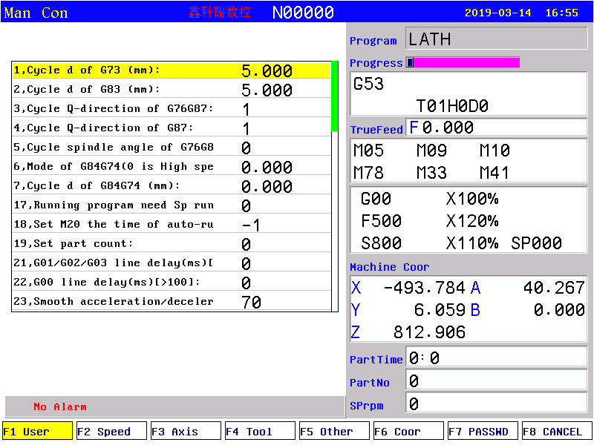
Press “F1-F7” correspondingly to enter corresponding interface after enter the parameter interface, press “↑ ↓” to select the number of parameter and press “Enter” to prompt a dialog box to import data and press “Enter” again to fix parameter successfully.
Instructions for parameter as follows:
3.7.1 User parameter (processing)
1,Retract value d of cycle G73(mm)
2,Retract value d of cycle G83(mm)
3,Offset Q-direction of G76G87(G71:1is +X,2 is -X, 3 is +Y, 4 is -Y)
4,Offset Q-direction of G87(G71:1is +X,2 is -X, 3 is +Y, 4 is -Y)
5,Orientated spindle stop angle of cycle G76G87(0.1degree)
6,Mode of G84G74(0 is high speed to d, 8 is to R)
7,Retract value d of G8474
8,Pause time before retract of G73G83[valid when absolute value >5, minus means by G01, otherwise by G00 ]
17,Run spindle before running program
[1 mean Yes, 0 mean No]
18, Set M20 the time of auto-running
[Negative mean immensity loop]
21, G01/G02/G03 interline delay (ms)[>100]
22, G00 line delay (ms) [>100]
23, Handwheel smooth acceleration/deceleration time constant [50-100]
33,M03/M04/S detect the spindle speed(0:M69 relay, 8: encoder feedback)
34,The error(rpm) of the spindle speed is detected by the encoder feedback
200, system screen protect times [>=2minutes]
202, system inner parameter
203, Whether strict inspection G41/G42 (2131970 means Yes, 34818 means No, 6326274 means rapid preread, 23103490 means special button)
210,Enable graphics display area(8:manual, 0:automatic)
211,X axis negative end in graphics
212,X axis positive end in graphics
213,Y axis negative end in graphics
214,Y axis positive end in graphics
215,Z axis negative end in graphics
216,Z axis positive end in graphics
230,Select executive program through input
(+4...+128,+256...+32768:X26-X31,X16-X23)
231,“Delete” mode(0:backward deletion, 1:forward deletion)
232,Detect the spindle home before tapping(18:Yes, 0:No)
233,G06 Circle teaching function[0:No, 1:Yes]
234,Program back function[[+8:back by handwheel]
307,M18xx/M28xx/WAT max waiting time before alarm(ms)[>=10]
400,Translate DXF file to G code[1:Sequencing,4:Start point sequencing ,8:No sequencing]
401,Translate DXF file to G code X-axis coordinate
402,Translate DXF file to G code Y-axis coordinate
500,G74 equal to ProgramG No.[101-170(101-150Modeless,151-170Mode)]
501,G81 equal to ProgramG No.[101-170(101-150Modeless,151-170Mode)]
502,G82 equal to ProgramG No.[101-170(101-150Modeless,151-170Mode)]
503,G83 equal to ProgramG No.[101-170(101-150Modeless,151-170Mode)]
504,G84 equal to ProgramG No.[101-170(101-150Modeless,151-170Mode)]
3.7.2 Speed parameter
1, X-axis's G00 speed(mm/min)
2, Y-axis's G00 speed(mm/min)
3. Z-axis's G00 speed(mm/min)
4. A-axis's G00 speed(mm/min)
5. Manual maximum feed speed(mm/min)
6, Auto Maximum feed speed(mm/min)
7, G01/G02/G03 default speed(mm/min)
8, Null run speed(mm/min)
9, Feed axis`s manual speed(mm/min)
10, Spindle`s manual speed(rpm)
11, Feed axis start speed(mm/min)
12, Feed axis maximum mutation speed(mm/min)
13, Limit G1G2G3 single axis speed
[1 mean Yes,0 mean No]
14, X G1G2G3 max speed(mm/min)
15, Y G1G2G3 max speed(mm/min)
16. Z G1G2G3 max speed(mm/min)
17. A G1G2G3 max speed(mm/min)
18, X acceleration/deceleration constant
[1～99999]
19, Y acceleration/deceleration constant
[1～99999]
20. Z acceleration/deceleration constant
[1～99999]
21. A acceleration/deceleration constant
[1～99999]
22, Auto run acceleration/deceleration constant
[1-500]
23, Handwheel acceleration/deceleration constant
[500--30000]
24, Test-run Handwheel acceleration/deceleration constant
[>500]
25, Test-run Handwheel G00 speed(mm/min)
[>10]
25-1,Auto-run Handwheel G00 start speed(mm/min)[>5]
26, Handwheel X limit speed(mm/min)
27, Handwheel Y limit speed(mm/min)
28. Handwheel Z limit speed(mm/min)
29. Handwheel A limit speed(mm/min)
30, Acceleration/deceleration type
[0 mean line,8 mean curve]
31, Curve initial acceleration/deceleration constant
[>=10]
32, curve acceleration/deceleration second constant
[>=10]
33, Curve max acceleration/deceleration constant
[>=500]
34, X go home positive speed(mm/min)
35, X go home negative speed(mm/min)
36, Y go home positive speed(mm/min)
37, Y go home negative speed(mm/min)
38. Z go home positive speed(mm/min)
39. Z go home negative speed(mm/min)
40. A go home positive speed(mm/min)
41. A go home negative speed(mm/min)
42, Spindle max speed in the first gear(rpm)
43, Spindle max speed in the second gear(rpm)
44. Spindle max speed in the third gear(rpm)
45, Spindle max speed in the fourth gear(rpm)
46, Second Spindle max speed(rpm)
47, G02/G03 backlash compensation mode(0 means A: length compensation,8 means B: set by the parameter, +2 means set by G17G18G19 +4 means: Arc IJK endpoint to center)
48, mode B backlash compensation speed (mm/min)
48-1, mode B backlash compensation Beginning feed speed (mm/min)[>10]
48-2, Acceleration constant of the B type backlash compensation(mm/min)/s)[>10]
49, Speed Mode [1 means yes, 0 means no]
50, Handwheel stop speed (mm/min) [>100]
51, Spindle speed when following tapping retracting(rpm)[>1]
52,Spindle reverse backlash compensation when tapping (pulse)
53,Advanced retract value before spindle reverse(um)[10-5000]
54,Tapping retract speed(mm/min)[>=60]
58,Hard limit drop speed critical(mm/min)
60,Smoothing function(+4:Manual;+8:Handwheel;+16:Program)
61,Manual smoothing time constant[2-500]
62,Handwheel smoothing time constant[2-500]
63,G01/G02/G03 smoothing time constant[2-500]
65,Manual enhancement smoothing time constant [2-50]
66,Handwheel enhancement smoothing time constant [2-50]
67,Program enhancement smoothing time constant [2-50]
68,Enhanced smoothing process rating [1-9]
(the bigger the rate, the more smooth)
101,X-Beginning feed speed(mm/min)[>1]
102,Y-Beginning feed speed(mm/min)[>1]
103,Z-Beginning feed speed(mm/min)[>1]
104,4-Beginning feed speed(mm/min)[>1]
105,5-Beginning feed speed(mm/min)[>1]
111,X-Jump speed at continuous track(mm/min)[>1]
112,Y-Jump speed at continuous track(mm/min)[>1]
113,Z-Jump speed at continuous track(mm/min)[>1]
114,4-Jump speed at continuous track(mm/min)[>1]
115,5-Jump speed at continuous track(mm/min)[>1]
200,G00 continuate run is valid[1 is No,16 is Yes]
Param#P87G1=
211,initial SP speed when start tapping(rpm)
Param#P167G1=
212,initial SP speed when retract tapping(rpm)
230,SP G00 speed(0.1rpm)
231,SP G01 mode[+4：F key,+8：G90/G91,+16：show value]
232,SP orientate direction under interpolation way[0：Positive,1：Negative]
233,SP home mode
(1:pulse,2: by driver, Output M61,check M22; 16 or 32 mean spindle orientate to P234 angle, 16: output M75, check M22 )
234,SP oriented stop angle(0.1degree)
235,SP home speed(0.1 rpm)

3.7.3 Axis parameter
1,Feed axis band switch
[1 mean Yes,0 mean No]
2,Spindle and G00 band switch
[1 mean Spindle,2, mean G00,0 mean No]
3,X-axis`s negative scope(mm)
4,X-axis`s positive scope(mm)
5,Y-axis`s negative scope(mm)
6,Y-axis`s positive scope(mm)
7,Z-axis`s negative scope(mm)
8,Z-axis`s positive scope(mm)
9,A-axis`s negative scope(mm)
10,A-axis`s positive scope(mm)
11,Spindle stop time(10ms)
12,Spindle stop long signal
[0 mean No,1 mean Yes]
13,Soft limited invalid
[D2X;D3Y;D4Z;D5A;0 inavaild,0 availd]
14,X-axis`s reverse backlash compensation(um)
15,Y-axis`s reverse backlash compensation(um)
16,Z-axis`s reverse backlash compensation(um)
17,A-axis`s reverse backlash compensation(um)
18,X-axis's direction signal
[1 mean normal,0 mean reverse]
19,Y-axis's direction signal
[1 mean normal,0 mean reverse]
20,Z-axis's direction signal
[1 mean normal,0 mean reverse]
21,A-axis's direction signal
[1 mean normal,0 mean reverse]
22,Close feed electronic gear
[1 mean Yes,0 mean No]
23,X-axis's electronic gear numerator(1-999999)
24,X-axis's electronic gear denominator(1-999999)
25,Y-axis's electronic gear numerator(1-999999)
26,Y-axis's electronic gear denominator(1-999999)
27,Z-axis's electronic gear numerator(1-999999)
28,Z-axis's electronic gear denominator(1-999999)
29,A-axis's electronic gear numerator(1-999999)
30,A-axis's electronic gear denominator(1-999999)
31,XYZA positive limit
[0 open,1 close]
32,XYZA negative limit
[0 open,1 close]
33,float zero bit parameter
[D3X;D4Y;D5Z;D6A;0 machine Zero;1 float Zero]
33-1,X of Reference point 1(mm)
33-2,Y of Reference point 1(mm)
33-3,Z of Reference point 1(mm)
33-4,A of Reference point 1(mm)
34,X coordinate of floating zero point setting
35,Y coordinate of floating zero point setting
36,Z coordinate of floating zero point setting
37,A coordinate of floating zero point setting
38,Feed axis home
[1 mean No use, 0 mean clew, 8 compulsion , 9 must compulsion]
39,Feed axis home mode
[0 reverse check,1 reverse No check ,2 No reverse check,3 No reverse No check]
40,Home reverse direction parameter
[D2X;D3Y;D4Z;D5A; 0 Positive;1 Negative]
41,Home switch normally closed bit parameter
[D0X;D1Y;D2Z;D3A;1Close;0Open; D6=1 handwheel/auto; D7=1 manual/auto]
42,X check zero max length(100um)
43,Y check zero max length(100um)
44,Z check zero max length(100um)
45,A check zero max length(100um)
46,X Home offset(10um)
47,Y Home offset(10um)
48,Z Home offset(10um)
49,A Home offset(10um)
50,Run spindle when shifting
[1 mean Yes,0 mean No]
51,Shifting Spindle speed(1/100rpm)
52,Shifting Spindle direction
[0 mean M03,1 mean M04]
53,Spindle pause time when shifting(10ms)
54,Spindle low-speed time when shifting(10ms)
55,Spindle stop time(10ms)
56,Check SP encode
[1 mean Yes,0 mean No]
57,SP encode pulse
[4 times encode thread]
57-1,SP encode alarm pulse value (diagnostics)[>10:Valid]
57-2,SP encode pulse[4 times encode thread](set as 0 if Encode:SP is 1:1, otherwise it must be integer >99)
58,Whether spindle reversing point[8:Valid]
68, Negative delay time of feeding axis(ms)
80,XZ axis coordinate plan [D2Zwordpiece,D3Xwordpiece,D4Ztool,D5Xtool,D6Zcircumrotate,D7Xcircumrotate]
81, Y axis function
[0 mean circumrotate axis,1 mean line axis]
82,workpiece coordinate when Y is circumrotate axis
[0 No;1 plan]
83,machine coordinate when Y is circumrotate axis
[0 No;1 plan]
101,A-axis function
[0 mean rotating axis,1 mean line axis]
102,machine coordinate when A-axis is circumrotate axis
[0 No;1 plan]
404,direction of spindle by pulse(0 reverse,1 normal)
405,SP-axis's electronic gear(0 Yes,1 No)
406,SP-axis's low electronic gear numerator(1-999999)
407,SP-axis's low electronic gear denominator(1-999999)
408,SP-axis's high electronic gear numerator(1-999999)
409,SP-axis's high electronic gear denominator(1-999999)
410,Interpolation tap SP axis[91 X,92 Y/C,93 Z,94 A,95 B]
411,Tap mode[2 follow encode;3 interpolation to SP]
412,SP tooth number(<P413)
413,Encode tooth number(>P412)
414,ABC-axis is moving by (7/8/9,17/18/19,27/28/29/D5..D13=1/A by X/Y/Z,C By X/Y/Z,B By X/Y/Z)
3.7.4 Tool parameter
1,C Tool radius compensation's establish(0 mean A,1 mean B)
2,C Tool radius compensation's cancel(0 mean A,1 mean B)
32,Tool position signal/WAT signal filter [+256+512+1024: 2/4/8ms of Tool position signal,+2048+4096+8192: 2/4/8ms of WAT signal]
D+number means the bit from right to left:
D8=1 means filter detection signal of tool position by 2ms;
D9=1 means filter detection signal of tool position by 4ms;
D10=1 means filter detection signal of tool position by 8ms, D8-D10 can be 1 at the same time;
D11=1 means filter WAT waiting input signal by 2ms;
D12=1 means filter WAT waiting input signal by 4ms;
D13=1 means filter WAT waiting input signal by 8ms, D11-D13 can be 1 at the same time;

3.7.5 Other parameter
1,Set handwheel type
[1 hand hold,0 panel]
3,use control switch
[1 Yes, 0 No]
4,Auto lubricate(0 yes/1 no)
5,Auto lubricate time(0.01s)
6,Auto lubricate interval time(s)
7,Door switch checking(0 no,1 yes)
8,Door switch(0 open,1 close)
9,bit parameter
D0：Null;
D1：“1”Start CNC system clear part Number.;
D2：“1”Automatic space before letter when editing program;
D3：Null;
D4：Null;
D5：“1”Do not stopping SP and cooling when pressing “Reset”;
D6：“1”G00 X and Z’s peed by oneself;
D7：“1”Tool redeem by oneself;
D8：“1”Save SP chuck(M10/M11) state when power off;
D9：Tool redeem input Mode1 or Mode2;
D10：“1” Program edit automatic compositor Line;
D11：“1” First SP +10V output from second output port;
D12：“1” Shield skip function (“/”is invalidation);
D13：“1” Sheld go home function;
D14：“1” Sheld “run” key;
D15：“1” Tool redeem display relative,“0”absolute;
10,Auto count part
[1 mean Yes,0 mean No]
11,Program edit number increase
12,Inner parameter
13,Interlock between Spindle & chuck(0 mean no)
14,Is available keys of lub&cool as running(0 mean no)
17,servo ALM0 (0 open,1 close)
18,SP ALM1 (0 open,1 close)
19,Tool ALM2 (0 open,1 close)
20,Chuck control signal(0 single,1 doubleM10/M71)
22,Outside chuck control(0 no,1 yes)
24,M10M11 short signal time(s)
26,Emergency Stop(0 open,1 close)
27,Emergency Stop2(0 open,1 close)
28,Run status output (M69 run M65 stop)
[0 invalid,1 valid]
29,Alarm status output M67(0 invalid,1 valid)
30,Set language(1means Chinese, 0 means English)
31,enable I/O PLC program
[1:Yes, 0:No, 32 means valid control output and PLC when diagnosis, 64 mean valid output point and invalid PLC when diagnosis]
32,enable High speed I/O PLC program
[0:No, 18: enable high speed, 28: super high speed]
35,valid manual soft-limit without home
[1 Yes,0 No]
36,Set system time
[year-month-day-hour-minute]
37,Velocity of RS232
[0=7200；1=9600；2=14400；3=19200；4=38400；5=57600；6=115200]
38,Lock Manual rapid func key
[8 Yes]
39,Special parameter
40,Special parameter
41,Backup current parameter
42,Resume original parameter
50,Locate at the end of last line before run from middle Program [8:Yes,0:No]
120,Manual axis moving keying reverse(4:is X;8:is Y;16:is Z;32:is A)
200.X axis alarm error between feedback and running. (pulse)[>1]
201.Y axis alarm error between feedback and running. (pulse)[>1]
202.Z axis alarm error between feedback and running. (pulse)[>1]
203.Fourth axis alarm error between feedback and running.(pulse)[>1]
205.X axis alarm error between feedback and stop. (pulse)[>1]
206.Y axis alarm error between feedback and stop. (pulse)[>1]
207.Z axis alarm error between feedback and stop. (pulse)[>1]
208.Fourth axis alarm error between feedback and stop. (pulse)[>1]
210.X axis feed back electronic gear numerator.
[Automatical count: crew pitch (um) and the number of encoder.]
211.Y axis feed back electronic gear numerator.
[Automatical count: crew pitch (um) and the number of encoder.]
212.Z axis feed back electronic gear numerator.
[Automatical count: crew pitch (um) and the number of encoder.]
213.Fourth axis feed back electronic gear numerator.
[Automatical count: crew pitch (um) and the number of encoder.]
215.X axis feed back electronic gear denominators.
[Automatical count: crew pitch (um) and the number of encoder.]
216.Y axis feed back electronic gear denominators.
[Automatical count: crew pitch (um) and the number of encoder.]
217.Z axis feed back electronic gear denominators.
[Automatical count: crew pitch (um) and the number of encoder.]
218.Fourth axis feed back electronic gear denominators.
[Automatical count: crew pitch (um) and the number of encoder.]
300.Feed axis matches absolute encoder motor or not.
[X—D2, Y—D3,Z—D4,A—D5, “0” means not match, “1” means match.]
301.Absolute encoder address of lower 16bits multi-turn data.
302.Absolute encoder address of higher 16bits single-turn data
303.Absolute encoder address of lower 16bits single-turn data.
304.X-axis one-revolution pulse.
305.Y-axis one-revolution pulse.
306.Z-axis one-revolution pulse.
307.Fourth axis one-revolution pulse.
309.X-axis one-revolution coordinate.[nm]
310.Y-axis one-revolution coordinate.[nm]
311.Z-axis one-revolution coordinate.[nm]
312.Fourth axis one-revolution coordinate.[nm]
314.X-axis multi-turn coordinate offset.
[Import “E” to clear multi-turn data]
315.Y-axis multi-turn coordinate offset.
[Import “E” to clear multi-turn data]
316.Z-axis multi-turn coordinate offset.
[Import “E” to clear multi-turn data]
317.Fourth axis multi-turn coordinate offset.
[Import “E” to clear multi-turn data]
319,Servo driver current/speed/power(284/283/435)16 bits address.
320,X-axis one-revolution coordinate denominator
321,Y-axis one-revolution coordinate denominator
322,Z-axis one-revolution coordinate denominator
323,4-axis one-revolution coordinate denominator
380,Automatic tool X setting initial coordinate(mm)
381,Automatic tool Y setting initial coordinate(mm)
382,Automatic tool Z setting initial coordinate(mm)
383,Automatic tool negative high speed(mm/min)
384,Automatic tool positive low speed(mm/min)
385,Automatic tool Z axis coordinate value(mm)
386,Automatic tool Speed of fast locating points(mm/min)
387,Automatic tool setting mode(1:Fixed tool,0:Floating tool)
388,Automatic tool Z axis minimum machine tool coordinate value(mm)
389,Automatic tool Z axis drop value(mm)
500,Machine tool No.
501,Interface display [1:is white,8:is black]
601.One key to define Step Parameter
602, One key to define Servo Parameter
900,User-defined dialog box[1:is invalid,4:is valid,12:is all]
901,Axis home sequence(>9)[5 bits,1/2/3/4 is X/Y/Z/A,last bit must is 0]
902, Inner parameter
904, Inner parameter
910,M18/M22/M24/M28 High speed input[1:Yes]
911,Whether enable M18 as the teaching, M28 as the recording function[1:Yes,0:No]
912,"Reset" to reset the output interface[1:Yes,0:No]
994,CNC controller serial number
995,Machine tool serial number
996,user-defined serial number
3.7.6 Coordinate system
The parameter has the function of multiple coordinate system, includes 6 workpiece coordinate system and a machine coordinate system G53. A processing program can set a workpiece coordinate system, workpiece coordinate system could move its original to change,the value of coordinate system in parameter is coordinate value of the original point (zero point) in the machine coordinate system.
Using G54 to G59 to set 6 workpiece coordinate system, in coordinate system interface could modify the coordinate value of original of 6 workpiece coordinate system in machine coordinate system.
Parameter:
1-0,Current group of workpiece coordinate[G54-G59]
1-1,X of work coordinates G54-G59(mm)
1-2,Y of work coordinates G54-G59(mm)
1-3,Z of work coordinates G54-G59(mm)
1-4,A of work coordinates G54-G59(mm)
1-5,B of work coordinates G54-G59(mm)
1-6,C of work coordinates G54-G59(mm)
1-7,Xs of work coordinates G54-G59(mm)
1-8,Ys of work coordinates G54-G59(mm)
2-0,Current group of workpiece coordinate[G54.1-G54.48]
2-1,X of work coordinatesG54.1-G54.48(mm)
2-2,Y of work coordinatesG54.1-G54.48(mm)
2-3,Z of work coordinatesG54.1-G54.48(mm)
2-4,A of work coordinatesG54.1-G54.48(mm)
2-5,B of work coordinatesG54.1-G54.48(mm)
2-6,C of work coordinatesG54.1-G54.48(mm)
2-7,Xs of work coordinatesG54.1-G54.48(mm)
2-8,Ys of work coordinatesG54.1-G54.48(mm)
1,X of work coordinates G54(mm)[Incremental input, E start entry means absolute]
2,Y of work coordinates G54(mm)
3,Z of work coordinates G54(mm)
4,A of work coordinates G54(mm)
6,X of work coordinates G55(mm)
7,Y of work coordinates G55(mm)
8,Z of work coordinates G55(mm)
9,A of work coordinates G55(mm)
11,X of work coordinates G56(mm)
12,Y of work coordinates G56(mm)
13,Z of work coordinates G56(mm)
14,A of work coordinates G56(mm)
16,X of work coordinates G57(mm)
17,Y of work coordinates G57(mm)
18,Z of work coordinates G57(mm)
19,A of work coordinates G57(mm)
21,X of work coordinates G58(mm)
22,Y of work coordinates G58(mm)
23,Z of work coordinates G58(mm)
24,A of work coordinates G58(mm)
26,X of work coordinates G59(mm)
27,Y of work coordinates G59(mm)
28,Z of work coordinates G59(mm)
29,A of work coordinates G59(mm)
30,B of work coordinates G59(mm)
41,X of work coordinates G54.1(mm)
42,Y of work coordinates G54.1(mm)
43,Z of work coordinates G54.1(mm)
44,A of work coordinates G54.1(mm)
45,B of work coordinates G54.1(mm)
46,X of work coordinates G54.2(mm)
47,Y of work coordinates G54.2(mm)
48,Z of work coordinates G54.2(mm)
49,A of work coordinates G54.2(mm)
50,B of work coordinates G54.2(mm)
51,X of work coordinates G54.3(mm)
52,Y of work coordinates G54.3(mm)
53,Z of work coordinates G54.3(mm)
54,A of work coordinates G54.3(mm)
55,B of work coordinates G54.3(mm)
56,X of work coordinates G54.4(mm)
57,Y of work coordinates G54.4(mm)
58,Z of work coordinates G54.4(mm)
59,A of work coordinates G54.4(mm)
60,B of work coordinates G54.4(mm)
61,X of work coordinates G54.5(mm)
62,Y of work coordinates G54.5(mm)
63,Z of work coordinates G54.5(mm)
64,A of work coordinates G54.5(mm)
65,B of work coordinates G54.5(mm)
66,X of work coordinates G54.6(mm)
67,Y of work coordinates G54.6(mm)
68,Z of work coordinates G54.6(mm)
69,A of work coordinates G54.6(mm)
70,B of work coordinates G54.6(mm)
71,X of work coordinates G54.7(mm)
72,Y of work coordinates G54.7(mm)
73,Z of work coordinates G54.7(mm)
74,A of work coordinates G54.7(mm)
75,B of work coordinates G54.7(mm)
76,X of work coordinates G54.8(mm)
77,Y of work coordinates G54.8(mm)
78,Z of work coordinates G54.8(mm)
79,A of work coordinates G54.8(mm)
80,B of work coordinates G54.8(mm)
81,X of work coordinates G54.9(mm)
82,Y of work coordinates G54.9(mm)
83,Z of work coordinates G54.9(mm)
84,A of work coordinates G54.9(mm)
85,B of work coordinates G54.9(mm)
86,X of work coordinates G54.10(mm)
87,Y of work coordinates G54.10(mm)
88,Z of work coordinates G54.10(mm)
89,A of work coordinates G54.10(mm)
90,B of work coordinates G54.10(mm)
3.7.7 Password
In this system in order to prevent from the parameter modification in accident, make sure the machine working, the system adopts the parameter setting of classify the authority. Divided into "CNC factory" and "Lathe factory", "User factory" three level authority. The "CNC factory" set for the function of the system,belong to internal parameter;"Lathe factory" set equipment configuration of machine and mechanical index and some parameter about safety;"User factory" set processing technology, performance and the processing program.
The initial situation of three-level classification in this system: "CNC factory" is enabled,"Lathe factory"and "User factory" both are not enabled. If you want to enable the authority function, you must use the initial password to enable access function, then set the corresponding new access password to enable.Pay attention to the initial code is only be used once, the code will invalid after setting a new code, please remember the new code.
Pay attention: the code must be 6 digits, the code can be number and letter.
Parameter:
1. Is enable CNC Co.’ password
2. Is enable Machine Co.’ password
3. Is enable User’ password
4. Modify CNC Corporation.’s password
5. Modify Machine Corporation.’s password
6. Modify User’s password
7. Curry work time
8. Software version

3.8 Set parameter of tool redeem
Press “Redeem” to enter interface of redeem in any interface, including “Radius compensation” “Redeem” “Clear all value” “Clear current value” “Measure tool” “Posit tool” “Set”, total 7 functions, correspond to “F1-F7” to enter corresponding interface，press “Esc” to back the primary menu interface.

3.8.1 Radius compensation
Press “F1” enter radius compensation interface in redeem interface. The parameter is used to set adopt corner radius of the tool.
Setting method: Press “↑ ↓” to make cursor move to the corresponding tool and press “Enter” to popup a dialog box, import corresponding tool radius, press “Enter” at last.

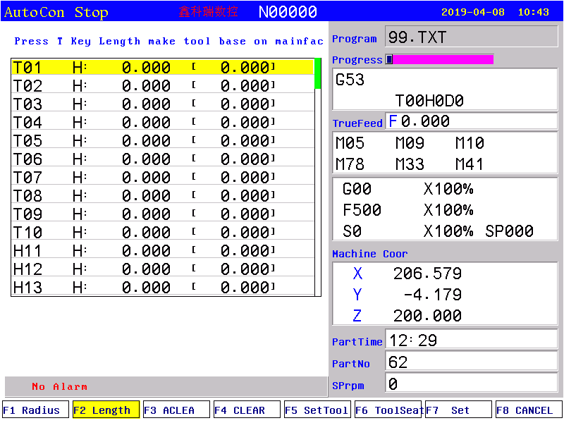
3.8.2 Length of redeem
Press “F2” to enter length of redeem interface. The parameter is used to modify the length which is adopt or reset the length.
Method of modifying the length:
Press “↑ ↓” to make cursor move to the corresponding tool number and press “Enter” to popup a dialog box, import the modifying axis into the dialog box and import the modifying value(import 0.05 to plus 0.05, import -0.05 to reduce 0.05), press “Enter” to confirm. The system calculates current value of redeem after finishing setting.
Method of set tool automatically:
Make machinemove to a position so that measure corresponding tool coordinate, press “↑ ↓” to make cursor move to corresponding tool number and press “A” to popup a dialog box, import the reset axis into dialog box and import the value of measuring the workpiece of corresponding axis, press “Enter” to confirm. The length compensation of corresponding axis has been reset. The system automatical refresh current value of redeem after finishing setting.It also can be set in manual status, press “H” in manual status to set tool automatically.
Method of initializing the length compensation value and radius of tool:
Press “F3” or “F4” to initialize all the length compensation or current length compensation.
Pay attention: the length compensation can be positive or negative number, but the radius compensation only can be positive number.
3.8.3 Posit tool
Press “F6” to enter posit tool interface in redeem interface. The parameter is used to set the kind of tool when adopting radius compensation of tool.
Method of setting: Press “↑ ↓” to make cursor move to corresponding tool number and press “Enter” to popup a dialog box, import the code of corresponding tool kinds and press “Enter” to confirm.
3.8.4 Set quantity
Press “F7” to prompt a dialog box in the redeem interface to set and manage the total tools.The quantity of the tool in this system can be set 99.

3.9 Screw compensation
Press “Parameter” twice in parameter interface to enter screw compensation interface to set the screw compensation.
Screw compensation is used for automatical compensating the error of screw pitch, compensate the influence from the error of screw pitch to the prevision of operating machine. The system adopts storage mode of screw compensation: Making the machine’s datum point as the starting point when debugging, measured the error curve of screw, studied out the correctional curve according to the error curve, import the value of correctional curve into the correctional parameter and system is going to compensate according to the parameter in automatical running.

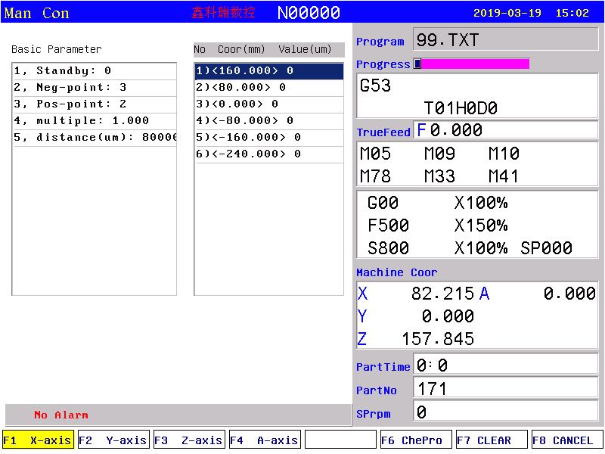
Screw compensation interface
Screw compensation by the axis as the unit to set storage, set X Y Z axis separately, by pressing “F1” “F2” “F3” “f4”to switch; Every axis of screw compensation interface has tow areas(basic parameter and set the compensation), by pressing “→ ←”to move the cursor to realize.
Basic parameter:
Press “↑ ↓” to select current basic parameter to set in basic parameter, press “Enter” to popup a dialog box to import the error compensation of every axis and import the basic information of screw compensation.
Set compensation value:
In the area of setting compensation, it will shows the value of compensation and every axis’ error compensation point of screw pitch. Press “↑ ↓ PgDn PgUp” to select current compensation point and press “Enter” to popup a dialog box to import the value of compensation, import the value of current compensation point.

Test program generate automatically
Automatical generate a program of laser interferometer to check the screw compensation. Enter the screw pitch interface and set basic parameter, press checking program to popup a dialog box and press “Enter” to generate corresponding checking program of screw compensation.
The number of compensation points can be set freely, the maximum number of each axis is 300. The basic parameter of every axis’ error compensation of screw pitch includes as follows:
1. Reserve.
2. Backward checking points.
3. Forward checking points.
4. Compensation override.
5. The spacing of compensation points (um).
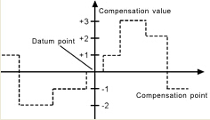

The system calculates every axis’ error compensation points’ positions of screw pitch according to basic parameter automatically, every axis’s error compensation points’ spacing is uniform, user can import compensation value of each point (This system requires importing absolute value, relating the of datum point).
The compensation points are uniform, set the spacing into each axis.
For example:
Example 1:Linear axis: when length of travel is -400mm～+800mm, spacing of points is 50mm,reference point compensation isNo.40, it can figure out that Compensation point of farthest end in negative direction is:
Machine negative travel/point interval +1=40-400/50+1=33.
Compensation point of farthest end in positive direction is:
Machine positive travel/point interval +1=40+800/50=56.
The corresponding relationship between machine coordinate and compensation point is:
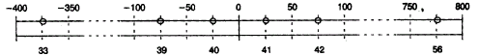
output compensation value in 0 position
parameters set as follows：
Compensation point No. of reference point: 40
Compensation point No. of farthest end in negative direction: 30
Compensation point No. of farthest end in positive direction: 56
Compensation override: 1
Compensation point interval: 50000
Corresponding compensation point and value:
The compensation value in corresponding compensation point:

No. | 33 | 34 | 35 | 36 | 37 | 38 | 39 | 40 | 41 | 42 | 43 | 44 | 45 | 46 | 47 | 48 | 49 |  | 56
Value | +2 | +1 | +1 | -2 | 0 | -1 | 0 | -1 | +2 | +1 | 0 | -1 | -1 | -2 | 0 | +1 | +2 |  | +1
The contrasted chart of compensation points and value as follows:
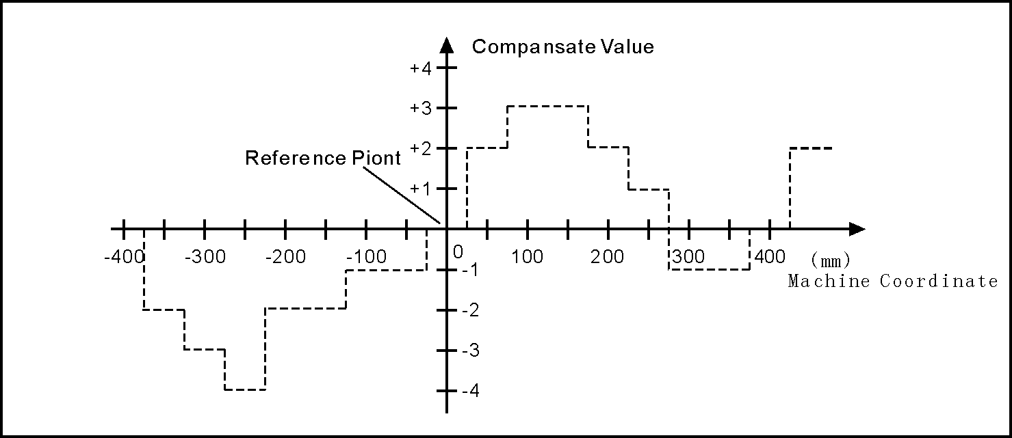
Example 2:rotor axis: when movement per revolution is 360°, interval of points 45°,reference point compensation NO. 60, Compensation point NO. of farthest end in negative direction is usually same as reference point compensation point NO.
Compensation point NO. of farthest end in positive direction is:
Reference compensation point NO.+ movement per revolution/compensation point interval=60+360/45=68.
Machine coordinate and compensation point NO. correspondence is:
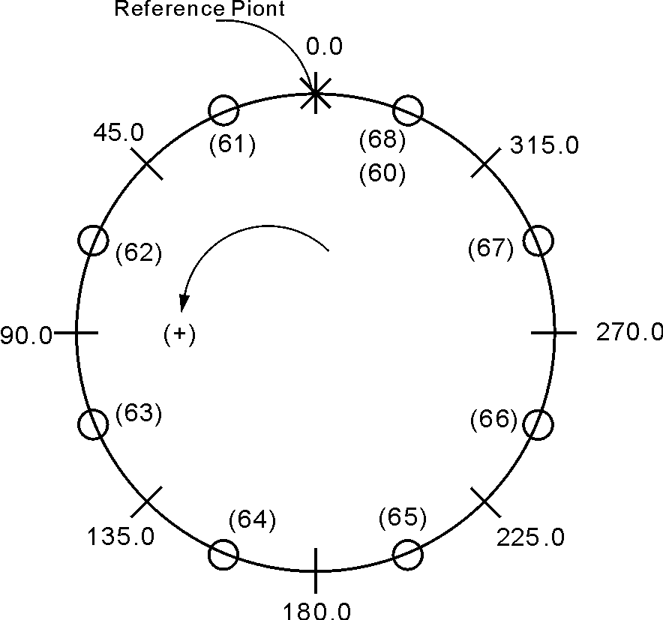
Note: input value in small circle. If the total amount from 61 to 68 doesn’t equal 0, accumulated pitch error per revolution will deviate, so same value shall be put in 60 and 68.
Output compensation value at corresponding point:

NO. | 60 | 61 | 62 | 63 | 64 | 65 | 66 | 67 | 68
VALUE | +1 | -2 | +1 | +3 | -1 | -1 | -3 | +2 | +1

Compensation point and value contrast:

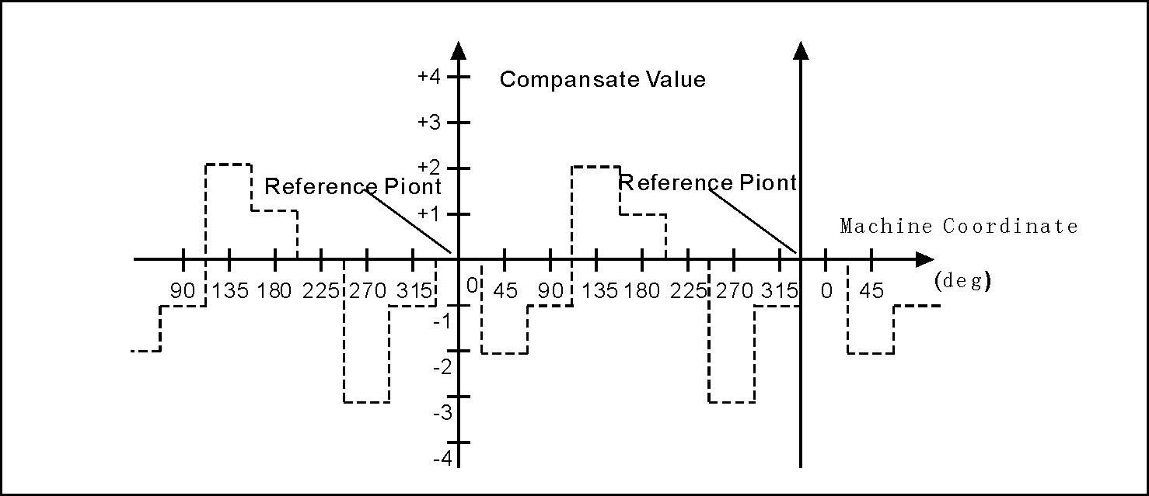

3.10 Diagnosis
Press “Diagnosis” to enter the diagnosis interface in parameter interface.
System diagnosis interface(Input signal)
Press “F2” and “Pgup Pgdn” to check the status of input and output, press “F4” to check alarm information.
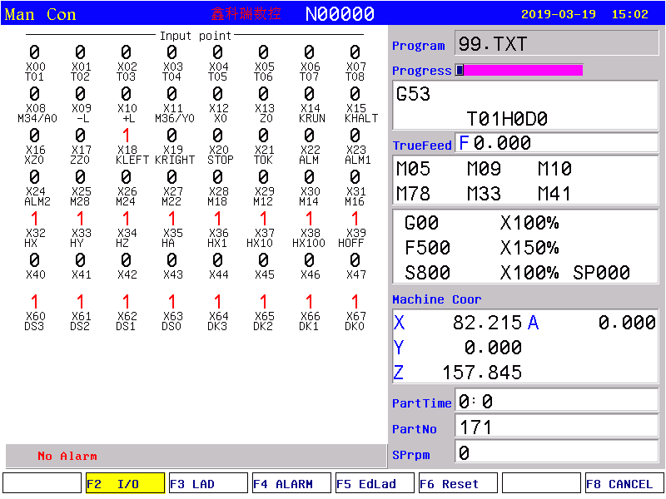

Checking interface of output signal
In the interface of output or input, No.0 or No.1 stands for status, 1 means effective, 0 means no effect.
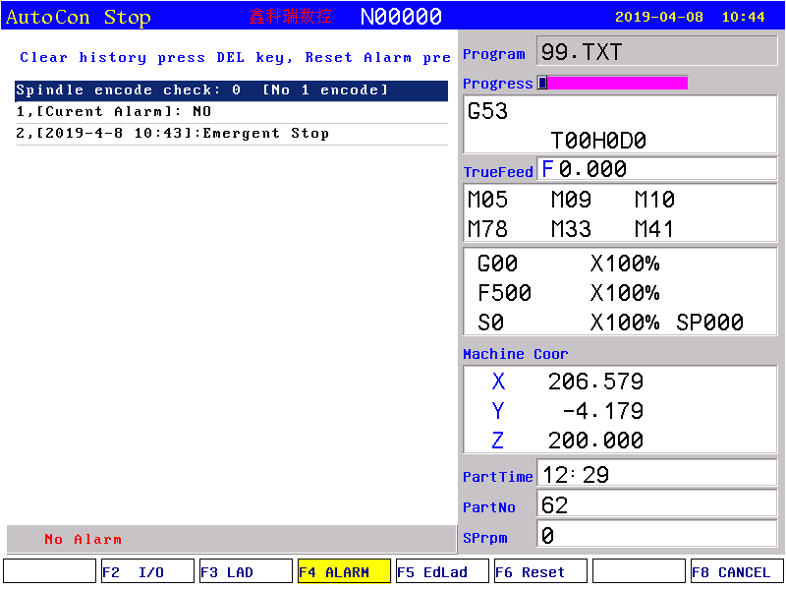
Alarm information interface
The first line in this interface shows the number of spindle encoder, the number of current and historical alarm information is record total 10, the superfluous part is clear automatically, only shows 10 alarm information recently.
PLC interface and edition:
Press “F3” to check PLC ladder, press “F5” to edit PLC ladder, press “S” to search when editing or diagnose PLC ladder. After editing and saving PLC, new PLC will be executed when the controller restart. If you want PLC to be executed immediately, please press”R” in PLC diagnosis interface.
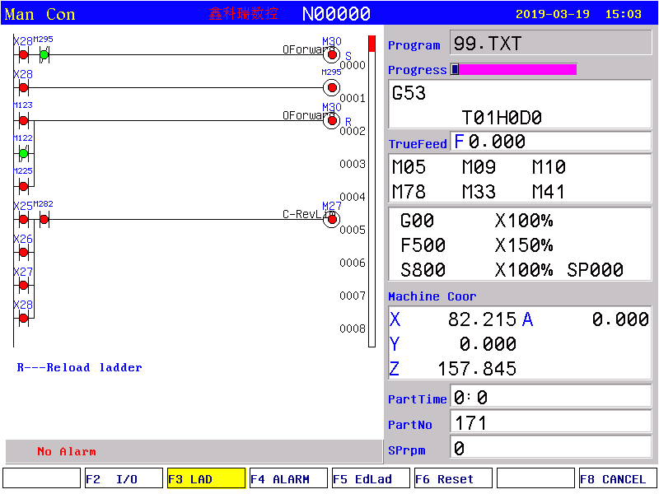

3.11 Operation of program
Press “Program” in any menu to enter into status of programming.
Program management is the same as file management, the storage of the system is 32M bits to contain program and there is no limit for quantity of program. Programming adopts full screen operation.
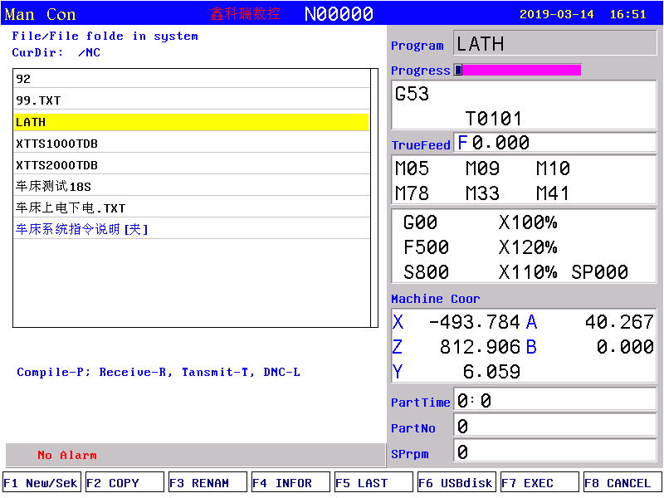
Center part of screen for program display，current program is showed by reverse display, press “PgUp、PgDn” to choose program, and then press “Enter” to edit current program. Functional keys “F1-F7” correspond to：“new file/search” 、“copy” 、“rename” 、“information”、“last grade” “USB disc”、“execute program”、“cancel”.
3.11.1 Editing
Select “New file/search” to popup a dialog box to import the name of program, if the name is existent, the quondam program is called up; If the name is inexistent, the system will build a new file.
The name of program can be number, letter or mix, the length is 100 bits.
The system doesn’t allow the namesake, build a new program or select a program and press “Enter” to enter the editing interface.
The file name and the Chinese input of program content:
The directory interface of the "new / search", "copy", "rename", "to copy into the system", "to copy into the USB" can enter the Chinese characters; change the input method according to the prompt of system. Also can input Chinese characters in program editing interface according to the prompt of system.
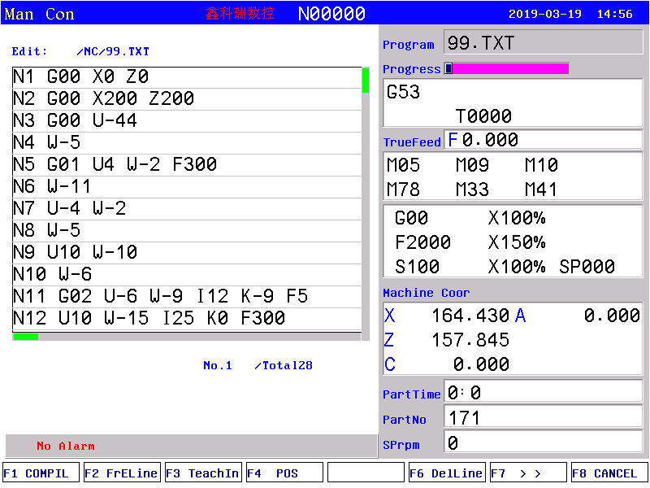
The screen prompt the editing program name at the top left corner in the editing status; The left is the content, the right is the information for machine status, the operation in the editing status as follows:
(1) The current cursor locate:
Press “↑↓←→” to move the cursor to any position of program content
Press "Pgup" to the last page.
Press "Pgdn" to the next page.
(2) Character modification: Delete the character at the position of the cursor, then enter the new character.
(3) The character insertion: Enter a new direct character at the cursor position. When the input is the letter,the letter in front of automatically generating space. If you want to enter a space, first enter a letter, and then delete this letter.
(4) The character deletion: Press "Del" directly at the cursor position
(5) Inset the line: Press "Enter" directly, inset a line in front of the current line if the cursor is at the first line, otherwise insert a line after the current line.
(6) "Fast" superposition key operation:
The first function:
First page of function:
A, "F1": compile the current program.
B, "F2": to the first or last line of program.
C, "F3": teaching function, enter the handwheel state; this can read the curent coordinate of tool according to the corresponding letter X/Z/Y/C/A/B/F4(All axis).
D, "F4": locate to the specified line.
E, "F5": no operation.
F: "F6": delete the current line.
G, "F7": the first, two page selection.
H, "F8": Chinese character and character input conversion.
The second function:
A, "F1": delete the program.
B, "F2": copy the specified program.
C, "F3": program sort.
D, "F4": search the specified character.
E, "F5": replacing the specified character.
F, "F6": all content to replace the specified character.
G, "F7": first, two page selection.
H, "F8": Chinese characters and character input conversion.
3.11.2 Copy
Press “↑ ↓” in program main interface to select program which need to copy and press “F2” to prompt a dialog box to import a new name of program, to copy which is the same content but different name so that to modify, rename and back-up copy.
3.11.3 Delete
Press “↑ ↓” in program main interface to select program which need to delete and press “Del” to delete the program.
The operation of delete need to be careful, it can’t be recovery.
3.11.4 Rename
Press “↑ ↓” in program main interface to select program which need to rename and press “F3” to popup a dialog box to import a new name.
3.11.5 Information
Press “↑ ↓” in program main interface to select program which need to check and press “F4” to popup a dialog box to check the size of program and the remainder space of the system.
3.11.6 Checking program
Press “↑ ↓” in program main interface to select the checking program and press “P”, the system will check the form and grammar of program. Prompting when finding mistake.
3.11.7 Folder management
You can build a file in this system, Press “F1” in program main interface to import a file name and press “.” to build a folder and it will prompt a “folder” after the name.
Move the cursor to the file name and press “Enter” to open to build a new file or folder in it.
Press “F5” go to the last folder.
Move the cursor to the file name and press “Del” to delete the folder.
3.11.8 Select automatic program to run
Press “↑ ↓” in program main interface to select a program and press “F7” to select the program and switch into the last interface.
3.11.9 Program communication
The system could adopt the RS232 serial port to deliver files.
Delivery (Transport)
Deliver the selected program in this system to another system or to PC to save. Press “↑ ↓” in program main interface to select program and press “T” to deliver, press “Reset” to interrupt in the deliver process.
Reception
Receive the selected program in another system or PC (Must be text file form). Press “K” to import a name of received program into the dialog box in program main interface, press “Reset” to interrupt in the receive process.
Pay attention: 1. Using the exclusive communication software to deliver program in User’s PC.
2. The speed of deliver of PC must be the same as the speed of receive, defeat otherwise.
3. The length of RS232 can’t greater than 10 meters.
4. The number of serial port must be the same as the system setting.
5. Editing program of PC must be text file form.
3.11.10 U-disk management
To exchange files of parameter or program with other system or PC by U-disk. It also can upgrade or back-up the software or parameter in system.
Pay attention: The name of folder can’t contain of space symbol.
Press “B” to enter the U-disk management interface in program main interface when U-disk connects the USB port. Press “B” again to back to the system interface.
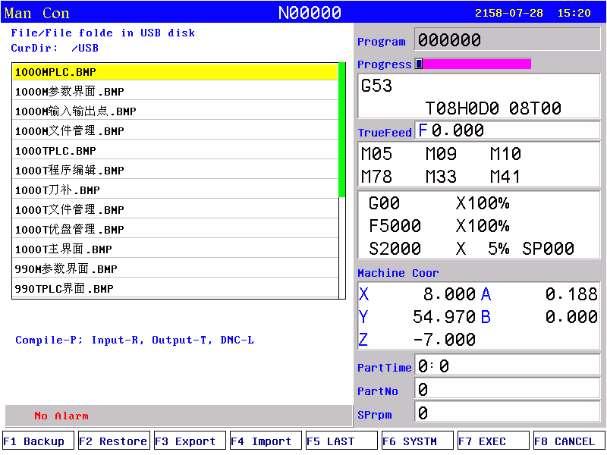
A. The processing program management
Copy the files or folder of U-disk into system
After connecting the U-disk, press “F6” to enter the U-disk directory in program main interface. Press “↑ ↓” to move cursor to select file or folder to copy and press “Q” to popup a dialog box to import name, press “Enter” to confirm. If there is the same name of program in the system, it will popup a dialog box to ask if cover the file or folder or not.
Press “R” to copy all the program in USB into system.
Copy the files or folder of system into U-disk
Press “↑ ↓” to move cursor to select file or folder and press “F6”, press “F3” to popup a dialog box to import name in U-disk interface and press “Enter” to confirm. If there is the same name of program in the system, it will popup a dialog box to ask if cover the file or folder or not.
Press “T” to copy all the program in system into USB.
Pay attention: Before unplugging the U-disk must return to the display system of program files directory interface. (Exit U-disk interface)
Otherwise the date which is copied just now will be loss.
The name of folder can’t have space symbol when using U-disk.
B. Using U-disk to manage parameter and system software
The system could use U-disk to deliver files or system software to upgrade and update, back-up files and parameter, the method of operation is as follows:
Using U-disk to copy parameter and system software into system(Upgrade, update).
First U-disk inserts the USB port and press “Program” to enter program main interface, press “B” to show the files in U-disk. Press “↑ ↓” to move the cursor to select a folder which is going to be copied into system and press “ Enter” to open it, press “F2” to import code when appearing the files and press “Enter” to confirm, wait for seconds to copied the parameter successfully. Press “F6” to exit U-disk after copying successfully, restart the system, the system will reloads the new files to upgrade the parameter.
Pay attention: The parameter is better to be derived into a separate folder in U-disk to defend from the error operation to destroy the system files.
To derive or back-up parameter files by U-disk
First U-disk inserts the USB port and press “Program” to enter program main interface, press “F6” to show the files in U-disk. Press “F1” to import the code and press “Enter” to confirm, waif for seconds to derive successfully. The parameter in system is already derived into U-disk. Press “F6” to exit U-disk.

Pay attention: The U-disk is empty better to arrange the files (Parameter files is lots of about several dozens) so that derive parameter or create a folder on your computer first, open the folder before deriving to derive the parameters into the folder.
3.11.11 Convert DXF files into G code.
In program directory, choose the DXF file then press”-”, it will be converted into G code file, whose name extension is .CNC. The format of the DXF file input into controller should be .DXF or .dxf. Parameter refers to process parameter No.400-402.
During generation of G code files, system will generate corresponding head and end code according to if there are HEADDXF.TXT and ENDDXF.TXT (or headdxf.txt and enddxf.txt) under current file directory.
Attention: head code file and end code file must be under current file directory.
3.12.12 The operation for folder of FTP server file
If the controller connect with Internet or Wi-Fi, could enter folder of FTP server.
- Press “N” in program interface.
- After entering folder of FTP server, press “N”(or F6) as the above operation to quit.
The advantage of FTP: You can see the contents of the PC folder on the controller , and you can choose the files you want to transfer freely, and it is more convenient to use it.

Chapter4 System installation and connection

4.1 System electrical specification
- 32bits high performance industrial grade ARM+DSP+FPGA
- 32M User’s storage space
- 800x600 TFT LCD adaptive brightness, LED backlight LCD
- Touch type key board to have excellent operational sensitivity.
- RS232 communication port
- USB port
- Highly anti-interference of switching power supply.
- Two-way spindle to variable frequency and speed governing
- Manual pulse generator
- The band switch trim the feeding speed and spindle speed

4.2 System technical index
- Controllable axis: X Y Z A B 5 axis
- Linkage axis: straight line X Y Z A B 5 axis, arc X Y Z any two axis
- Pulse equivalency: 0.001mm
- Maximum speed: 30000mm/min
- Processing speed: 0.01-15000min/min
- Minimal input unit: 0.001mm
- Programme size range: ±99999.999mm
- Programme coordinate system definition: IOS-841 international standard
- Programme code: IOS-840 international standard
- Mean Time Between Failure (MTBF): Greater than 6000 hours

4.3 Environment of operation
- Power supply: AC 220V (+10%,-15%), frequency 50Hz ±1%
- Power source≤100W
- Running temperature: 5~45℃, relative humidity: 40~80%
- Storage and transportation temperature: 0~55℃, relative humidity less than 90%(40℃)

4.4 System installation and connection
At first, users should check whether the hardware is complete, unwounded and compatible, such as: CNC system, driving power, servo motor, photoelectric encoder, electric tool carrier.
The installation of CNC system must be fastened tightly, with some spaces around to ensure the ventilation of air. Panel should be put in a place where it is not only convenient to operate and but also able to avoid hurt of heating by scrap iron.
Intense current, week current must be put separately; CNC system and driver should be possibly away from the machine intense current. In order to reduce interference, all signal cables should be kept away from AC contactor. Photoelectric encoder, limit, basic point signal are advisably not to be connected directly to CNC system through intense current box. All power cords must be grounding.
Fix all plugs with screw. Forbid to insert and extract all cables when power is on.
In installation of CNC system, panel should avoid hurting by hard and sharp materials. If the painting of other part of machine is needed, please take off CNC system to keep it clean.
To ensure there is no strong magnet and current interference, keep away from inflammable, explosive and other danger materials.
Pay attention:
  - Must install in an electricity cabinet which is good for protect from lightning.
  - Must install firmly to in case of vibrating and loosing.
  - Don’t install on the inflammable things or nearby to keep away from fire.
4.5 System installation dimension （400x245x120）
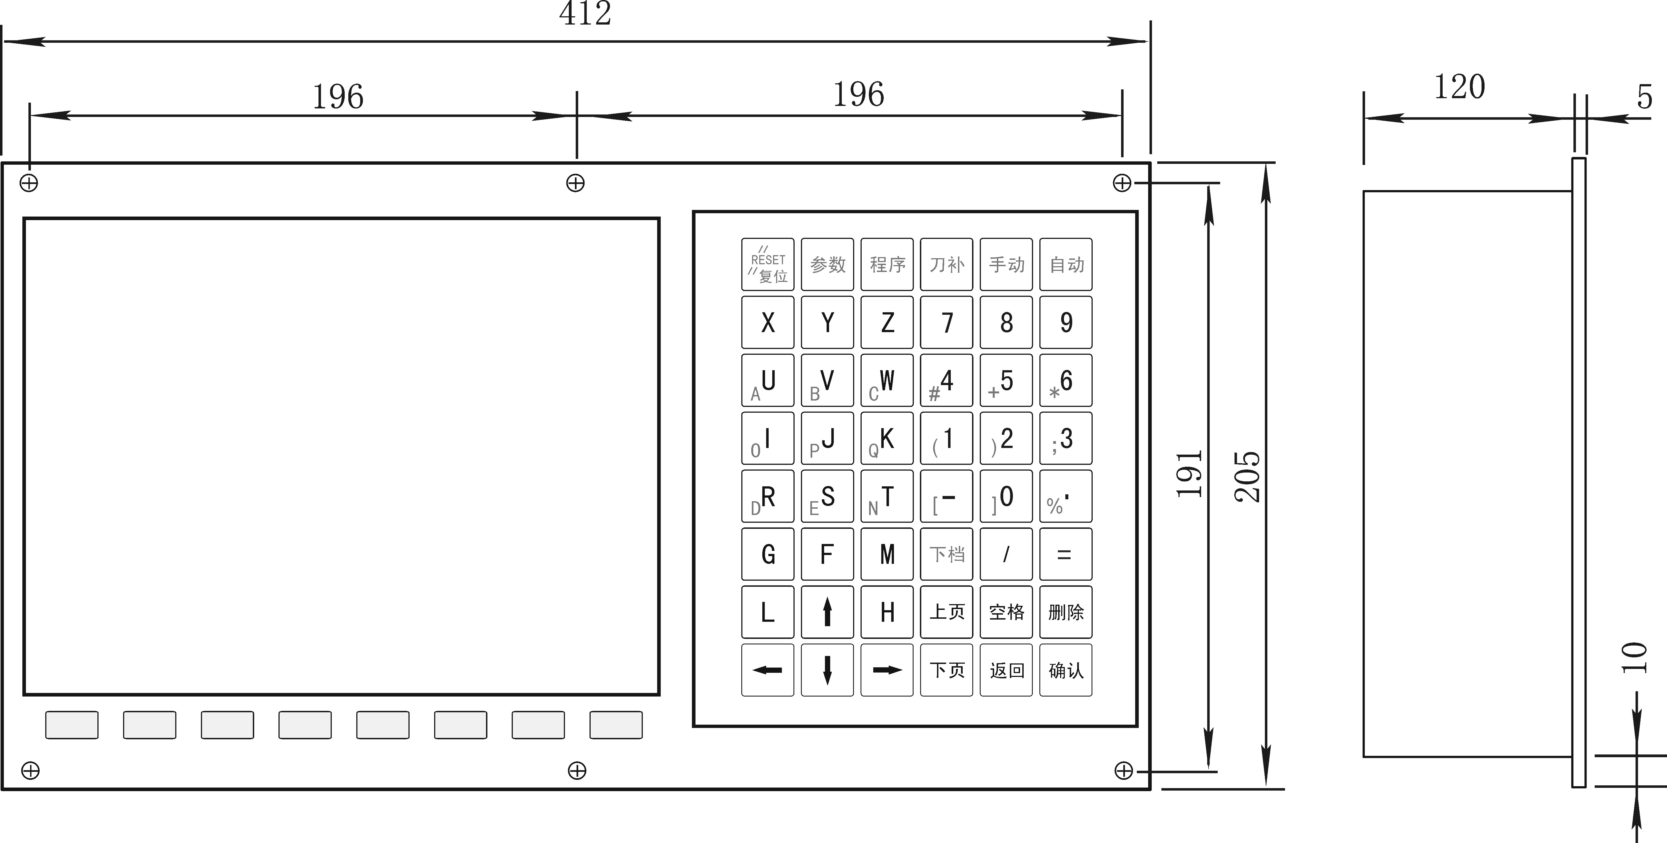

A type:
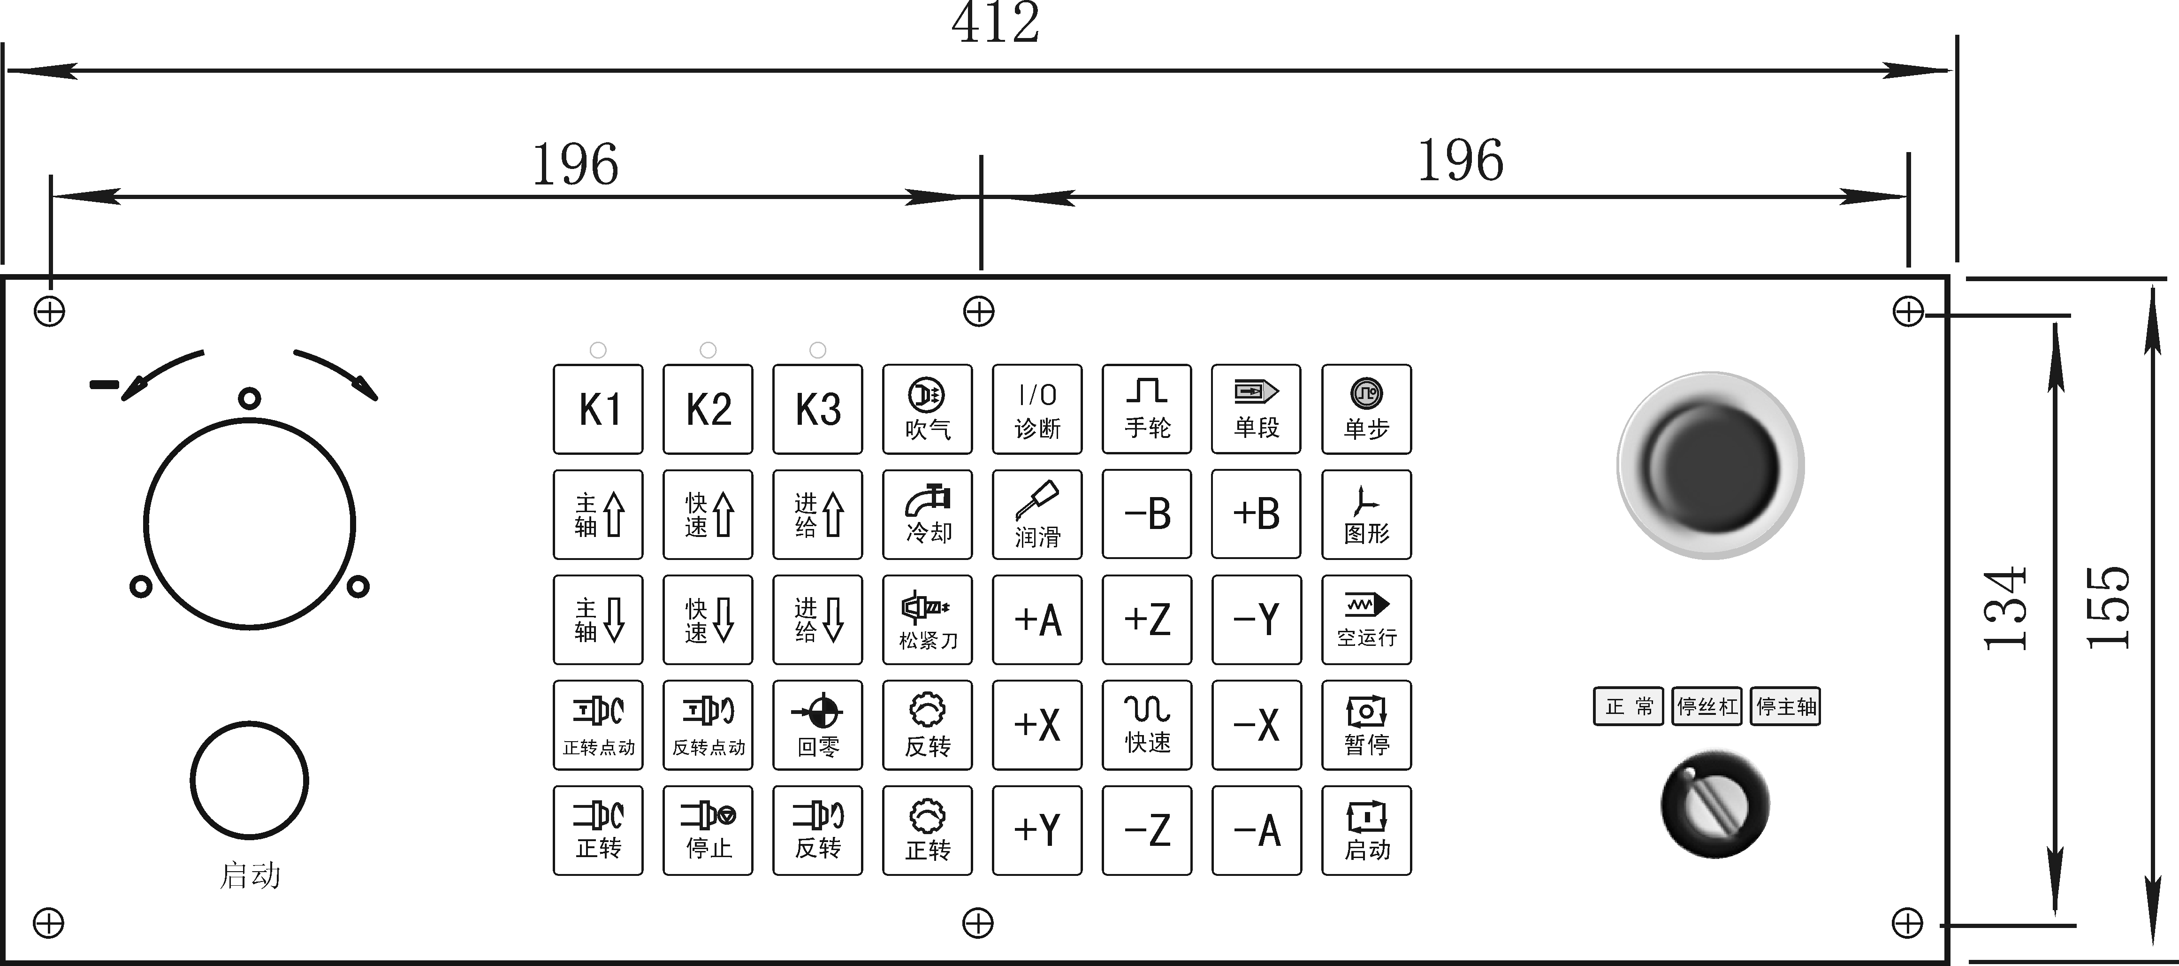
C type:
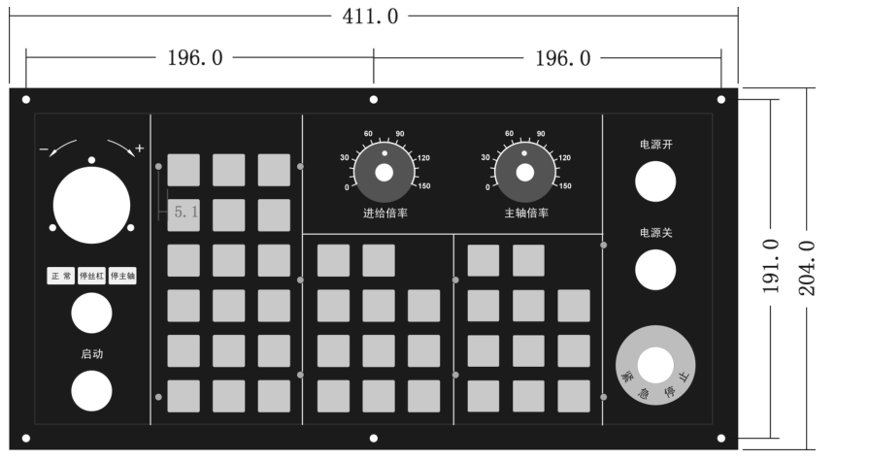

4.6 System rear view
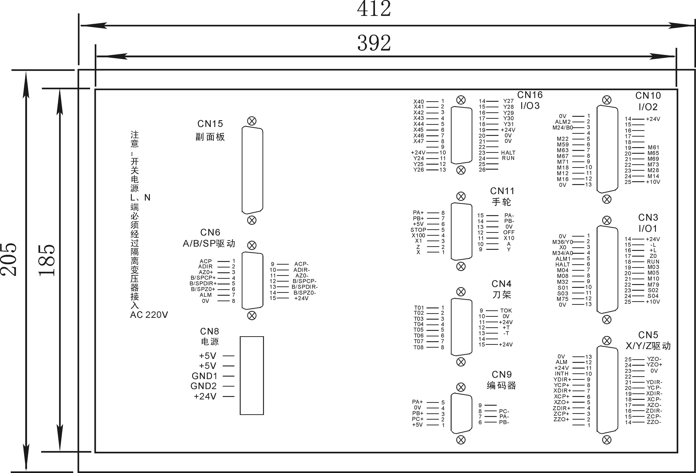

Pay attention:Switching power supply L N must through isolation transformer and insert to AC 220V, current 0.5A.

4.7 Interface connection graph
4.7.1 Communication socket CN6 connect to the hole socket DB9
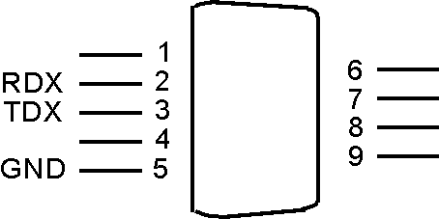
CN6 communication signal with the hole socket DB9
Signal | Pin number | I/O | Function | Effective voltage
0V | 5 | OUT | The ground of signal | 0V
RXD | 2 | IN | The received data signal
TXD | 3 | OUT | The transmission of data signal
+5V | 1 | OUT | Power supply | +5V
LEDT | 4 | IN | Interfere left side | 0V
HALT | 6 | IN | Spindle of stop | 0V
RIGHT | 7 | IN | Interfere right side | 0V
RUN | 8 | IN | Spindle of running | 0V
STOP | 9 | IN | Emergency stop signal | 0V
Pay attention:
1. Connect to external PC with data communication, must be equipped with our special communication software.
2. Communication line must adopt the shielded twisted pair cable, the length shall not exceed 10m.
The signal of CN6 connect to PC:
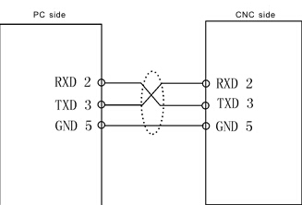

Pay attention: When PC programming, the files should be text files.
4.7.2 The machine CN3 connect to the hole socket DB25
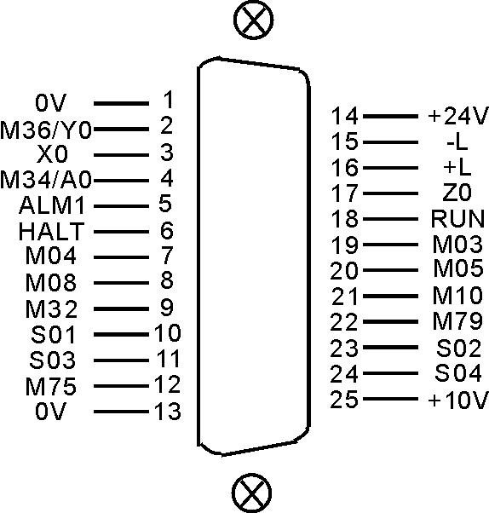
CN3 DB25(hole) I/O1 machine signal
signal | pin | I/O | function | Availability
0V | 1 | OUT | 0V | 0V
+24V | 14 | OUT | +24V | +24V
M36/Y0 | 2 | IN | M36/Y0 | 0V
X0 | 3 | IN | X axis Zero | 0V
Z0 | 17 | IN | Z axis Zero | 0V
-L | 15 | IN | Positive limit | 0V
+L | 16 | IN | Negative limit | 0V
M34/A0 | 4 | IN | M34/A0 | 0V
ALM1 | 5 | IN | Transducer alarm1 | 0V
HALT | 6 | IN | Pause | 0V
RUN | 18 | IN | Run | 0V
M03 | 19 | OUT | spindle clockwise | 0V
M04 | 7 | OUT | SP counter clockwise | 0V
M05 | 20 | OUT | SP stop | 0V
M08 | 8 | OUT | coolant | 0V
M10 | 21 | OUT | spindle chuck | 0V
M32 | 9 | OUT | lubricating | 0V
M79 | 22 | OUT | spindle tailstock | 0V
S01 | 10 | OUT | spindle first gear | 0V
S02 | 23 | OUT | spindle second gear | 0V
S03 | 11 | OUT | spindle third gear | 0V
S04 | 24 | OUT | spindle fourth gear | 0V
M75 | 12 | OUT | C axis mode | 0V
+10V | 25 | OUT | the first spindle converting | 0～10V
0V | 13 | OUT | Ground of converting | 0V
4.7.3 The machine CN10 connect to hole socket DB25
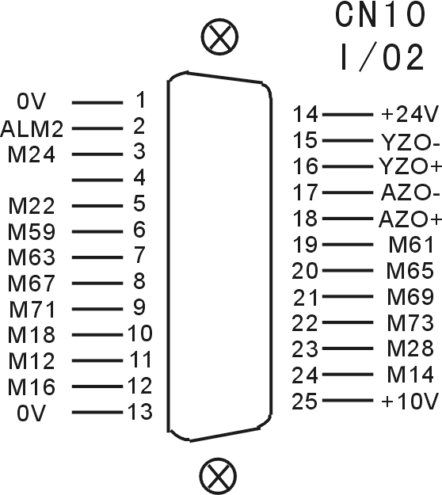
CN10 DB25 I/O2 machine signal
Spindle | Pin | I/O | Function | Effective voltage
0V | 1 | OUT | Ground of the power supply | 0V
+24V | 14 | OUT | 24V power supply | +24V
ALM2 | 2 | IN | machine alarm2 | 0V
M24 | 3 | IN | User-defined input7 or return to the zero point signal of B axis | 0V
M22 | 5 | IN | M01 orientation input | 0V
M59 | 6 | OUT | Huff output | 0V
M61 | 19 | OUT | User-defined output1 | 0V
M63 | 7 | OUT | User-defined output2 | 0V
M65 | 20 | OUT | User-defined output3 | 0V
M67 | 8 | OUT | User-defined output4 | 0V
M69 | 21 | OUT | User-defined output5 | 0V
M71 | 9 | OUT | User-defined output6 | 0V
M73 | 22 | OUT | User-defined output7 | 0V
M18 | 10 | IN | User-defined input1 | 0V
M28 | 23 | IN | User-defined input2 | 0V
M12 | 11 | IN | User-defined input3 | 0V
M14 | 24 | IN | User-defined input4 | 0V
M16 | 12 | IN | User-defined input5 | 0V
YZO+ | 16 | IN | Positive zero point of Y axis motor | 5V
YZO- | 15 | IN | Negative zero point of Y axis motor | 5V
AZO+ | 18 | IN | Positive zero point of A axis motor | 5V
AZO- | 17 | IN | Negative zero point of A axis motor | 5V
+10V | 25 | OUT | The second spindle frequency conversion | 0～10V
0V | 13 | OUT | Ground of frequency conversion | 0V
4.7.4 Driver signal CN5 socket connect needle socket DB25
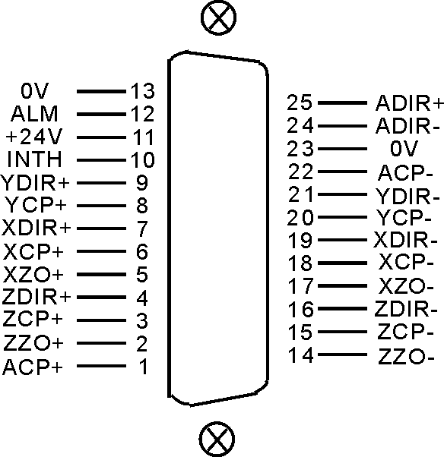
CN5 DB25(pin) servo drive signal
signal | pin | I/O | Function | Availability
XCP+ | 6 | OUT | X pulse signal + | 5V
XCP- | 18 | OUT | X pulse signal - | 5V
XDIR+ | 7 | OUT | X direction signal + | 5V
XDIR- | 19 | OUT | X direction signal - | 5V
YCP+ | 8 | OUT | Y pulse signal + | 5V
YCP- | 20 | OUT | Y pulse signal - | 5V
YDIR+ | 9 | OUT | Y direction signal + | 5V
YDIR- | 21 | OUT | Y direction signal - | 5V
XZO+ | 5 | IN | X motor Zero + | 5V
XZO- | 17 | IN | X motor Zero - | 5V
ZCP+ | 3 | OUT | Z pulse signal + | 5V
ZCP- | 15 | OUT | Z pulse signal - | 5V
ZDIR+ | 4 | OUT | Z direction signal + | 5V
ZDIR- | 16 | OUT | Z direction signal - | 5V
ZZO+ | 2 | IN | Z motor Zero + | 5V
ZZO- | 14 | IN | Z motor Zero - | 5V
ACP+ | 1 | OUT | A pulse signal + | 5V
ACP- | 22 | OUT | A pulse signal - | 5V
ADIR+ | 25 | OUT | A direction signal + | 5V
ADIR- | 24 | OUT | A direction signal - | 5V
0V | 13、23 | OUT | 0V | 0V
ALM | 12 | IN | Servo alarm | 0V
+24V | 11 | OUT | +24V | 24V
INTH | 10 | OUT | Clear alarm | 0V
Pay attention:
1. The signal line must adopt shielded twisted pair cable, the length is 20m at most.
2. Whether the alarm signal ALM is always open or close is set by No.17 parameter in other parameter.
Servo alarm signal:
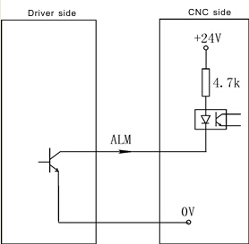
4.7.5 External switch, electrical handwheel socket CN11 connect to DB15 needle socket

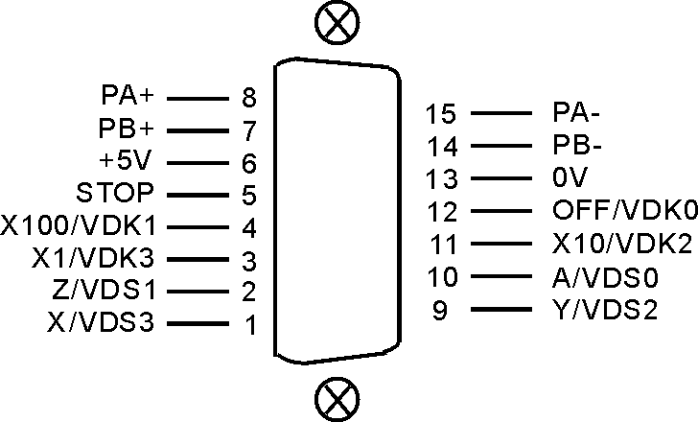
CN11 DB15 I/O signal
Signal | Pin | I/O | Function | Effective voltage
0V | 13 | OUT | Ground of power supply | 0V
+5V | 6 | OUT | 5V power supply | +5V
PA+ | 8 | IN | Positive signal A | 5V
PA- | 15 | IN | Negative signal A | 5V
PB+ | 7 | IN | Positive signal B | 5V
PB- | 14 | IN | Negative signal B | 5V
STOP | 5 | IN | External emergency signal | 0V
OFF/VDK0 | 12 | IN | Turn off gear signal,selection signal of B axis | 0V
X100/VDK1 | 4 | IN | One hundred gears signal | 0V
X10/VDK2 | 11 | IN | Ten gears signal | 0V
X1/VDK3 | 3 | IN | One gear signal | 0V
A/VDS0/HALT | 10 | IN | Selection signal of A axis/Stop signal | 0V
Z/VDS1 | 2 | IN | Selection signal of Z axis | 0V
Y/VDS2/RUN | 9 | IN | Selection signal of Y axis/Running signal | 0V
X/VDS3 | 1 | IN | Selection signal of X axis | 0V
Pay attention: The inner power supply are all +5V of all signal, do not access voltage higher than 5V.
4.7.5.1 Usage for electrical handwheel(Manual pulse generator)
You can connect standard external handwheel when No.1 parameter in other parameter is 1 and can not use band switch to adjust spindle, feed and external stop running button,so No.1 No.2 parameter in axis parameter only set to be “0”
PA+ PB- PA+ PA- corresponding input signal of handwheel pulse A B.
Handwheel contact diagrammatic as:
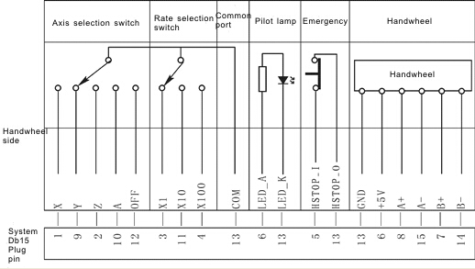
Pay attention:
1. The output signal of handwheel adopts line output, the power supply is +5V.
2. Just connect PA+ PB+ if adopt voltage output.
3. Manual pulse generator needn’t “Enter” button, if there is a “Enter” button, use the line to short the ends of switch.
4.The inner power supply are all +5V of all signal, do not access voltage higher than 5V.
The input signal of handwheel:
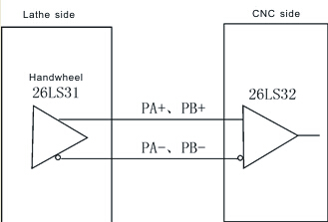
4.7.5.2 Usage for terminal band switch behind sub panel
Could use the band switch when the No.1 No.2 parameter in "axis parameter" are set to 1,the No.1 parameter in "other parameter" should be set to 0, A、Z、Y、X、OFF、X100、X10 and X1 are corresponding to select the feeding axis and the gear of the spindle.
VDS0 (A), VDS1 (Z), VDS2 (Y), VDS3 (X) are input signal which is for trimming gear of spindle speed, four position control,total 16 gears. VDK0 (OFF), VDK1 (X100), VDK2 (X10), VDK3 (X1) are input signal which is for trimming gear of feeding speed,four position control,total 16 gears.
4.7.5.3 Using for external emergency button
STOP signal is the input signal of external emergency button, No.27 parameter in other parameter controls the emergency button is normally open or close.
4.7.6 Spindle encoder socket CN9 connect to needle socket DB9
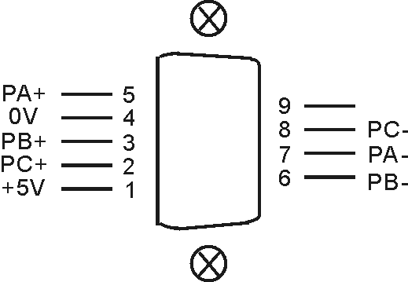
CN9 DB9(pin) spindle encoder
signal | pin | I/O | function | availability
0V | 4 | OUT | 0V | 0V
+5V | 1 | OUT | +5V | +5V
PA+ | 5 | IN | +A signal | 5V
PA- | 7 | IN | -A signal | 5V
PB+ | 3 | IN | +B signal | 5V
PB- | 6 | IN | -B signal | 5V
PC+ | 2 | IN | +Z signal | 5V
PC- | 8 | IN | -Z signal | 5V
Pay attention:
1. The output signal of encoder adopt the output way is line output, the power supply is +5V.
2. The signal line must adopt shielded twisted pair cable, the length is 20m at most.
The input signal of encoder PA PB PC:
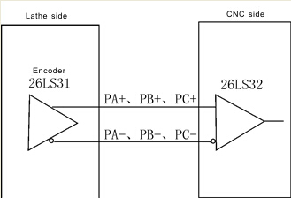
4.7.7 Feedback signal of coordinate axis position socket CN13 connect to needle socket DB26
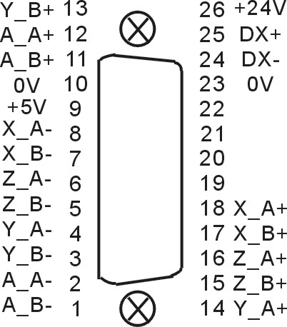
CN13 DB26 I/O signal
Signal | Pin | I/O | Function | Effective voltage
0V | 10,23 | OUT | Ground of power supply | 0V
+5V | 9 | OUT | 5V power supply | +5V
+24V | 26 | OUT | 24V power supply | +24V
DX+ | 25 |  | RS485+
DX- | 24 |  | RS485-
XA+ | 18 | IN | Positive signal A of X axis | 5V
XA- | 8 | IN | Negative signal A of X axis | 5V
XB+ | 17 | IN | Positive signal B of X axis | 5V
XB- | 7 | IN | Negative signal B of X axis | 5V
YA+ | 14 | IN | Positive signal A of Y axis | 5V
YA- | 4 | IN | Negative signal A of Y axis | 5V
YB+ | 13 | IN | Positive signal B of Y axis | 5V
YB- | 3 | IN | Negative signal B of Y axis | 5V
ZA+ | 16 | IN | Positive signal A of Z axis | 5V
ZA- | 6 | IN | Negative signal A of Z axis | 5V
ZB+ | 15 | IN | Positive signal B of Z axis | 5V
ZB- | 5 | IN | Negative signal B of Z axis | 5V
AA+ | 12 | IN | Positive signal A of A axis | 5V
AA- | 2 | IN | Negative signal A of A axis | 5V
AB+ | 11 | IN | Positive signal B of A axis | 5V
AB- | 1 | IN | Negative signal B of A axis | 5V
This function is specified by No.200-220 in other parameter. If it alarms, press ”G” in diagnosis interface to clear command position and feedback position, and reset out-of-tolerance alarm.
Notes:
1. output signal of encoder or linear scale adopts long-term output, power is +5V.
2. The signal line must adopt shielded twisted pair cable, the length is 20m at most.
3. this is optional function
4.7.8 Trimming method for the system matches the absolute bus type of motor
1. Turn on the power supply.
2. Set the axis parameter in system to trim motor mode of XYZA axis.
3. Set the axis parameter in system to trim the electrical gear.
P11=00000001 soft limit effectively;
Machine setting P23=11111011; Milling setting P33=11111011; Returning to zero with floating mode;
4. Set the other parameter in system
P300=01111100; the absolute value function;
P301=92; P302=91; P303=90;
P304/P305/P306/P307=131072;
P309/P310/P311/P312 set the coordinate values, such as when the screw pitch with direct of Z axis is 6mm,
P311=6000000;
5. Set the coordinate axis which corresponds the No.56 parameter in driver parameter
P1=1, enter the password;
P56=1/2/3/4 corresponds to the X/Y/Z/A, such as the Z axis drive is set to 3;
Press "Enter" for a while to save parameter in EP-status;
6. MDI to run the M500 instruction, the small circle in front of the coordinate axis should be changed into "green", means read the absolute encoder data correctly;
7. Set the coordinate value and direction of machine:
1) manual move coordinate and remember the machine coordinate value;
2) MDI to run M501/M502/M503/M504(corresponds to the X/Y/Z/A axis) instruction, reading whether the absolute value coordinate is the same as previous coordinate value or not, modifying the symbol of No.309 No.310 No.311 No.312 parameter in other parameter, such as the X coordinate is not right, the original is P309=4000000, to modify to P309=-4000000;
3) Repeat 1) 2) test for two times;
8. Setting the zero point of machine: manually move to the position which is nearby the zero point , set the No.314 No.315 No.316 No.317 No.318 parameter in other parameter(Corresponds to X/Y/Z/A/B axis), press "Enter" and press "E" to clear the machine coordinate;
9. Manual move every axis to the limit position of machine to set the soft limit value in axis parameter;
10. Set the No.41 parameter in other parameter and back up the current system parameter

4.8 Installation of machine electronic parts .
4.8.1 Limited position: take X Y Z A axis is limited position positively as example
Model 1: NPN approach switch
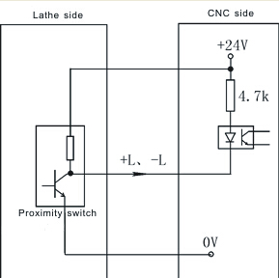

Mode 2: General switch
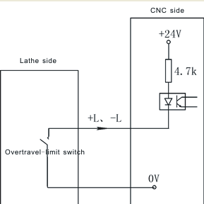
Axis parameter:
No.27 parameter is for setting the type of hard limit switch for +L positive, 0 means always open, 1 means always close.
No.28 parameter is for setting the type of hard limit switch for -L negative, 0 means always open, 1 means always close.
Pay attention:
1. X Y Z A axis limited shares a signal to always open or close together, positive limited and negative limited corresponding stand for +L and –L signal.
2. Could select our electrical appliance plate of machine.
3. The system could define X0 Y0 Z0 A0 to be limited input signal of X Y Z A axis. X0 signal as the limited signal and datum point of X axis, the same switch to control.Y0 signal as the limited signal and datum point of Y axis, the same switch to control. Z0 signal as the limited signal and datum point of Z axis, the same switch to control. A0 signal as the limited signal and datum point of A axis, the same switch to control.
The function must copy our exclusive PLC software.
4.8.2 Machine’s datum point(reference point or 0 point): take X axis as example (the same as Y Z A axis)
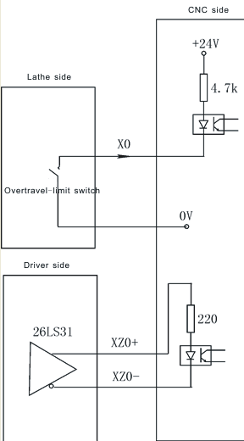
Backing to the datum point
At the function of setting floating datum point is invalid conditions, backing to the datum point need to check approach switch signal and motor Z pulse signal. No.33 parameter in axis parameter is set to be “00000000”.
No.38 parameter in axis parameter set the function of backing to the datum points:
There are four ways for system to set backing to the datum point when turn on the system:
Needn’t when it is 1: system doesn’t prompt and no limits when turn on the system every time.
Prompting way when it is 0: system popup a dialog box to prompt user to process operation of backing to the datum point, it has no limits.
Forcing mode when it is 8: system popup a dialog box to prompt user to process operation of backing to the datum point and not to process before running automatically, the system will import “Feeding axis doesn’t back to the datum point” and not to process program.
Super forcing mode when it is 9: moving the feeding axis when turn on system every time, the system will popup a dialog box to process operation of backing to the datum point, it will prompt “Feeding axis doesn’t back to the datum point” and not to process action if not to process operation of backing to the datum point.
No.39 parameter in axis parameter set the checking signal mode of backing to the datum point:
When it is 0: After hitting the datum point switch when backing to the datum point, run reverse to check the switch off and check 0 pulse signal of motor encoder.
When it is 1: After hitting the datum point switch when backing to the datum point, run reverse to check the switch off.
When it is 2: After hitting the datum point switch when backing to the datum point, continue running to check the switch off and check 0 pulse signal of motor encoder.
When it is residual value: After hitting the datum point switch when backing to the datum point, continue running to check the switch off.
The mode of backing the datum point should according to the circuit situation of equipment, at common conditions, it suggests to set to be 0 or 2, because if not to check 0 pulse signal of motor encoder, the accuracy can’t be promise.
No.40 parameter in axis parameter set the direction and sequence of backing to the datum point:
Every axis is to set separately. The parameter is positional parameter,D2 controls the processing direction of X axis, D3 controls the direction of backing to zero point in Y axis,D4 is for direction of Z axis, 1 means negative, 0 means positive;
No.41 parameter in axis parameter set the type of datum point switch:
Every axis is to set separately. The parameter is positional parameter, D0 position controls X axis,D1 position controls Y axis,D2 position controls Z axis, 1 means always close, 0 means always open.
No.42~No.45 parameter in axis parameter is set to check the processing length of motor Z pulse when backing to the datum point:
To set the scope of checking the motor encoder zero pulse signal after switch off when X(No.42) Y(No.43) Z(No.44) A(No.45) axis backing to the datum point. Unit: 0.1mm.
Pay attention: The parameter value must less than the distance of motor turns a round, otherwise could cause the wrong datum point situation.
No.34 No.36 No.38 No.40 parameter in speed parameter set the speed of reaching to zero point switch when backing to datum point (zero point):
The processing speed of reaching to datum point switch when X(No.34) Y(No.36) Z(No.38) A(No.40) axis backing to positive datum point. Unit: mm/min. Numerical range: Less than the G00 speed of X axis.
No.35 No.37 No.39 No.41 parameter in speed parameter is set to check the processing speed of motor Z pulse when backing to the datum point:
When the X (P35) Y (P37) Z (P39) A (P41) axis backing to the datum point, the speed of checking the motor Z pulse signal after disengaging the switch for datum point. Numerical range: 20-500.
Pay attention: The parameter value influence with the accuracy of backing to the datum point, the smaller the value the higher the accuracy. This value has been set which not to change anymore, otherwise it will affect the reference point too.
No.46~No.49 parameter in axis parameter set the offset of finishing back to the datum point:
Used to set how much distance to offset before returning to the reference point when the X(No.46) Y(No.47) Z(No.48) A(No.49) axis backing to zero and checking the zero pulse signal of servo motor. Unit: 0.01mm. Numerical range:-99999~+99999.
The parameter value is related to the install position of machine’s datum point and the machine’s coordinate.
Pay attention: After backing to the datum point, the offset speed is determined by G00.
1. The speed reduce switch is also can use NPN switch.
2. Must consider the length of speed reduce when installing the speed reduce switch.Must be less than or equal to 25mm.

4.8.3 The controlling signal of switch: M03 as example (the same as M04 M05 M08 M10 M32 M79 M75 M59 M61 M63 M65 M67 M69 M71 M73 S01—S04)
M03 signal control:

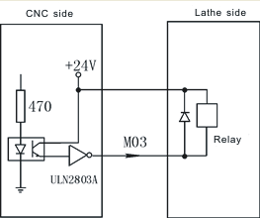
As the picture say, it will form a return circuit with 24V when system outputting M03, The intermediate relay is working and a group of normally open contact form a circuit with spindle rotation AC contactor.
All the low level 0V of output signal is effective.
Pay attention:
1.When the relays and others load, must connected with the diode to absorb the reverse current so as not to damage the system, if use the electromagnetic contactor, then plus resistive and capacitive spark circuit.
2. Chip ULN2803A corresponds output ports:
1). U28 corresponds to M59 M61 M63 M65 M67 M69 M71 M73
2). U29 corresponds to M03 M04 M05 M08 M10 M79 M32 M75
3). U30 corresponds to +T –T S01 S02 S03 S04 LRUN INTH
3.When user-defined signal M71/M70 is used for input signal of spindle chuck and thumbstall, it can’t be the other user-defined. No.20 No.21 parameter in other parameter to set.
4. When user-defined signal M65 M67 M69 is used for input signal of “Emergency”, it can’t be the other user-defined. M65 the program stops to output,M69 the program runs output,M67 the alarm output. No.28 No.29 parameter in other parameter to set.

4.8.3.1 System spindle control (M03/M04/M05)
System output two spindles (First spindle, second spindle) controlling signal, relative parameter as follows:
Axis parameter
No.9 parameter: Set the braking time of spindle, also the it’s the output of the hold time, the time less the brake fast.Unit:10ms.
No.10 parameter: Set the braking signal is long signal 1 or short signal 0.
No.43 parameter: Whether turn on the spindle or not when spindle shifting [1 means on, 0 means off]
No.44 parameter: The turning speed of motor when spindle shifting (1/100rpm)
No.45 parameter: The turning direction when spindle shifting (0 means positive, 1means negative)
No.46 parameter: The stopping time when spindle shifting (10ms)
No.47 parameter: Turning time of low speed when spindle shifting (10ms)
No.48 parameter: Stopping delay time of spindle (10ms)
Speed parameter
No.9 parameter: To set the speed of spindle setting value at manual condition. Unit: rpm.
No.42 parameter: To set the highest speed of spindle, that’s the turning speed of corresponding 10V instruction voltage.
No.43 parameter: To set the highest speed of spindle low gear(second gear) or the highest speed of second spindle, that’s the turning speed of corresponding 10V instruction voltage. Unit: r/min
No.44 parameter: To set the highest speed of spindle (Third gear), that’s the turning speed of corresponding 10V instruction voltage. Unit: r/min
No.45 parameter: To set the highest speed of spindle (Fourth gear), that’s the turning speed of corresponding 10V instruction voltage. Unit: r/min
No.46 parameter: To set the highest speed of second spindle, that’s the turning speed of corresponding 10V instruction voltage. Unit: r/min

4.8.3.2 System lubrication control (M32/M33)
No.4 parameter in other parameter controls the function of lubricate automatically. No.6 parameter set the spacing time of lubrication (Unit: S); No.5 parameter in other parameter set the lubrication time (Unit: S).
Pay attention: The signal is controlled by M32 output.
Other parameter:
No.13 parameter: To set whether spindle and chuck is interlocking or not: 0 means they are separately; 1 means the spindle only start turning when chuck on. The thumbstall can’t be use when the spindle is turning.
Setting parameter is related with the configuration of machine and user’s service condition, but consider for safe, suggest setting 1.
No.20 parameter: To set system controls chuck only need one signal (one-way valve) or two signals (two-way valve), this parameter is related with equipment of machine.
M10 is just a output signal to control tautness of chuck when set to 0, system carry out chuck to tighten when M10 is effective, loosen chuck when M10 is invalid;
M10 and M71 corresponding control loose and tight of chuck when set to 1, system carry out chuck to tighten when relay M10 is effective, M71 is invalid, loosen chuck when M10 is invalid and M71 is effective. Output M10 when M10, output M71 when M11.
No.22 parameter: To set external button to control loose and tight of chuck( or foot switch), the signal is reciprocating, it means loosen once and then tighten once, reciprocating mode. No external button when set to 0; There is an external button to control chuck when set to 1, the signal is M16.
No.24 parameter: To set the retention time when the output signal M10 M71 of chuck is short signal, set to 0 means the signal is long signal. Unit: S.
Pay attention: M16 is a multiple function signal, only choose one function to use.

4.8.4 System alarm signal: ALM, ALM1, ALM2, Door alarm M12 and Emergency
No.7 parameter: To set the system whether to check the switching signal of protective door, no door switch when set to 0, there is a switch to control protective door when set to 1; Suggest to set 1 for safe.
No.8 parameter: To set the type of door switch, 0 means always open, 1means always close.
No.17 parameter: To set the type of system checking the servo alarm signal (twelfth pin of CN5 ALM), 0 means always open, 1 means always close.
No.18 parameter: To set the type of system checking the spindle alarm signal of machine (fifth pin of CN3 ALM1), 0 means always open, 1 means always close.
No.19 parameter: To set the type of system checking the alarm signal of machine (second pin of CN19 ALM2), 0 means always open, 1 means always close.
No.27 parameter: To set the Emergency always open or close of system CN11, suggest setting always close for safe.
Emergency STOP: Press “Emergency” when appearing emergent accident, the machine will stop all actions and the screen of system shows “Emergency”. Wait for pressing up the button. Output M67 signal is effective (output alarm) when No.29 parameter in other parameter is effective. This output signal can be used to protect the machine (Cut off power supply).
No.29 parameter in other parameter is effective when appearing alarm, the output signal M67 is effective.

4.8.5 User-defined output signal M12 (M14 M16 M18 M28 M22 M24,M24, external “Run”, external suspend “HALT”, external “STOP” as the same)
M12 switch use overtravel-limit switch to wiring:
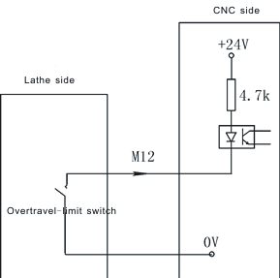
M12 switch also can use NPN as checking witch:
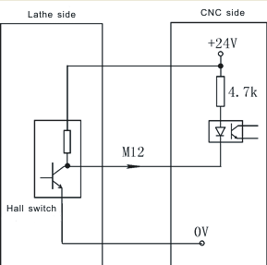

4.9 Electrical appliance plate of machine
Our company produces the electrical appliance plate of machine to choose as follows.
I/01 socket and CN3 are corresponding one-to-one with CN3 pins of system;
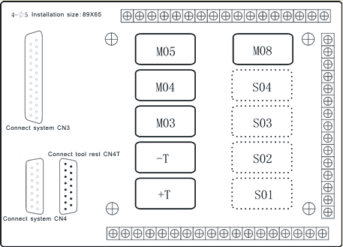
4.9.1 Spindle controlling
C1 is the common port of M03 and M04.
C2 is the common port of M05, M5B is always close.
4.9.2 Spindle gear controlling
C4 is the common port of S1 and S2, S1B and S2B are always close.
C5 is the common port of S3 and S4, S3B and S4B are always close.

